Check In

Paid Cash $____

Paid Check $____
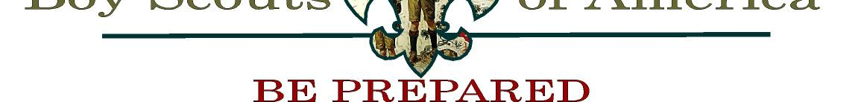

 |  |  |  |  | TROOP 5 PERMISSION SLIP
Scout’s Name:
Trip:
Date(s):
Meeting time: |  |  |  |  |  | Place:
Pickup time: |  |  |  |  |  | Place:
Medical Insurance:
Company: |  |  |  |  |  | Policy #
Physician

Phone Number

Please list any allergies or other medical conditions that warrant notification. Please note any activity he may not participate in. If necessary use the back of this form.

Please list any medications your son is currently taking. If necessary use the back of this form.

My/our son has reviewed his equipment checklist in his scout Handbook and I/we are satisfied that he is properly dressed and equipped for this activity. I/we understand that all troop activities are conducted in the spirit of the Scout Oath & Law. Any scout who, in the opinion of the adult leadership, does not live up to these principles may be required to call his parents and have them bring him home.

In consideration of the benefits to be derived, and in view of the fact that the Boy Scouts of America is an educational institution, membership in which is voluntary, and having full confidence that every precaution will be taken to ensure the safety of my son on this activity, I hereby agree to his participation and waiver all claims against the leader of this trip and officers, agents, and representatives of the Boy Scouts of America. In the event of an emergency and I / we cannot be contacted, I give permission for emergency treatment by qualified medical personnel.

Parent’s signature: |  |  |  | Date:
Print Parent’s Name: _________________________________________
Home Phone: ________________________________ |  |  | Cellular / pager: _____________________________
Emergency contact other than Parents: _______________________ |  |  |  |  |  | Phone: _______________________
My son will be picked up by _______________________________ (if other than parent)

This form is required for all trips. There will always be adequate supervision for your son and we will do everything in our power to protect him.

Brian White, Scoutmaster

