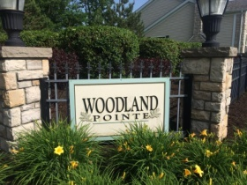
10 Reasons to Volunteer
to Serve on the Board
- Protect your property value and maintain or even improve the
quality of life in your community.
- Suggest improvements with landscaping/snowplowing/maintenance.
- Be sociable. Meet your neighbors, make friends, and exchange
opinions.
- Give back. Repay a little of what has been done for you.
- Advance your career. Build your personal resume by including your community volunteer service. Network with other professionals.
- Have some fun. Association work isn’t drudgery. It’s fun accomplishing good things with your neighbors.
- Get educated. Learn how it’s done - we will train you.
- Express yourself. Help with creative projects like community
beautification.
- Earn recognition. If you would like a little attention or validation, your contributions will be recognized and celebrated.
- Try some altruism (unselfish concern for the welfare of others).
Improve your association by helping others.
The purpose of the annual meeting is NOT to raise your hand and complain, but to raise your hand and run for the board.

