GFWC BWC NEWS
  - club Monthly updates
SNACK DRIVE
We donated the following to Hiteon Elementary, Greenway Elementary and Nancy Ryles Elementary School!
160 Packages of Gold Fish Crackers
142 Granola Bars
66 Packages of Raisins
566 Packages of Fruit Snacks
54 Packages of Applesauce

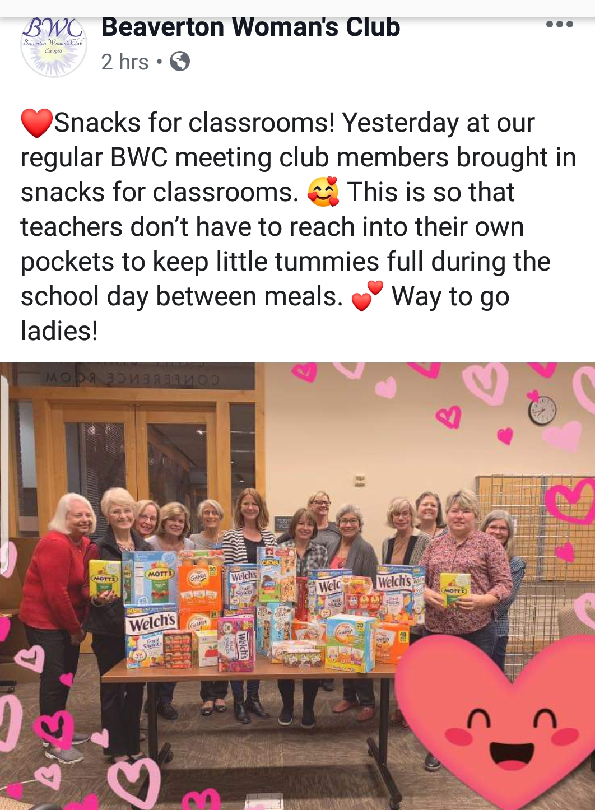
ADOPT A ROAD  Sunday, October 20  1:00 – 3:00 pm  Meet at corner of Ranch 99 Parking Lot (Hall/Greenway)  Beaverton  8155 SW Hall Blvd.  Beaverton, OR 97008  November Meeting  November 5 th 7:00 pm  Griffith Building Room #340  Bring: Toiletry Items for Crime VictimsToothpaste, laundry detergent, baby wipes, granola bars, applesauce cups, fruit snacks, jelly/jam, macaroni, pasta sauce, cereal  Program: International Affairs | OCTOBER 29 CHARITY BUNCO  6:30 PM  Home of Allison Belisle  Bring: $20, Wine/Snack to share  Costumes Encouraged  Proceeds to go to OFWC Fine Arts Contest  RSVP: sajcb@yahoo.com  THANK YOU’S  Vicki Lance for voluteering for Sunshine Committee  Sue Pike for arranging BAM showcase at Library  Kelli Roesch for being 20th Year Gala Tea Chairman

