Opportunity Equity for High-Poverty Students:
A 2020 Legislative Priority
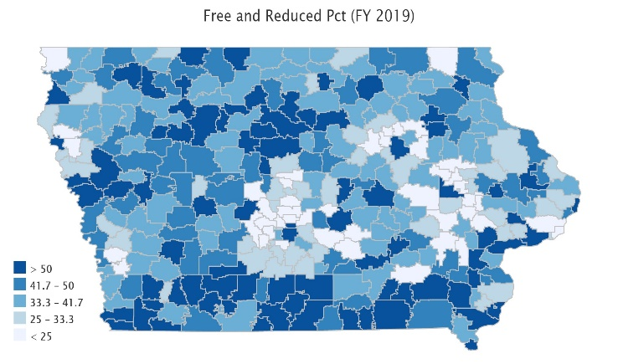
Background: Iowa’s funding formula does not sufficiently recognize poverty as a driver of at-risk student programing. In 2001, about 28% of students were eligible for Free/Reduced Price Lunch (FRPL), with the lowest district percentage of eligibility at 4.2%. That rate has since nearly doubled. Dropout Prevention funding is based on total enrollment count, not the percentage of students at-risk. Although flexibility for use of DoP funds has been legislatively expanded, DoP funding is still limited to 2.5% of the total regular program district cost or up to 5% of regular program district cost based on historical practice.
Current Reality: In FY 2019, 43.0% of students, or 207,835 children, were FRPL eligible.
- Poverty is now found throughout the state and it’s a rural challenge. The map’s darkest color shows districts with 50% or more of enrolled students eligible for FRPL. Of the 83 school districts with more than half of students eligible, 71 are rural. In districts below 300 enrolled, 50.3% of enrolled students are eligible. Rural Iowa communities further lack other resources to help low-income families.
- Iowa’s funding for at-risk and dropout prevention translates into less than 10% funding commitment for students in poverty, well short of the national average 29% beyond the base for low-income students. (AIR, Study of a new Method of Funding for Public Schools in Nevada, Sept. 2012)
- Students from low-income families are more likely to begin school academically behind, exhibit nonproficient literacy skills, especially in early elementary, and fall further behind over summer breaks, unless schools have the resources, staff and programs to meet their needs.
- Districts must waive student fees for FRPL-eligible families, meaning those districts with concentrated poverty have less resource for textbooks and drivers’ education, further stressing the general fund.
- High-poverty School Investments boosts achievement. Education Week, Student Outcomes: Does More Money Really Matter? Fresh research bolsters the case for K-12 cash—and a rough road without it, Daarel Burnette II, June 4, 2019 reports: "Now, a growing number of researchers are pushing back against what they see as a simplistic, reductionist view of the role that spending plays in school quality and student performance. More money does, in fact, make a difference, they say—provided that you spend enough, and in the right manner. They point to research in the past five years that provides examples of instances where politicians and taxpayers invested more money in teacher salaries, school construction, and schools with high populations of low-income students and saw students’ test scores jump.”
- Low-income rural students are an important piece of Iowa’s workforce puzzle, will stay in Iowa, and will either be the backbone of our rural communities’ potential or a drain on future resources.
RSAI calls on the Iowa Legislature to provide Opportunity Equity for High-Poverty Students: RSAI supports resources for at-risk students. Resources should be based on need, such as the percentage of students eligible for Free and Reduced Price Lunch (FRPL), in addition to enrollment of the district. The current disparity in dropout prevention capacity, (some districts held to 2.5% and others up to 5% of regular program district cost) is arbitrary, based on history no longer relevant to supporting student needs. All school boards should be able to realize the full 5% dropout prevention funding. The formula must further recognize the disproportionate cost of providing equal educational opportunities to low-income students. School districts should be granted spending authority for FRPL eligible students’ fees mandated to be waived by state and federal law.
Margaret Buckton, RSAI Professional Advocate margaret@iowaschoolfinance.com, (515) 251-5970

