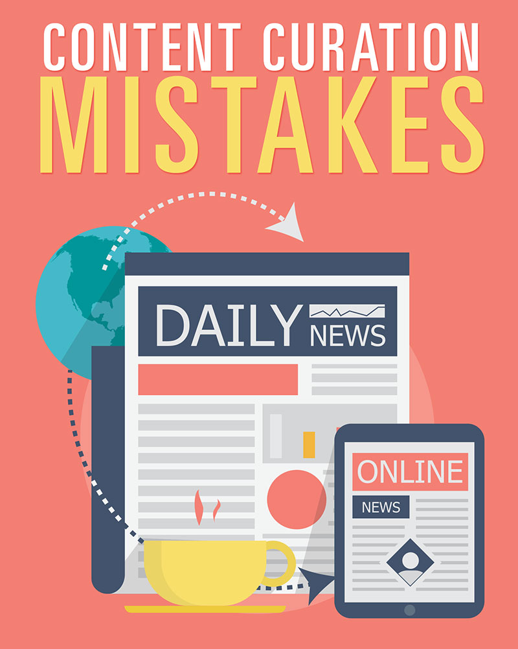

Table of Contents

Table of Contents 2
Introduction 3
Mistake #1 – Linking to Poor Quality Content 4
Mistake #2 – Using the Same Few Sources 5
Mistake #3 – Curating Only Blog Posts 6
Mistake #4 – Automating Content Curation 7
Mistake #5 – Failing to Give Proper Attribution 8
Mistake #6 – Using ONLY Curated Content 9
Mistake #7 – Adding No Value 10
Mistake #8 – Not Doing Keyword Research 11
Mistake #9 – Being Faceless 12
Mistake #10 – Having No Call to Action 13
Conclusion 14
Resources 15
©2015 All Rights Reserved.
No part of this publication may be, including but not limited to, reproduced, in any form or medium, stored in a data retrieval system or transmitted by or through any means, without prior written permission from the publisher.
The information contained herein has been obtained from sources believed to be reliable at the time of publication. The opinions expressed herein are subject to change without notice.
The publisher disclaims all warranties as to the accuracy, completeness, or adequacy of such information.
The publisher assumes no liability for errors, omissions, or inadequacies in the information contained herein or from the interpretations thereof. The publisher specifically disclaims any liability from the use or application of the information contained herein or from the interpretations thereof.

Introduction

Content curation is one of the biggest trends in content development, and there are several reasons for that.

- It takes less time than traditional content development. You simply link to other people’s content, perhaps with a short excerpt, and add your own unique commentary.
- It gives you content ideas you might not have thought of on your own. Browsing websites in your niche will let you find all sorts of ideas quickly and easily.
- Google loves it when you link out to other sites. It’s not all about backlinks, anymore. Now it benefits you to link TO quality sites.

But there are a few pitfalls you might fall into when using content curation on your website. This guide is going to discuss some of those common mistakes people make, and how you can avoid making them on your own site.

You’ll find out how to avoid potential legal problems, how to avoid mistakes that might upset Google and get your site penalized, and how to be sure you’re using content curation properly.

So let’s get started.

Mistake #1 – Linking to Poor Quality Content

When you’re in a hurry to get some content posted, it can be tempting to just Google your topic and link to a bunch of different articles without taking the time to really vet the content to ensure it’s actually worth linking to.

Sure, it may have a spiffy image or a very interesting headline, but is the content itself well-written, informative, and interesting? Is it full of grammatical errors as though it were written by someone whose first language was obviously not the language it was written in? Are there factual errors?

Not only that, but if you’re linking to a site that has been banned by Google or is seen as spammy and has received a penalty, you could hurt your own website, too.

Be sure you’re linking to quality content that is on domains that are in good standing with Google. (If you Google site:domain.com it will tell you how many pages are indexed from that domain. As long as there are a decent number of indexed pages, you’re probably safe linking to it.)

Always check the content before you link to it to be certain that both Google and your readers would approve.

Mistake #2 – Using the Same Few Sources

One trap a lot of webmasters and bloggers fall into is using the same few websites on a regular basis, thus limiting their scope as far as content and SEO benefits. Sure, you’ll probably want to pull most of your content from a few trusted sources, but it’s important to seek other sources from time to time, as well.

It’s tempting to fall into this trap because you know the sources you’re using are posting only high quality content on a regular basis, and you trust those sources. But if you’re only linking to those same places, you won’t get as much SEO benefit and your visitors may just start going directly to those sources instead of your site because they see the same ones again and again.

Pinterest is a great place to find potential content, because it’s all organized by keywords and it’s represented visually, making it faster to find what you’re looking for. Plus, there is content from thousands of sites in pretty much any niche.

Facebook is another perfect place to locate different sources. Just locate a few fan pages or groups in your niche and watch what is being shared. This is especially true if you’re looking at fan pages that are NOT run by website owners.

Mistake #3 – Curating Only Blog Posts

Google loves to see a lot of different types of media on blogs and websites, not just articles. This means posting videos, infographics, PDF files, images, and so forth.

Fortunately, this means you can find an abundance of content just by searching sites like YouTube and Pinterest. (Remember, though, if you’re posting images and such, you’ll need to get permission to post the full document. Otherwise, you can only legally use a thumbnail sized image.)

Fortunately, YouTube allows embedding of their videos. In fact, they encourage it because it gets more views of their content, thus increasing value for advertisers.

Simply embed a video into your blog post or web page and describe the video with a paragraph or two of text. You can also work keywords into this text to be sure you’re attracting search engine traffic with your post.

Mistake #4 – Automating Content Curation

Content curation can certainly be automated if you’re not really interested in providing a good user experience and you don’t really care what type of content shows up on your website, but there are several reasons you do NOT want to automate content.

- Google doesn’t like automated content, and they could penalize or ban your site if that’s all you’re posting. (Or even if it’s a majority of your content.)
- AdSense has already stated that you’re not allowed to post their ads on sites that are comprised primarily of automated video or article postings that offer no added value.
- Spammy or offensive content could get posted on your blog and upset your visitors. Imagine a pornographic video being added to a blog about children’s toys, for example!

The only way automated content might work well is if you moderate every single post BEFORE it goes live, simply placing those automated posts in review until you can check them for quality and add your own unique description to each one.

Mistake #5 – Failing to Give Proper Attribution

Content curation is something that straddles the line of copyright infringement if it isn’t done correctly. Considering you could face thousands of dollars in fines if you are found guilty of infringing on someone else’s copyright, it’s vital to be certain you’re properly attributing all content.

Here are some ways to be sure you’re following best practices as far as attribution:

- Do not post other people’s content in its entirety. Use excerpts, posting only small parts of their content and adding your own commentary.
- Be sure you mention the original source of the content, and ideally link to the original article. This is beneficial for your SEO, too.
- When using photos, be sure you use only a thumbnail unless you ask for permission first. Thumbnail images (according to Kelly v. Arriba Soft Corp in the U.S. Court of Appeals) fall under fair use.
- Don’t use no-follow on links. People deserve full link juice for your use of their content.

Mistake #6 – Using ONLY Curated Content

It’s never a good idea to post solely curated content on your website. It’s a great idea to post high-quality, original content, too.

First of all, Google loves unique content. Yes, they love when you link to other high-quality websites, too. But unique content will always trump curated content.

Find a good balance. You should aim for at least 10% original content to balance out your curated content, and make sure those posts are high quality and have at least 500-1000 words. (In fact, these days, the longer the better as far as Google. They love long posts!)

You can use a plugin to break your content up into multiple pages for your visitors while still showing as one long article to Google. Or you can use the “Blog pages show at most” value in WordPress.

You can read more about how to use pagination on your WordPress blog at the link below:

>> https://codex.wordpress.org/Pagination

Mistake #7 – Adding No Value

One of the biggest mistakes people make with curating content is when they post nothing but curated content, or links to other people’s content, without adding any value.

Not only is this bad for your users, it’s also terrible as far as SEO is concerned. Search engines need words on the page to index content. While Google can index videos and other types of content, they still need some content to determine context. This means you need to add some commentary that contains a keyword to two in order to get the best SEO benefit possible.

Plus, if you’re posting curated content without adding any value, it’s pretty much just scraping. You can’t expect to post nothing but an excerpt of someone else’s content and for that to be enough for visitors and search engines, and you can’t expect to post their full content without being seen as a thief.

Be sure you’re using only links or excerpt and adding value by describing the content or adding your own unique spin on things. This will improve user experience as well as offering unique content for SEO purposes.

Mistake #8 – Not Doing Keyword Research

Many people think that they don’t need to do keyword research when curating content, but that’s incorrect. It’s still important to find relevant keywords and focus on those keywords when you post your content.

Curated content is just like any other content as far as SEO goes. You still need to include some unique content. You still need to be sure you’re adding keywords and staying relevant to the topic of your website.

Just look at your curated posts as you would any other post on your website. Do your keyword research and use the proper tags and add those keywords to your content. Just be sure not to overdo things, as you can get penalized for keyword stuffing if you add too many keywords or repeat a phrase too many times.

Write naturally, but at the same time, be sure you’re using the words people would likely use to find that content.

Here are some popular keyword tools:

>> http://www.wordtracker.com

>> http://www.wordstream.com

>> http://keywordtool.io

Mistake #9 – Being Faceless

Let’s face it; there are literally millions of websites online in pretty much any niche you can think of. If you aren’t setting yourself apart somehow, you are going to have to work a lot harder to succeed.

It’s important to create a persona for your website or blog so that people can identify with you. Ideally, you’ll want that persona to be your own, because it will be easier to connect with people. But you could use a pen name, if necessary, to get your audience to identify with you.

For example, if you’re a male who is running a blog about knitting, you might want to create a female persona since most of your traffic would likely be female. Or if you’re a woman running a blog about classic cars, it might help to use a male persona.

Of course, you could just be you. Remember that males do knit, and females do like classic cars, for example.

But either way, you need to create someone for your audience to connect with. This is the best way to make sure people comment, like, share, etc. And ultimately, that’s great for SEO and traffic.

Mistake #10 – Having No Call to Action

Every piece of content you write should have some sort of call to action in it that benefits you in some way.

Here are some calls to action that you might want to consider:

- Asking readers to subscribe to your YouTube channel
- Asking readers to join your mailing list
- Asking readers to share your content on social media
- Asking readers to follow you on social media
- And, of course, asking readers to buy a recommended product

One thing I’ve seen a lot of people doing that you should avoid is asking people to click your ads, especially those that pay per click. No advertiser wants traffic that is clicking only to support your website and has no interest in their product or service. Even companies that pay per sale or commission don’t want unproductive traffic.

Make sure you get value out of each and every piece of content you post, even if it’s just asking people to comment on the article. You want to get people used to doing what you ask them to do, especially when it comes time to sell them something!

Conclusion

Content curation is a great way to create a good deal of content quickly and easily. It’s also the perfect source for ideas for your blog or website. But it can get you into hot water faster than you can imagine if you’re not doing it correctly.

Curated content, when done improperly, can subject you to all sorts of legal and ethical issues. It’s important to be sure you’re always properly attributing your sources and that everything you do falls within “fair use” with regards to U.S. copyright laws.

If you have any doubts with regards to what you can and cannot use, you can check out copyright laws as they pertain to “fair use.”

Done correctly, curation will let you create content quickly and easily without having to write long, involved posts of your own every time. Just be sure you’re not making these common mistakes, and always be respectful of those people who take the time to create the content you’re posting. Remember to use proper accreditation for everything you post.

Good luck!

Resources

If you need more help with content curation, here are some resources:

>> http://blog.hubspot.com/marketing/best-practices-effective-content-curation

>> http://www.contentcurationmarketing.com/category/tips-best-practices/

>> http://blog.hootsuite.com/beginners-guide-to-content-curation/

