CAPE FEAR POULTRY ASSOCIATION

APA/ABA SANCTIONED OPEN SHOW
JUNIOR SHOW AND YEPA JUNIOR SHOWMANSHIP
THE CAPE FEAR POULTRY ASSOCIATION MEMBERS WISH TO EXTEND A SPECIAL INVITATION TO YOU,
YOUR FAMILY, AND YOUR FRIENDS TO EXHIBIT BIRDS WITH US AT OUR 2017 DECEMBER SHOW.
THANK YOU FOR YOUR SUPPORT OF OUR SHOW AND CLUB.
SHOW DATE
DECEMBER 9, 2017
Entry Deadline – DECEMBER 4, 2017
JOHNSTON COUNTY LIVESTOCK ARENA
520 COUNTY HOME ROAD
SMITHFIELD, NORTH CAROLINA 28577
************************************************
COMPETITION OPEN TO THE FOLLOWING:
BANTAMS, LARGE FOWL, WATERFOWL, TURKEYS, AND GUINEAS
JUDGES
BRIAN DECKER, TATAR BRITT, MIKE WASYLKOWSKI
SHOW DIRECTOR: WILBUR HANLEY
NEW EVENT
YOUTH PHOTO CONTEST
SEE THE DETAILS ON
PAGE 7 UNDER EVENTS
OPEN TO ALL YOUTH
AGES 5 - 18
SHOW SECRETARY: CAROLYN LYNN
TREASURER: LARRY JINNETTE
CLUB SECRETARY: DONNA WORTHINGTON
WEBSITE
www.capefearpoultryassociation.com
(Entry Forms & Catalog available online)

SHOW RULES AND REGULATIONS
- Competition is open to all breeds of poultry listed in the APA and ABA Standards. All entries, exhibitors and visitors are subject to these rules and regulations.
- Entry fee is $3.00 per bird. We are accepting entries as single birds only. Double cooping is available on a limited basis at a fee of $6.00 per double cooped entry. Clean up fee of $1.00 per exhibitor.
- Birds will be entered at the sole risk of the owner. Cape Fear Poultry Association will not be responsible for the loss or accident to any birds or persons. Ample supervision of the birds and facilities will be provided at all times. Birds are to be handled only by the owner, Judge, or CFPA Administration.
- Every person making an entry is responsible for the entry fee, even if the individual is unable to attend. Checks and Money Orders must be made payable to Cape Fear Poultry Association. All fees must be paid before birds are cooped in. All returned checks are subject to a $30.00 return fee!
- deadline for all MAIL IN entry forms MUST BE RECEIVED BY DECEMBER 4, 2017, and must be accompanied by the entry fee. Any entries RECEIVED AFTER DECEMBER 4TH WILL BE RETURN.
- ALL BIRDS for exhibition in NC shall originate from U.S. Pullorum-Typhoid Clean Flocks, or have a negative Pullorum-Typhoid Test within 90 days, 30 DAYS FOR OUT OF STATE BIRDS, of the day of exhibition. All NC owned birds must be tested by agents of the NC Department of Agriculture. For North Carolina birds and for out of state birds from U.S. Pullorum-Tyhpoid clean states, these test requirements may be satisfied by a negative test conducted by a NC Department of Agriculture agent at the time of entry. Poultry for exhibition shall not have been vaccinated with a live virus vaccine within the last 30 days preceding exhibition. Each bird must be identified with a “tamper-proof” band at the time of Pullorum-Typhoid test. A copy of the Pullorum-Typhoid test chart must accompany birds to exhibition. Birds are subject to examination (including blood test and swabs) by a representative of the NC Department of Agriculture. Birds shall not be accepted which are infected with or showing any clinical signs of a contagious disease, or infested with lice or mites. OUT OF STATE BIRDS shall be admitted provided they are from an area that is not under quarantine for an infectious disease and have a negative ANITGEN detection test for Avian Influenza performed within 21 days prior to exhibition, or paperwork proving flock is AI certified. YOU MUST HAVE YOUR AI TEST PAPER WORK WITH YOU AT THE SHOW TO COOP IN.
- ALL PERSONS SELLING POULTRY ON THE PROPERTY AT THE SHOW MUST HAVE DISPLAYED A CURRENT LICENSE/CERTIFICATE FOR POULTRY/RATITE DEALER (Green Card) AND BIRDS MUST MEET THE NC HEALTH REQUIREMENTS AS STATED ABOVE.
- To obtain your exhibitor number please see the Show Secretary, Carolyn Lynn, before cooping in.
- Aisles will be CLOSED during judging. Only the JUDGE, CLERK, and Show Officials will be allowed in these areas.
- The club provides feed, BUT IT IS YOUR RESPONSIBILITY TO FEED AND WATER YOUR BIRDS.
- NO ALCOHOLIC BEVERAGES ARE ALLOWED ON PREMISES!! SMOKING IS NOT ALLOWED IN THE BUILDING. THIS IS A COUNTY OWNED COMPLEX.
- All matters not covered herein should be addressed as needed to the Executive Board of the club, and or Judges. ALL DECISIONS ARE FINAL. The Show Committee reserves the right to refuse any entry submitted.
- No entries will be taken from any state having active AI.
- The Cape Fear Poultry Association will use every precaution to guard against accident, mistake, loss or damage, but will not be responsible should any occur.
- The CFPA reserves the right to substitute and/or add judges as necessary.
- ABSOLUTELY NO EARLY COOPING OUT! This rule will be strictly enforced by CFPA Administration. Please remember that your entry form SIGNATURE states that you understand and agree to follow this rule. PLEASE RESPECT YOUR FELLOW EXHIBITORS by observing this rule! No exceptions unless approved by the CFPA Administration.

JUNIOR SHOW RULES AND REGULATIONS
The rules and regulations for the Junior Show are the same as the open show,
Including the following guidelines:
1. The Junior Show is open for ages 5 to 18 years of age. Showmanship is open for ages 5 to 18.
2. The Junior exhibitors are solely responsible for cooping and grooming their own birds.
3. The Junior exhibit will be in a separate area from the open show.
4. Juniors are NOT required to show in the Junior Show. They CAN show in BOTH
Shows if they make SEPARATE entries for both shows. However, the same bird
CANNOT be shown in BOTH SHOWS.
5. Junior exhibitors are required to handle their own birds.
6. Junior exhibitors must be present to receive any awards they may win.
7. Please specify on the top of the entry form JUNIOR entry, the exhibitor’s age at the time of show, and
indicate if you will participate in the showmanship program. If not marked as JUNIOR, birds will be
entered in the open show and cannot be changed.
ENTRY FEES FOR THE JUNIOR SHOW ARE THE SAME AS THE OPEN SHOW

ENTRIES
PHONE ENTRIES: Deadline - SUNDAY, DECEMBER 3, 2017, no later than 9:00 pm
CALL IN TIME: 5:00 pm – 9:00 pm
Carolyn Lynn: 910-897-8001 Donna Worthington 252-827-2491
Wilbur Hanley 919-796-2936
EMAIL ENTRIES: - Deadline - Monday, DECEMBER 4, 2017 by MIDNIGHT please allow 24 hours for acknowledgement of entry,
PLEASE INCLUDE ALL INFORMATION AS SHOWN ON THE ENTRY FORM
kincalf@aol.com
MAIL ENTRIES: MUST be IN HAND no later than DECEMBER 4, 2017
Mail to: Donna Worthington
118 Kincalf Lane
Macclesfield, NC 27852
Please verify your name to make sure it is listed the same as the APA and ABA to ensure that your earned points from the show are recorded correctly.

EVENTS SCHEDULE
FRIDAY, DECEMBER 8, 2017 SATURDAY, DECEMBER 9, 2017 SHOW HALL OPENS 4:00 PM FOR EXHIBITORS SHOW HALL OPENS AT 6:00 AM FOR EXHIBITORS
NC TESTERS AVAILABLE FOR NPIP TESTING NC TESTERS AVAILABLE FOR NPIP TESTING
4:00 PM to 8:00 PM 6:00 AM TO 8:55 AM
Meet & Greet Social 5:30 PM -7:00 PM JUDGING STARTS AT 9:00 AM
SHOW HALL CLOSES AT 8:00 PM AND LOCKED CONCESSIONS: OPENS 6:30 AM AND CLOSES 2:30 PM

ALL BIRDS MUST BE COOPED IN NO LATER THAN 8:55 AM
NC TESTERS WILL LEAVE AT THIS TIME

JUDGING BEGINS AT 9:00 AM
Judges and Clerks will break for lunch between 12:00 and 1:00 pm
Close of Show and Awards around 3:00 pm (or sooner) SHOW HALL CLOSES AS SOON AS
ALL EXHIBITORS ARE COOPED OUT
OPEN SHOW AWARDS

CHAMPION OF SHOW TROPHY/$50.00
RESERVE CHAMPION OF SHOW TROPHY/$25.00
***************************************************
Champion Land Fowl and Reserve Land Fowl are paper awards made only on the APA Show Report

CHAMPION LARGE FOWL TROPHY/$50.00
RESERVE CHAMPION LARGE FOWL TROPHY/$25.00

CHAMPION BANTAM TROPHY/$50.00
RESERVE CHAMPION BANTAM TROPHY/$25.00

THE FOLLOWING BREED CLASSES OF BOTH THE OPEN AND JUNIOR SHOW WILL RECEIVE ROSETTES FOR CHAMPION AND RESERVE CHAMPION
AMERICAN, ASIATIC, ENGLISH, MEDITERRANEAN, CONTINENTAL, AOSB, MODERN GAME BANTAMS, OLD ENGLISH GAME BANTAMS, SCCL, RCCL, FEATHER LEGGED, AOCCL, BANTAM DUCKS, TURKEY, GEESE, DUCKS, AND GUINEA

JUNIOR SHOW AWARDS

CHAMPION OF SHOW TROPHY/$10.00
RESERVE CHAMPION OF SHOW TROPHY/$5.00

YEPA (APA/ABA) SANCTIONED SHOWMANSHIP
NOVICE CLASS AGES 8 & UP (HAS NEVER DONE SHOWMANSHIP) PRE-JUNIOR CLASS: AGES 5-7
JUNIOR CLASS: AGES 8-10 INTERMEDIATE CLASS: AGES: 11-13 SENIOR CLASS: AGES 14-18
(ALL SHOWPERSONS SHOULD BE CLEAN, WELL GROOMED, AND NEATLY DRESSED)
Junior Exhibitors must have a separate bird for showmanship (no additional cost). If you are not an Exhibitor in the Junior Show, you will need to have a bird available and there is a $3.00 fee for showmanship.

SHOWMANSHIP TIME: 10:00 AM
A TROPHY WILL BE GIVEN FOR 1ST AND 2ND PLACE IN THE JUNIOR, INTERMEDIATE, AND SENIOR CLASS
PARTICIPATION RIBBONS WILL BE GIVEN TO EVERYONE PARTICIPATING IN THE NOVICE CLASS
AND PRE-JUNIOR CLASS

CHINESE RAFFLE ***** 50/50 DRAWING
A BIG “THANK YOU” TO ALL THE CLUB MEMBERS FOR THEIR DONATIONS. TICKETS WILL BE ON SALE STARTING AT $1.00 PER TICKET – SO GET YOUR TICKETS AND TRY YOUR LUCK AT WINNING YOUR FAVORITE ITEM. THE RAFFLE TICKETS WILL BE DRAWN STARTING AT 12:30 PM
BUY A TICKET STARTING AT $1.00 FOR A CHANCE TO WIN CASH IN THE 50/50 DRAWING. YOU WILL RECEIVE ONE HALF OF THE CASH COLLECTED FROM THE TICKET SALES.

SILENT AUCTION
THIS IS WHERE YOU WILL FIND QUALITY BIRDS FROM SOME OF THE TOP BREEDERS. BECAUSE THE INTENT IS TO PROVIDE FANCIERS AN OPPORTUNITY TO ACQUIRE QUALITY BIRDS TO EXPAND THEIR FLOCK OR BREEDING PROGRAM, THERE WILL BE A REASONABLE MINIMUM STARTING BID PLACED ON ALL OF THE BIRDS. A SPECIAL THANK YOU FOR YOUR DONATIONS. THE BIDDING WILL END AT 1:30 PM
CAPE FEAR POULTRY ASSOCIATION SHOW MEETS

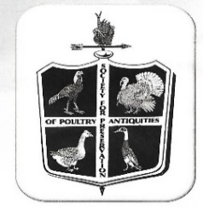
NATIONAL MEETS
SPPA- THE SOCIETY FOR THE PRESERVATION OF POULTRY ANTIQUITIES
EASTERN DIVISION NATIONAL MEET
Awards are open to SPPA members only.
Poultry that qualify for the Meet are listed in the Breeders Directory.
Join now by sending dues to:
Dr. Charles Everett, 1057 Nick Watts Rd., Lugoff, SC 29078
One Year - $15, Two years - $25.00 Three years - $40.00, Life Membership - $200.00
Membership includes quarterly Bulletins and the largest Rare Poultry Breeders Directory printed in the United States and Canada.
The SPPA is the oldest conservation society dedicated solely to poultry in the United States & Canada.
Dr. Charles Everett will be present the morning of the Show, December 9, 2017,
to sign up new members and take renewal dues

DISTRICT MEETS
United orpington club

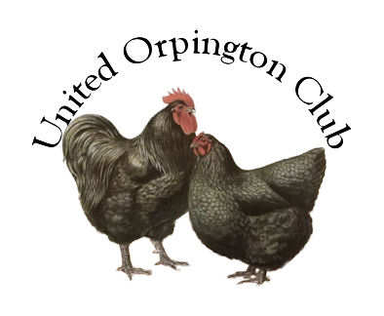
The UOC is dedicated to continued improvement of the Orpington breed, through selective breeding, exhibition, and promotion, in both large fowl and bantam.
Members receive a quarterly newsletter, the All Orp, and an annual breeder’s list/membership list. Send membership application with dues to
UOC, c/o Vern & Sandy Gikzhueter, 316 Grove St. NW, Bemidji, Mn. 56601
Ph. (218)751-2214 Email: pinegrow@yahoo.com – Membership application are available on website
Individual Membership -$10.00 per year or $25.00 for 3 years
Family $15.00 per year or $40.00 for 3 years (Husband & wife and children under 16)
Junior - $5.00 per year (ages 10-17)

STATE MEETS

Rhode Island Red Club of America
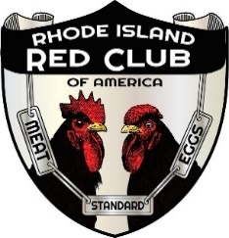
The Rhode Island Red Club of America offers meets in order to boost the breeding, exhibiting and promotion of the most exceptional of all breeds, the Rhode Island Red. Only members in good standing may compete for points for the Red Club Master Exhibitor and Master Breeder Awards
. To join the Rhode Island Red Club of America, send dues of $15.00 for adult
($20 US Funds for Foreign)
or $5 for junior membership to: RIRCA P.O. Box 52, Campbell Hall, NY 10916
(281-770-4750) rircasecretary@gmail.com
All members receive the Chronicle, the club publication.

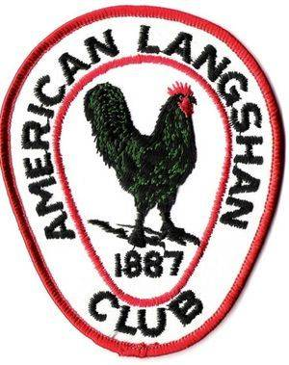
AMERICAN LANGSHAN CLUB
To enjoy the benefits of the American Langshan Club, you must be a current member within the club. The club offers a quarterly newsletter, special awards and recognition for its members.
PLEASE SEND DUES (PAYABLE TO AMERICAN LANGSHAN CLUB) TO
MICHELLE OAKLEY, 15643 ST.RT.720, LAKEVIEW, OHIO 43331 977-539-6588
YOUTH MEMBERSHIP $5.00, ADULT MEMBERSHIP $15.00, LIFETIME MEMBERSHIP $200.00
THE NATIONAL SEBASTOPOL GEESE ASSOCIATION
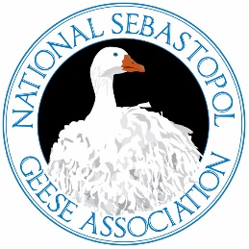
The National Sebastopol Geese Association was founded with the intentions to form a group of Sebastopol Geese enthusiast and breeders that believe in promoting the breed of Sebastopol true to the American Poultry Association Standards.
As a member, your membership will include Quarterly Newsletter, via email, Advertising of sales/farm name in newsletter, Membership Card, Membership Directory, hard copy of newsletter will be available for a cost to cover printing and postage. Junior Members will receive all benefits of an adult member except the rights to vote.
Junior members will also be eligible for club awards.
Memberships: Adults (18+) - $20.00, Family (2+ in same household) - $30.00, Junior (Under 18) - $10.00
4-H/FFA - $5.00 (must show valid proof of membership) & Foreign (US funds) - $25.00
Membership Forms are found at www.nationalsebastopol.com

CLUB MEET

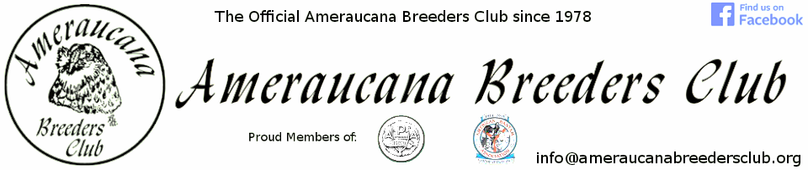
Please visit our website and Forum: Ameraucanabreedersclub.org
In Junior Competition, we offer a rosette for Best of Breed/Champion bantam and large fowl
With 3 or more bantam exhibitors in the Open Show we offer a Best of Breed Ribbon.
With 3 or more large fowl exhibitors in the Open Show we offer a Best of Breed Ribbon
With 5 or more bantam exhibitors in the Open Show we also offer a Reserve of Breed Ribbon
With 5 or more large fowl exhibitors in the Open Show we also offer a Reserve of Breed Ribbon
Members receive quarterly Bulletins & only club members are eligible for awards offered by the club.
New Members also receive an ABC Handbook. Yearly Membership Dues are $10 – Juniors,
$12.00 – Individual and $18.00 -Family. Sign up at ameraucanabreedersclub.org/membership.html

SPECIAL MEETS
MODERN GAME BANTAM CLUB OF AMERICA
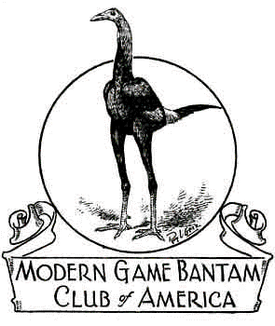
Secretary/Treasurer
Lee A. Traver
4134 NY Highway 43
Wynantskill, NY 12198
traverfarm@wildblue.net

District #2 Director
Robbie Toney
100 Water Filter Plant Rd.
Morganton, NC 28655
jrtsbantams@gmail.com

AWARD REQUIREMENTS-ONLY PAID UP MGBCA MEMBERS, PRIOR TO JUDGING ARE ELIGIBLE FOR CLUB AWARDS, THERE MUST BE A MINIMUN OF 28 MODERNS ENTERED, WITH A MINIMUM OF 3 MEMBERS SHOWING
ANNUAL DUES $20.00- SEND DUES TO THE SECRETARY OR MAY BE PAID TO THE DISTRICT DIRECTOR

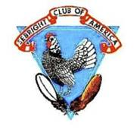
SEBRIGHT CLUB OF AMERICA

President: Jerry Bonds – P O Box 136, Ila. Ga, 30647
Vice President: William Sandoe – 1606 Joe Goldsborough Rd., Smyra, De. 19977
Secretary – Treasurer: H. R. Rogers – 1023 Beam Road, Demer, Pa., 17517
717-314-5323 - hrrogers1@yahoo.com
Craig Fields – District #3 Director – craigandlayla@yahoo.com
ANNUAL DUES: $20.00

OTHER SPECIAL MEETS
Old English Game Bantam Club of America,
Belgian Bearded d’Anver Club of America, Belgian d’Uccle and Booted Bantam Club,
ABA and APA Sanctioned Meet, Plymouth Rock Fanciers Club of America, International Waterfowl Association

PENDING MEETS
Additional Meets may be placed.
If your breed club is not listed, we will be happy to sponsor your meet if you let us know

CAPE FEAR POULTRY ASSOCIATION SHOW EVENTS

“MEET AND GREET”
CAPE FEAR POULTRY ASSOCIATION MEMBERS INVITE OUR EXHIBITORS TO JOIN THEM FOR LIGHT REFRESHMENTS FRIDAY, DECEMBER 8, 2017 FROM 5:30 PM TO 7:00 PM AT THE JOHNSTON COUNTY LIVESTOCK ARENA. THIS WILL BE EVERYONES TIME TO SAY “HELLO” TO OLD FRIENDS AND MEET NEW FRIENDS”! WE WANT TO THANK EACH OF YOU FOR YOUR SUPPORT OF OUR CLUB AND SHOW. COME JOIN US!

ACTIVITY TABLE
THIS IS WHERE THE YOUNG AND OLD CAN TAKE TIME TO PLAY GAMES, COLOR, DO CROSSWOOD PUZZLES, CREATE WITH PLAY DOUGH, and more.
HOPE EVERYONE WILL ENJOY THEIR TIME WHILE AT OUR SHOW!!

CAPE FEAR POULTRY ASSOCIATION YOUTH PHOTO CONTEST
OFFICIAL RULES AND REGULATIONS

- CONTEST IS OPEN TO ALL YOUTH AGES 5 – 18
- ENTRIES WILL BE ENTERED IN ONE OF THREE GROUPS
AGES 5 – 8, AGES 9 – 13, AND AGES 14 – 18
- LIMIT OF ONE PHOTO PER ENTRY. PLEASE PUT YOUR NAME AND AGE ON THE BACK OF YOUR PHOTO
- YOUTH MUST TAKE THEIR OWN PHOTO OF THEIR CHICKEN, DUCK, GEESE, TURKEY, OR GUINEA (PICTURE MUST BE OF BIRD ONLY)
- PHOTO MUST BE A 5 X 7 COLOR PHOTO
- YOU DO NOT HAVE TO BE A YOUTH EXHIBITOR TO ENTER CONTEST
- NO CHARGE TO ENTER
- PHOTOS MAY BE MAILED TO CAPE FEAR POULTRY ASSOCIATION
118 KINCALF LANE, MACCLESFIELD, N. C. 27852
- PHOTOS MAY BE EMAILED AS AN ATTACHMENT TO: kincalf@aol.com
- PHOTOS MUST BE SUBMITTED BY 9:00 AM ON DECEMBER 9, 2017
- PARTICIPATION RIBBONS WILL BE GIVEN
- FIRST PLACE AND SECOND PLACE AWARDS WILL BE GIVEN IN EACH AGE GROUP (AWARDS TO BE ANNOUNCED AT SHOW)
- VOTES FOR BEST PHOTOS ARE DONE BY DONATING TO YOUR FAVORITE PHOTO. THESE DONATIONS WILL BE GIVEN ON A 50/50 BASIS
- FIRST & SECOND WINNERS WILL BE THE PHOTOS IN EACH GROUP THAT RECEIVES THE MOST VOTES
- THE CAPE FEAR POULTRY ASSOCIATION RESERVES THE RIGHT TO ADD, DELETE OR REVISE THESE OFFICIAL RULES AS NECESSARY WITHOUT NOTICE
CAPE FEAR POULTRY ASSOCIATION

CAROLYN LYNN, PRESIDENT WILBUR HANLEY, VICE PRESIDENT
910-897-8001 919-796-2936
DONNA WORTHINGTON, SECRETARY LARRY JINNETTE, TREASURER
252-827-2491 919-738-7001

DRIVING DIRECTIONS
JOHNSTON COUNTY LIVESTOCK ARENA
520 COUNTY HOME ROAD
SMITHFIELD, NC 27577 - PHONE # 919-934-9569

COMING FROM I-95 NORTH OR SOUTH TAKE EXIT 95 WEST (SMITHFIELD) ON TO
HWY 210/70 (MARKET STREET) GOING WEST 2.7 MILES THEN VERR OFF TO THE LEFT ONTO
HWY 210. CONTINUE ON HWY 210 ABOUT 6.6 MILES TURN RIGHT ON TO COUNTY HOME ROAD, GO ABOUT 1/4 MILE AND WE ARE ON THE RIGHT.

COMING FROM I-40 NORTH OR SOUTH TAKE EXIT 319 EAST (TOWARD COATS CROSSROADS) ON TO HWY 210 EAST, CONTINUE ON HWY 210 ABOUT 7.9 MILES UNTIL YOU SEE COUNTY HOME ROAD ON THE LEFT, TURN ON TO COUNTY HOME ROAD, GO DOWN ABOUT 1/4 MILE WE ARE ON THE RIGHT.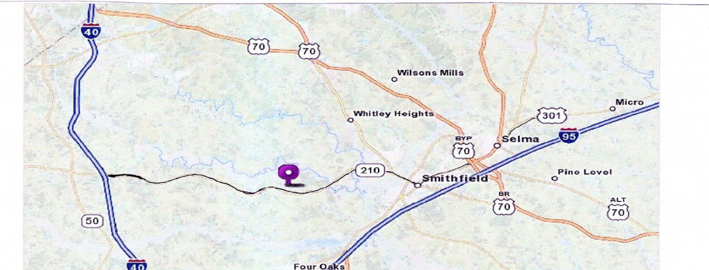

LODGING

COMFORT INN BECKY’S LOG CABIN
126 CLEVELAND CROSSING DRIVE 2491 US HWY 70 BUSINESS EAST
GARNER, NC 27577 SMITHFIELD, NC 27577
PHONE # 919-773-1110 PHONE # 919-934-1534
½ MILE OFF I-95 AT EXIT 95
LODGING, RESTAURANT AND LOUNGE

HOST HOTEL

SUPER 8 MOTEL
735 INDUSTRIAL PARK DR
SMITHFIELD, NC 27577
PHONE: 919-989-8988

LET THEM KNOW YOU ARE WITH THE CAPE FEAR POULTRY SHOW

Exhibitor #_________ Received ___________ Amount Paid_________ check no._________ received by __________
CAPE FEAR POULTRY ASSOCIATION SHOW ENTRY FORM
DATE OF SHOW: DECEMBER 9, 2017 ENTRY DEADLINE: DECEMBER 4, 2017
OPEN _____ JUNIOR SHOW _____ JUNIOR AGE __________ JUNIOR SHOWMANSHIP YES ___ NO____
I, ________________________________________, make the following entry subject to the rules and regulations in the show catalog.
By making this entry I give Cape Fear Poultry Association permission to use my contact information (address, phone#, email) for the Exhibitors List, club members, etc. and I agree and accept the NO EARLY COOPING OUT rule. I acknowledge and accept the
North Carolina State Health Requirements for exhibiting poultry in North Carolina.
STREET ADDRESS____________________________________ PHONE: (________) ________ ______________
CITY____________________________________________________STATE_____________ZIP__________
EMAIL ADDRESS _______________________________________________________________________
PLEASE USE YOUR SAME NAME AND ADDRESS AS RECOGNIZED BY THE APA/ABA & BREED CLUBS
FOR YOU TO RECEIVE YOUR POINTS.
UNDER TYPE USE “L” LARGE FOWL, “B” BANTAM, “T” TURKEY, “Ga” GUINEA, “D” ALL DUCKS “G” ALL GEESE
UNDER VARIETY use Bearded or Non-Bearded, SC (single comb) or RC (rose comb) only if it applies with that color or breed
FORMS MAY BE COPIED FOR MORE SPACE, MORE THAN ONE ENTRY OR JUNIOR ENTRY
BREED | VARIETY | TYPE | COCK | HEN | COCKEREL | PULLET | TOTAL  BIRDS
EXAMPLE: PLYMOUTH ROCK  EXAMPLE: SILKIE  EXAMPLE: RHODE ISLAND RED | WHITE  NON-BEARDED BLACK  ROSE COMB OR SINGLE COMB | L  B  L | 1 DC  2  3 DC | 2  3  2 | 3 DC  4  4 DC | 2  5  3 | 8  14  12
Total number of birds entered_______ X $3.00 per bird Entry Fee ________________
Number of double coops ______ X $3.00 (Please specify bird for Double Coop DC Fee _________________
Clean Up Fee $1.00 per Exhibitor Clean Up ____1.00_________
TOTAL AMOUNT DUE $______________
Send completed form with check or money order payable to Cape Fear Poultry Association
C/O Donna Worthington, 118 Kincalf Lane, Macclesfield, NC 27852
Phone: 252-827-2491 Email: kincalf@aol.com
CONTINUED SHOW ENTRY FORM

UNDER TYPE USE “L” large fowl, “B” bantam, “T” turkey, “Ga” guinea, “D” all ducks, “G” all Geese
Under VARIETY use Bearded or Non-Bearded, SC (singe comb) or RC (rose comb) only if it applies with that color or breed
FORMS MAY BE COPIED FOR MORE SPACE, MORE THAN ONE ENTRY OR JUNIOR ENTRY

ENTER THE NUMBER OF BIRDS IN EACH SEX
BREED | VARIETY | TYPE | COCK | HEN | COCKEREL | PULLET | TOTAL  BIRDS
(Example)PLYMOUTH ROCK  (Example) Silkie | WHITE  Non-Bearded Black | L  B | 1 DC  2 | 2  3 | 1 DC  4 | 3  1 | 7  10

