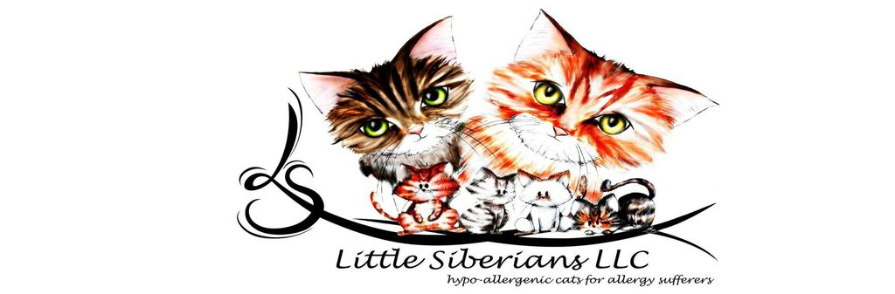
Sales Agreement for 100% pure bred Siberian Cats/Kittens
This agreement is made effective as of ________________, by and between ___________________________, at ____________________________________________________________ and _Little Siberians LLC, of 252 Stoney Creek Way, Chapel Hill, NC 27527.
In this agreement, the party who is contracting to receive the kitten shall be referred to as “owner”, and the party who will provide the kitten shall be referred to as “breeder”
Owner desires to purchase a kitten provided by breeder.
Therefore, the parties agree as follows:
- DESCRIPTION OF TRANSACTION. The breeder has agreed to sell a purebred Siberian kitten to the owner as a pet. The owner can pick up the kitten at an agreed upon time and location after 8 weeks from date of birth.
- PAYMENT. The owner will pay $300 deposit to hold the kitten. This deposit secures your pick of kitten based on the waiting list priority. If the first person on the waiting list chooses to pass their pick due to color or gender preference, then we move to the next person on the waiting list. The owner will pay the remaining balance before picking up the kitten. The owner will pay all costs plus $50 surcharge for any return checks.
- DISCOUNTS. The breeder may opt to give a discount for owners who purchase additional kittens, this discount is 100% at the discretion of the breeder and not guaranteed.
- PAPERS. The breeder will provide the kitten’s pedigree papers only after the owner has provided proof the kitten has been spade or neutered.
- SHIPPING AND HANDLING. The owner will pay all fees and costs when it is necessary to ship the kitten plus a $75 handling fee.
- VACCINATIONS: The breeder will supply the kitten’s first round of vaccinations including: deworming, Panleukopenia, Feline Viral Rhinotracheitis and provide a health certificate signed by a licensed Florida Veterinarian. The owner is required to have a vet administer the next two sets of vaccines. Rabies vaccines and Neutering/Spaying should be done between 4-6 months of age.
- WARRENTEE. The breeder warrantees all kittens against death due to birth defects or disease within 356 days of birth. If the kitten should die or be defective the owner will provide proof of said issue from a licensed veterinarian of the cause of death. The solution in such case will be the first pick of the next litter or return of the original purchase price, not including any additional fees or costs. The breeder does not warrantee any other items including but not limited to color, energy levels, demeanor, behavior, etc…
- RETURN POLICY. In the event the kitten needs to be returned due to allergic reactions, the owner will do so within 7 days of receiving the kitten and the owner will be responsible for all associated costs to including but not limited to travel.
- TERMINATION. If the owner or breeder decides the purchase of the kitten is not in the best interest of the kitten before the owner takes possession of the kitten then all deposits will be returned within 30 days and the kitten will be sold to another interested party at the breeder’s discretion.

- NON-COMPETE. Owner agrees not to compete with breeder for ten (10) years after receiving the kitten. The geographical area shall include: Florida, Georgia, Virginia, Maryland, Washington D.C., West Virginia, New Jersey, New York, North and South Carolina and Pennsylvania. This non-compete agreement shall include immediate family as well.
Owner (PRINT)________________________________
(SIGN)___________________________________(DATE)_______________
Breeder (PRINT) By Catherine Littleton __
(SIGN)_BY _________________________________(DATE)_______________

