FINANCIAL POLICIES
- Cash Session Fee: Session fees are on a sliding scale per 50-minute session. Please determine your family's combined income. This number should be approximately the same as the Gross Income amount from your most recent 1040 Form. This amount includes wages, tips, alimony, child support, and other income. Please provide Katt with previous year's tax return upon request.
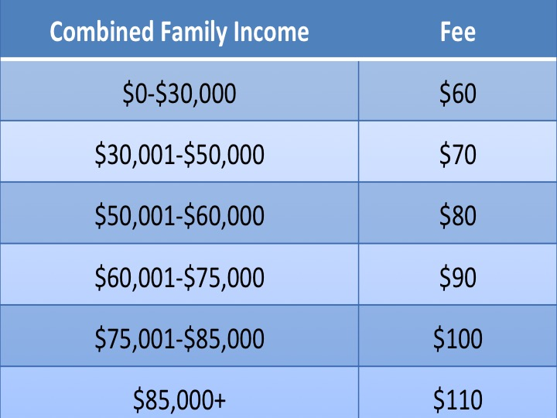
- Payment Methods: Cash, checks, debit cards, and credit cards are the preferred methods of payment. Checks are to be made payable to Theresa Hubbard. All debit and credit card information is kept securely on file. (Note: A $25 fee will be added to your account for each returned check).
- Debit/Credit Card: I require a debit or credit care to be kept on file. Regular session fees will not be charged to this card unless I am instructed to do so below.
- Late Cancellations and Missed Appointments: The first time you miss or cancel a session with less than 24 hours' notice, your on-file debit or credit card will be charged $25. The second time, your debit or credit card will be charged $50. On the first and any future late cancellations or missed appointments, your debit or credit card will be changed $75 for each occurrence. (Note: You will not be notified before your card is used to pay these fees).
- Phone Calls and Emails: Appointment times are typically set at the end of the current appointment of over the phone. Phone calls and emails to or from you, or on your behalf that are over 10 minutes long may be charged to you at a prorated portion of your session fee (i.e. 15 minutes = 1/4 charge of your regular session fee). These particular fees are not able to be filed with your insurance and will be charged directly to your on-file debit or credit card.
- Reports and Court: If you request a report, there will be a charge for its preparation based on the time required to prepare it. There is a separate fee for testifying in court or for depositions. These particular fees are not able to be filed with your insurance.
Debit/Credit Card Information
Name on Card Card #

Expiration Date Security Code Billing Zip Code

□Yes, I would like to pay my regular session fees with the above debit/credit card.
□No, I have another debit/credit card I would like to use to pay my regular session fees. (Please provide)
□No, I would not like to pay my regular session fees with my debit/credit card.

Signature of Client/Parent/Legal Guardian Printed Name Date

