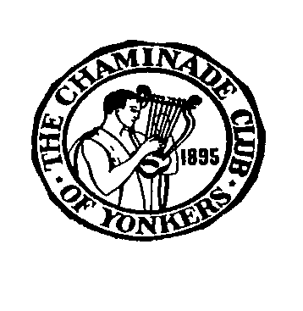

CHAMINADE SCHOLARSHIP REQUIREMENTS 2025

1. SPECIFIC QUALIFICATIONS

A high school junior or senior who is a resident of Westchester County **OR is** sponsored by a member of the Chaminade Club.

1. AMOUNT OF AWARDS

Donated by Clarinetist Michael Webster (former Chaminade Scholarship winner)

$1,500 First prize

$ 500 Second prize

If there is a tie for first and second place each winner will receive $1,000

3. BASIS OF AWARD

An audition is required, in which the applicants will be expected to present a program (length: up to 15 minutes) of **three compositions** of their choice from memory. **Singers must perform two (2) classical compositions from an opera/operetta or an art song and a third composition of their own choice.** The audition will be performed before a panel of judges who are professional musicians. All performers except pianists must have their own accompaniment. (see application for details).

1. SPONSOR

Chaminade Music Club of Yonkers

1. APPLICATION PROCEDURES
2. Complete the application form (copy enclosed)
3. Enclose one letter of recommendation from the applicant’s guidance counselor, teacher or private music teacher (if available).

Please mail the above to: Chaminade Club

c/o Marcia Klein

15 Round A Bend Road

Tarrytown NY 10691

APPLICATION DEADLINE: April 9, 2025

AUDITION DATE: April 29, 2025

AUDITION LOCATION: Grinton I Will Library, Auditorium.

1500 Central Park Avenue (near Tuckahoe Road)

Yonkers, NY 10710

For more information contact Joyce Henery at [joycehenery@aol.com](mailto:joycehenery@aol.com)

or Marcia Klein at chaminade9@optonline.net

Applicants will be contacted with specific time between 2 pm and 5 pm to audition