
OCEAN CITY CHAPTER 1917
Presents

CHARLESTON, SC & SAVANNAH, GA
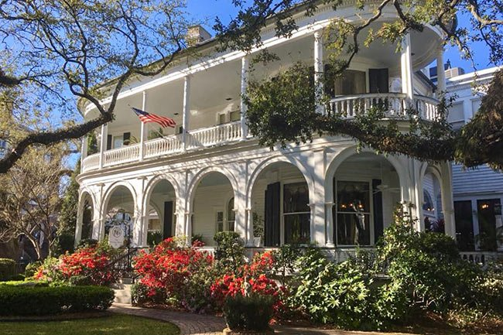

MAY 17-23, 2021
7 DAYS/6 NIGHTS

$950/PERSON (DBL); $1300 (SNGL)

PACKAGE INCLUDES: *Round Trip Motorcoach Transportation with Jor-Lin Transit,
6 nights Deluxe Accommodations including 2 nights in Charleston, SC, 2 nights in Savannah GA and 2 nights stop-over accommodations in Fayetteville, NC.
6 Breakfasts, 5 Dinners, All Taxes and Gratuities.

SAMPLE ITINERARY (Subject to Change):
Day #1 – Depart Ocean City for Fayetteville, NC - Travel to your en-route hotel (Hampton Inn Patriot’s Point), freshen up and then enjoy a relaxing included dinner at Cracker Barrel. (Departure Location to be determined)

Day #2 – Depart Fayetteville for Charleston, SC. – Following breakfast, depart for beautiful Charleston, SC. In the afternoon, we’ll arrive at the Magnolia Plantation -- the oldest public garden in the country. You will enjoy a train ride around the plantation and a wonderful house tour. Following the tour, you will check into your Charleston Host hotel (Country Inn & Suites) and freshen up before dinner. Dinner tonight will be at Sticky Fingers Ribhouse, known for their Memphis style smokehouse ribs, wings and barbecue pork & chicken.

Day #3 – Charleston, SC. – Following breakfast, we’ll depart for the amazing Charleston Tea Plantation. Learn first-hand how tea is made and enjoy an informative tour of the factory. We’ll then take a Trolley Tour through the tea fields and enjoy all the tea you can drink! This afternoon, you’ll enjoy a Guided Tour of Ft. Sumter, including a Sightseeing Narrated Boat Cruise. Tonight you’re in for a treat. Dinner is served at the famed Charleston Crab House. Enjoy!

Day #4 – Charleston & Savannah – Following breakfast, we’ll meet our guide and depart for a Guided Tour of Charleston, SC where you’ll learn all about this amazing city.
This afternoon, we’ll depart for the beautiful city of Savannah, GA. After settling in at our Host Hotel in Savannah (Country Inn & Suites), we’ll depart for a sumptuous dinner at Corleone’s Trattoria.
Day #5 – Savannah, GA. Rise and shine! A fine breakfast awaits you at your host hotel. After meeting our guide, we’ll depart for an informative Tour of Savannah. We’ll see all the spots that have made this city one of the most visited cities in the world. Enjoy time for lunch on your own and enjoy free time to explore the city’s most famous River Street.

This afternoon we’ll enjoy a Guided Tour of Boon Hall Plantation – one of the country’s oldest working plantations, having grown crops for almost 380 years. Tonight we’re off to the famed Lady & Sons Restaurant where we’ll sample some of Paula Deen’s homemade dishes.

Day #6 – Depart for Fayetteville, NC. – Following breakfast, we’ll depart for our stop-over destination in Fayetteville, NC. Upon arrival, we’ll visit the US Army & Special Ops Museum, including a special Simulator Experience. We’ll then check in to our en-route hotel. Dinner is on your own.

Day #7 – Depart for Ocean City, MD. – Following breakfast, we’ll begin our journey home.

FOR INFORMATION AND RESERVATIONS,
CONTACT SANDY KVECH AT 443-664-2003
$250.00 DEPOSIT DUE BY FEB 12th
BALANCE IS DUE NO LATER THAN APRIL 9th

*TRIP ASSURANCE PROTECTION IS AVAILABLE FOR MEDICAL REASONS ONLY - $59.00/PERSON

--------- Registration Form – CHARLESTON & SAVANNAH - Cut Here -----------

NAME(S): ______________________________ ________________________________

STREET ADDRESS: ______________________________________________________________

CITY: _________________________ STATE:__________________ ZIP:________________
PHONE: __________________ CELL: __________________ E-mail ______________________
EMERGENCY CONTACT - NAME & NUMBER: _________________________________________

NAME OF ROOMMATE, IF REGISTERING SEPARATELY: _________________________________

[ ] CASH: _______________ [ ] CHECK AMT $:_______________ CHECK#:____________

I/WE ACKNOWLEDGE THAT I HAVE BEEN OFFERED TRIP INSURANCE: [ ] DECLINED [ ] ACCEPT
I/WE ACKNOWLEDGE THAT I HAVE READ THE TRAVEL-TRIP RULES AND AGREE TO ACCEPT [ ]
SIGNATURE: _______________________________________________ Date_____________
MAKE CHECKS FOR TRIP PAYABLE TO: AARP 1917, Travel, PO Box 4193, Ocean City, MD 21843
DISCLAIMER: These trips are a project of and are offered to the Ocean City, MD Chapter 1917 of AARP. The chapter and any agent it may use in arranging these or any other trips are not responsible in whole or in part to the traveling member for any loss, damage, or injury, whether financial or otherwise, to persons or property, however caused during or in connection with these or any other trips. These trips are activities conducted by Ocean City, MD AARP Chapter 1917 and are in no way offered, sponsored, or conducted by AARP, which has no responsibility in connection with such trips.

