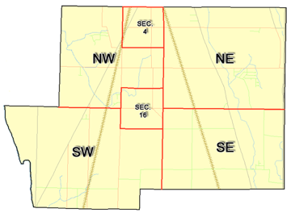 | Pleasant Township  Zoning Commission Minutes  1035 Owens Rd W.  Marion, Ohio 43302
Meeting called by: | Scheduled | Type of meeting: | Regular Monthly
Chairperson: | Mr. Holler | Secretary: | Tim Michael
Timekeeper: |  | Date: Feb.13, 2020 | Time 7:00 pm
Call to Order by: | Mr. Holler Moment of silence followed by the pledge to the flag.
Roll Call: | Scott Ballenger, Jack Dean, Harry Holler, Tom Leib, Dwight Williams  Tim Michael Secretary / Alternate
Minutes: | Read and approve minutes from previous meeting. (May pass out earlier)  Motion to approve minutes by: Mr. Williams Seconded by: Mr. Ballenger Roll call: All approved
Attendees Address Board: Have sign in sheet on desk by door.
Type in attendees and addresses:
.
----- Agenda Topics -----
Business
Zoning Reports: | Zoning Inspector goes over reports and provides copy to board.
Unfinished:
New:
Announcements: | Next meeting will be: February 20, 2020
Adjournment: | Motion to adjourn by: Mr. Williams Seconded by: Mr. Leib all in favor: all approved
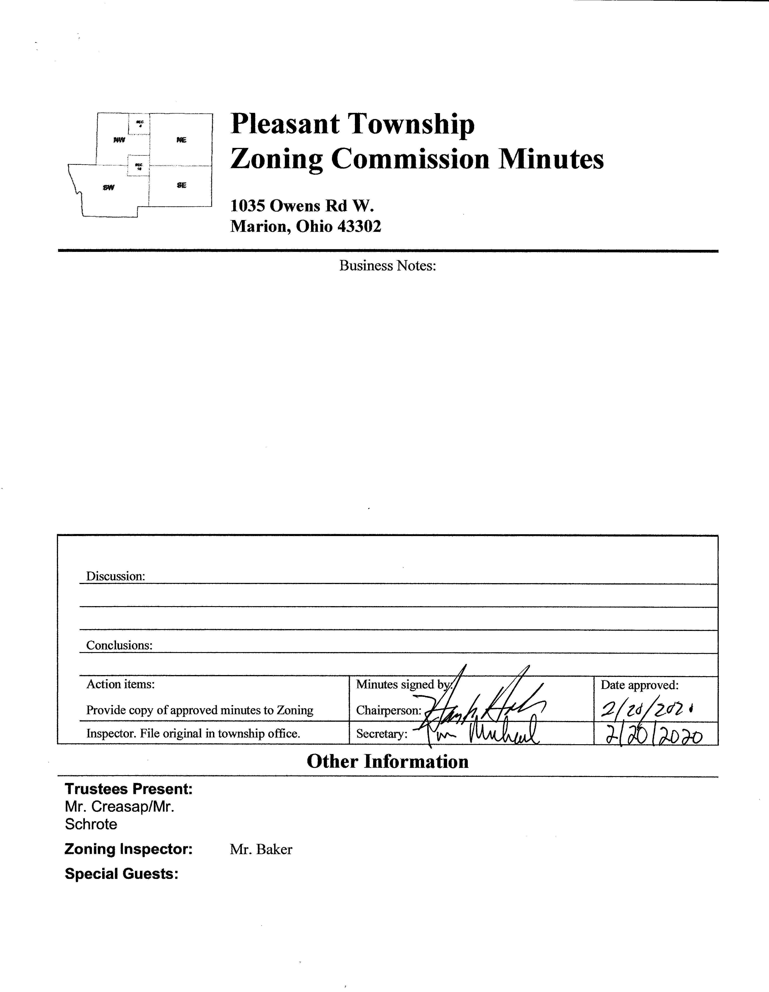

Minutes
- The Pleasant Township Zoning Commission met for a Special Meeting on February 13th, 2020 at the Pleasant Township Trustee Office. Zoning Commission Board members present were: Mr. Ballenger, Mr. Dean, Mr. Leib, Mr. Williams Chairperson Mr. Holler, and Secretary Mr. Michael. Township Trustees Mr. Creasap and Mr. Schrote and Township Zoning Inspector Mr. Baker. Mr. Robert Morris of the Marion County Regional Planning Commission was also in attendance.
- This meeting concerned additions suggested by the Marion County Regional Planning Commission to be incorporated into the Pleasant Township Zoning Resolution which when and if adopted would allow for the use of Solar Energy Production Facilities on a conditional basis in the A-1 and R-1 Districts of Pleasant Township
- After lengthy discussion the Pleasant Township Zoning Commission made numerous additions and suggested clarifications to the document provided by Mr. Morris, not the least of these was Pleasant Township Zoning Commission’s desire to not only address Solar Energy Equipment and Solar Energy Production Facilities but also Accessory Solar Energy Systems in the update to the Zoning Resolution. On the afternoon of 2/20/2020 the Zoning Commission Secretary made effort to obtain these additions and suggested clarifications which when obtained will be included in the meeting documents.
- As a result of these discussions Mr. Morris has provided a revised document which was distributed to the board members via email on February 18th, 2020. This document will be reviewed and updated at the Zoning Commission meeting on February 20, 2020. In addition, Mr. Morris advised that he did hear back from the County Prosecutor office and their legal opinion is that the liability of any equipment left on the property of a Solar Energy Production Facility would be the property owner’s responsibility, similar to how they handle solid waste infractions.

- It is believed that the goal of the Zoning Commission is to have the proposed documents finalized and ready for public presentation and discussion at the next regularly scheduled Zoning Commission meeting to be held on March 19th 2020.
- There being no additional business for discussion Mr. Williams made motion to adjourn, seconded by Mr. Leib all Zoning Board Members in attendance agreed and the meeting was adjourned. The next scheduled Zoning Board Meeting will be held on February 20th 2020 at 7:30 PM.

