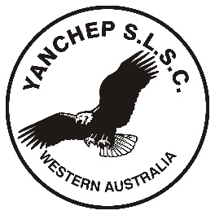

Yanchep Surf Lifesaving Club
Nomination Form 2018-2019
Each field must be completed for full nomination to be accepted.

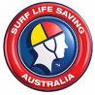

Child 1:-
First Name: -___________________ Surname:- __________________________________ DOB:__________________________ Age at 30/9/18:-______________________________
Medical Conditions or Allergies __________________________________________________

Child 2:-
First Name: -____________________ Surname:- __________________________________
DOB:__________________________ Age at 30/9/18:-_____________________________
Medical Conditions or Allergies __________________________________________________

Child 3:-
First Name:-_____________________ Surname:- _________________________________ DOB:___________________________ Age at 30/9/18:-___________________________
Medical Conditions or Allergies _________________________________________________

Child 4:-
First Name:-_____________________ Surname:- _________________________________
DOB:___________________________ Age at 30/9/18:-_____________________________
Medical Conditions or Allergies ___________________________________________________________

CHILD DETAILS

-

Parent 1:-
First Name:- ________________________ Surname:- _____________________________________
DOB:-____________________________ WWC/Police Check:-_____________________________
WWC No:_____________________________ WWC Expiry Date: __________________________
SLS Awards:-_______________________________________________________________________
Address:____________________________________________________________Postcode:______
Phone (H)__________________(M)____________________Email:___________________________
Previous member of Yanchep SLSC Yes/No

Parent 2:-
First Name:- ________________________ Surname:- _____________________________________
DOB:-____________________________ WWC/Police Check:-_____________________________
WWC No:_____________________________ WWC Expiry Date: __________________________
SLS Awards:-_______________________________________________________________________
Address:____________________________________________________________Postcode:______
Phone (H)__________________(M)____________________Email:___________________________
Previous member of Yanchep SLSC Yes/No

PARENT DETAILS

Please turn over – Declarations and signature required.

I__________________________________________________________ understand that:

- one listed parent MUST be in attendance EACH week;

- Nippers at Yanchep Surf Lifesaving Club will be involved in activities where they may be photographed. Photographs of Nippers may be used in a variety of media to promote activities at the YSLSC. I do give / do not give permission for my child/ren photograph to be used;

- All prospective members will be required to assist the club in the operation procedures each Sunday during the Nippers Season.

I am willing to:-
Be an Age Manager (no water quals required) BBQ
Age Manager Assistant Patrol (SRC or Bronze Medallion required)

Complete an SRC (Water Safety) Nippers Set up / Clean Up

Uniforms

Parent signature ________________________________ Date___________________

Please return form to: Yanchep SLSC Box 121 Two Rocks WA 6037 prior to Saturday 13th October 2018.

