
To the Parents/Guardians and Students of the 2017 Kids SmART Summer Program:

We are so excited that you have chosen Kids SmART as your summer camp! In order to ensure that the summer is exciting and fun-filled while also being safe, we have listed a few reminders for the parents below. PLEASE be sure to read this in it’s entirety as it is very important in helping assure the quality and safety of the program.

HOURS OF OPERATION: Mon-Fri 6:30am-6:00pm May 30- August 16. We will be closed July ¾.
Parents must physically come in and sign their children in/out each day not only for safety reasons, but also to allow for effective communication between the families and camp staff.
We cannot accept children prior to 6:30am. Children picked up after 6:00pm will be charged $1/minute that they are late.
CAMP LOCATIONS: Please note that whichever camp you register for is the one you are required to drop off and pick your child up at. Although the general structure of the camps are the same, they do not combine nor go on all the same trips. See the camps monthly activity calendars for specific theme/FT/Outreach information.
Glennon Heights Elementary- 11025 W Glennon Dr Lakewood. In the cafeteria.
Emory Elementary-1275 S Teller St Lakewood. In the cafeteria.
Edgewater Elementary- 5570 W 24th Ave Edgewater. In temp 7, just south of the school.
Mtn. Phoenix – 4725 Miller St Wheat Ridge, In building D, room 13D.
TUITION: EVERY PARENT is expected to fill out a tuition calendar stating the dates their children will be attending, and pay in advance. For those families on CCAP, you will still be expected to fill out a calendar and your monthly parent fee will be due by the 1st of every month. Remaining families are required to turn in payment with your tuition calendar every Wednesday for the upcoming Monday thru Friday. You may also pay by the 25th for the entire upcoming month’s planned attendance for a 10% discount. With our procare accounting system, accounts will be automatically suspended if balance is over $100. Balances are updated every Friday PM. If you have signed up your children and they will not be at camp, please call/text the camp phone to let us know not to expect them.
EMORY: TBD; GLENNON: TBD; EDGEWATER: TBD; MTN PHNX: TBD.
There will not be credits or refunds for unattended days, although you do not have to pay for any days that you do not plan on sending your child(ren).
CCAP SWIPING: If you are on CCAP, you should have a card to swipe your children in and out each day. This is IMPERATIVE for Kids SmART to be reimbursed for your child’s care. If you do not swipe correctly, and with accurate times YOU will be responsible to pay for care out of pocket. CCAP will not pay for care if your child is not swiped correctly.
PARENT TABLE: Parents MUST check their children in and out every day on the tablets. Existing parents/guardians can continue to use their individual established PIN # to check in/out. New authorized pick-ups will need to establish new PIN #s. The children cannot sign themselves in or out. Parents are expected to read the information on the parent table every day as well. This is how we will communicate important camp information to all of the parents about field trips, etc.
You may also “Like” us on Facebook to get daily/weekly information- we are listed under kidsSmartInc.
THINGS TO BRING EVERY DAY: *Breakfast *AM Snack *Water Bottle
*Sunscreen (Banana Boat SPF 30/45)- Please purchase bottles that you can leave at camp for your child. Please also put a coat of sunscreen on your children prior to their arrival to camp.
LUNCH: We are extremely fortunate to be able to offer free lunch (and breakfast) for the campers for the majority of the summer. Your child is still welcome to bring their own lunch if they so desire. FAMILIES are asked to bring sack lunches from 5/29-6/2 as we cannot provide lunches prior to 6/5.
SWIMMING: Every Monday we will be going to various swimming pools to swim. Children are expected to wear their swimsuit under their clothes, and bring a change of clothes with them to change into after swimming. They are also expected to bring a towel. The pools we will be going to accommodate all swimming levels, so no need to worry about your child’s swimming ability. If the pool is an outdoor pool, it is extremely important that you sunscreen them prior to coming to camp AND make sure they have sunscreen at camp to re-apply. Unless otherwise noted, the pools do not allow water toys so please leave those at home.
WHEELS DAY: Every Tuesday children are encouraged to bring their “wheels” with them to ride. They are required to bring the following pads with them as well: Bicycle or Scooter- Helmet; Rollerblades or skateboard- Helmet, elbow and knee pads. If they do not have all of the appropriate gear, they will NOT be allowed to ride. NO EXCEPTIONS. There will be no sharing of the wheels or protective gear allowed. Depending on the camp, we may have access to the bike rack, but each child will be responsible for bringing their own bike lock. No motorized wheels will be allowed.
FIELD TRIPS: Most Wednesdays we will be going on a field trip. The majority of the field trips planned are during the afternoon, but please be sure and check the parent table so you get your child to camp before we leave. We will walk to a few of the field trips, but for the most part we will transport in a Jefferson County School Bus. The cost of the field trip is included in your daily fee. Be sure and check the parent table for specifics on the field trip and what you may need to send with your child.
PERSONAL BELONGINGS: Children are allowed to bring personal belongings with them, provided that they have them properly labeled with their name and it is appropriate for camp. If the belonging causes any issues, it will be taken away and given to the parents at the time of pick-up. This policy includes cell phones- we understand the desire for you to stay in touch with your child throughout the day, but in the interest of all of their safety we reserve the right to confiscate their phones and return it upon their leaving camp. Kids SmART is not liable for lost/damaged items.

If you would like specifics on any additional policies or procedures of Kids SmART, Inc. you may request a copy of the parent handbook. If you have any questions or concerns now, or throughout the summer, please do not hesitate to ask. We may be reached via camp cell phone (listed on previous page), at our main office: 720-550-6728 or via email- lclark@kids-smart.com. The on-site staff are also available to answer your questions.
We will do everything we can to ensure this is the best summer your child has had! Please help us make that possible by following the above guidelines.

Thanks so much for sharing your children with us!

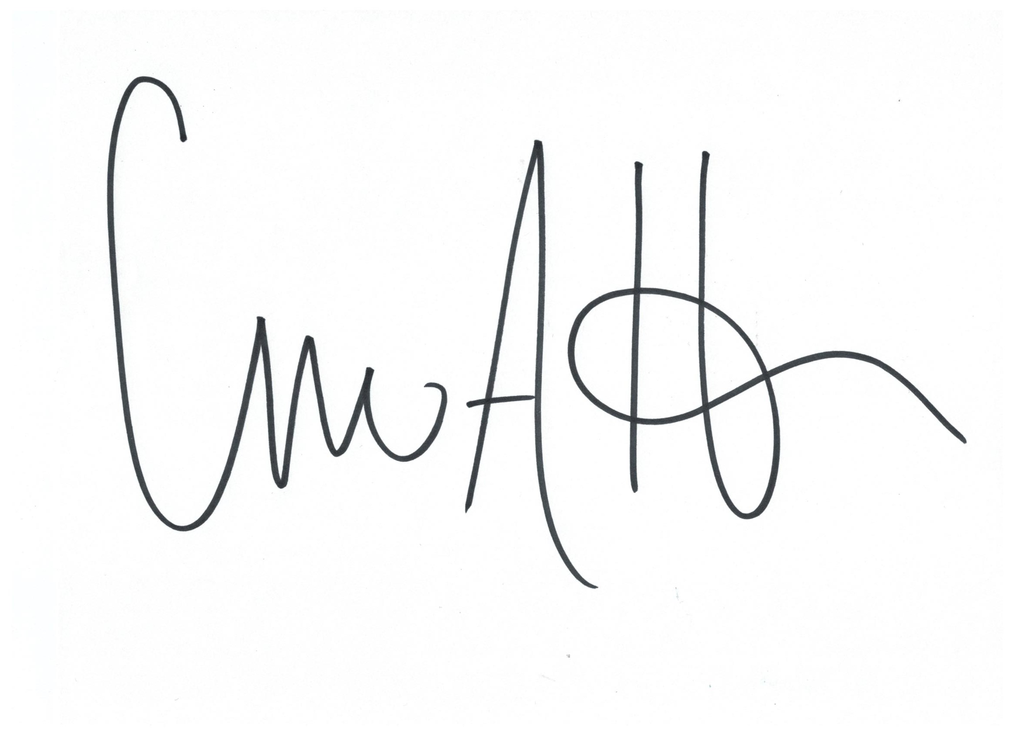
-Kids SmART, Inc. Staff

