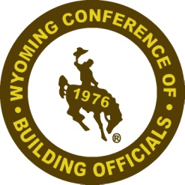
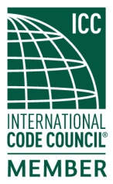
Wyoming Conference of Building Officials

Annual Conference Business Meeting Agenda
November 4, 2020
Teleconference Meeting, 2:00 p.m.

President: Ken Rogers
City of Gillette (307) 686-5260
ken@gillettewy.gov

Vice President: Jason Gutierrez, PE
Natrona County (307) 235-9435
Jgutierrez@natronacounty-wy.gov

Secretary: Tom Scranton
Wilson & Associates, LLC (307) 632-1776
tom@wilsonandassociateswy.com

Treasurer: Billy Nunn
Teton County (307) 733-3959 x8415
bnunn@tetonwyo.org

Director: Matt Allred
Town of Guernsey (307) 836-2335
matt@togwy.us

Director: Kevin Bare
City of Sheridan (307) 674-5941
kbare@sheridanwy.net

Director: Byron Mathews
City of Cheyenne (307) 637-6311
bmathews@cheyennecity.org

Past President: Keith Bowar
Retired
wyobigk@gmail.com

Call Meeting to Order..………………………………...President Rogers

Roll Call of Officers/Directors………………………... Secretary Scranton

Approval of Minutes of Previous Meeting…..…….…...President Rogers

Treasurer’s Report...…………………………………... Treasurer Nunn

Reports of Officers and Committees………………….. President Rogers
- Scholarship Committee………………….……Treasurer Nunn, Chairman

Old Business……………………………………………President Rogers
- ?

New Business………………………………………….. President Rogers
- Election of Officers (2) / Director (1)
(Report of Nominating Committee)
- WAM Support for $1,000.00 (yes or no)
- Spring Meeting scheduled for April x-x, 2021
- Update from Jim Brown, ICC Director

Other Business…………………………………………..President Rogers

Adjournment………………………………………….....President Rogers

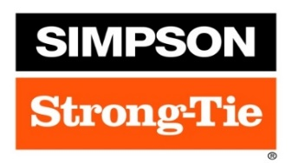
Partners & Sponsors

