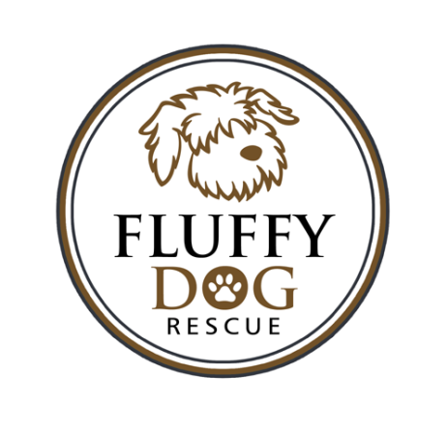
Thank you for your interest in a Fluffy Dog.
Every dog has had the following vetting:
- Some form of parvo/distemper combo vaccine.
- Rabies vaccine.
- Spay or neuter
- Heartworm test (over 1 year of age)
Please read the information on heartworm disease on our Resources page. Heartworms take six months to develop from microfilaria (babies transferred from a mosquito) to a worm living in the heart. It is possible six months from the negative heartworm test that your dog might come up with a positive heartworm test. If this happens please contact us.
- Microchip
This is a small chip placed under your dog’s skin that will identify you as the owner if your dog is lost. This only works if the chip is registered. You must register the chip. The information on the company that the chip was purchased from will be in your vet records. Most of these companies do have an annual fee for the services they provide.
- Worming
Almost all of our dogs come to us with whipworms, hookworms, roundworms or tapeworms. We do worm them at least one time for these worms. Because worms lay eggs, it is possible that worms may be present. This is the reason that we require a fecal sample be taken to your vet at the vet visit.
- Heartworm preventative (April-October)
- Flea protection (April-October)
Almost all of our dogs come to us with fleas anytime of the year because they are coming from the south. We put one dose of flea protection on them and continue monthly if fleas are detected. Fleas have a three month life cycle. If your dog has arrived here within the past three months, you will want to discuss flea protection with your vet at the vet visit.

You should have paperwork confirming the distemper, rabies, heartworm test and microchip. If not, please let me know immediately. We make every attempt to adopt out healthy dogs with good temperaments. Our dogs have all been seen by a veterinarian, but it is possible that some things have not been detected, as we do not do bloodwork and x-rays. Parasites and ear infections are the most common issue that we see. We do dentals on some dogs, but it is possible that your dog may need a dental which could require extractions.

We thank you for working with us and rescuing a Fluffy Dog.
The Fluffy Dog Team

