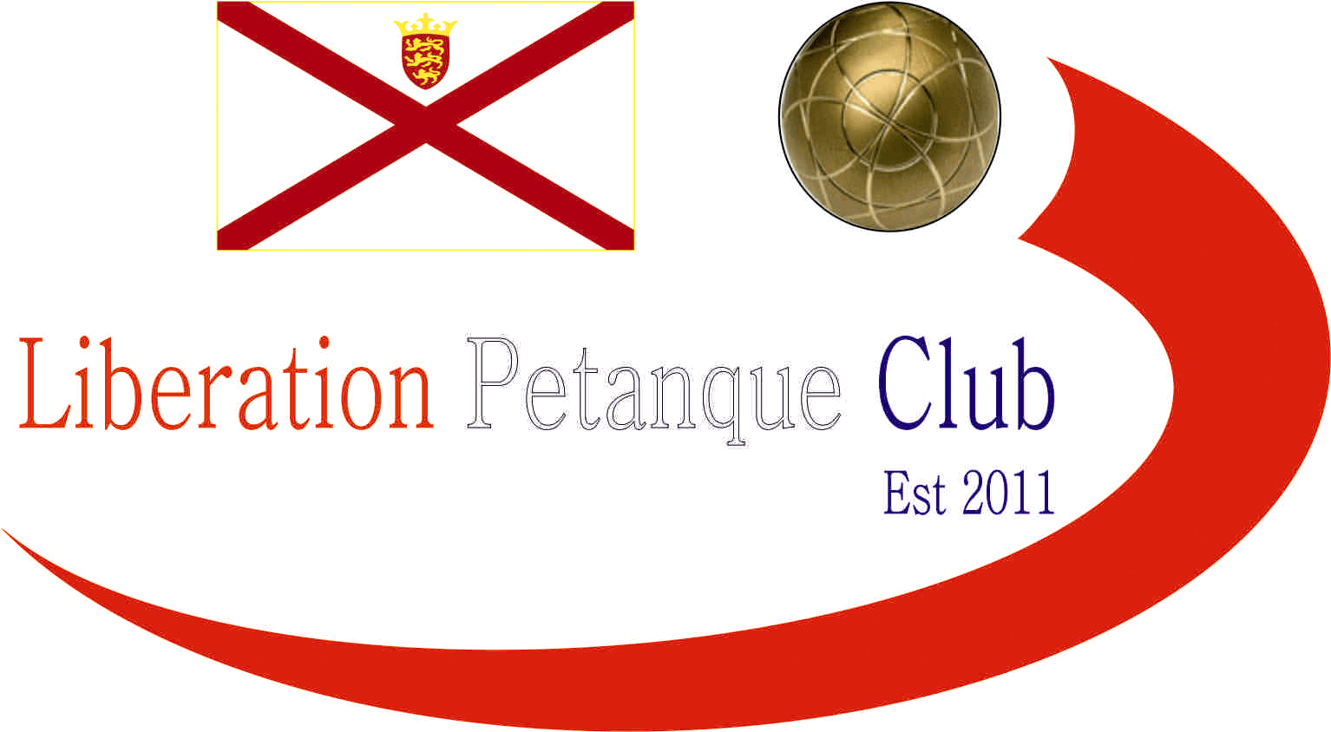

Summer 2020
End of Season
Report
What a great season it has been despite the circumstances, with a number of players achieving their first title successes.
Premier League Double Champions
Laurent Pellaton & Matt Pinel
Despite some close matches Laurent & Matt cruised to victory with 7 wins and 1 draw finishing above Andrew Bellamy-Burt & Callum Stewart in second and Neil Selby & Ross Payne in third.
Commiserations to Geoffroy Buffetrille & Matt Buesnel and Gary Cowburn & Wendy Ritzema who finished in the bottom three.
Division 1 Double Champions

Gavin Scott & James Rondel

Gavin & James cruised to victory ending unbeaten and with an impressive +115 points difference. Four points behind was Alex & Jean Stewart who also ended unbeaten with much improved Branden De La Haye & Tim Jackson pipping Kat Stewart & Paul Bell for third.

Premier League Singles Champion
Joey Le Clech
What a win for Joey taking the title on the lats week of the season over Neil Selby who was the only undefeated player in the league with last years champion Andrew Bellamy-Burt taking third.
Commiserations to Alex Stewart, Matt Ryan and Alice Ibitson who finished in the bottom three, with the latter suffering this fate by 1 point on points difference to Ross Payne.

Singles Division 1 Champion
Laurent Pellaton
A close league won by Laurent who returns to the Premier league at the first attempt. Andrew Limbrick and Brigitte Ibitson finishing second and third.

Commiserations to David Ibitson and James Gennoe who finish in the bottom three due to withdrawals.

Singles Division 2 Champion
Gavin Scott
What a way to win the league with seven wins out of seven. Gavin finished above Paul Bell by seven points with Tim Jackson taking another third place.
Commiserations to Branden De La Haye who finished bottom of the league.

Club Singles Cup Winner
Brian Harris
Brian prevented Andrew Bellamy-Burt from making it three in a row by beating him in the final with beat Neil Selby in the final for his third success. Toby Northern finished third with a win over Laurent Pellaton.

Club Doubles Cup Winners
Mark Nicol & Matt Pinel
Mark & Matt took the title beating Andrew Bellamy-Burt & Callum Stewart 13 – 8 in the final with a five point ending winning the match. Brian Harris & Paul Le Moine took third with a win over Alice & David Ibitson.
Club Super 7’s Cup Winner
Matt Pinel
A late entry paid off for Matt who won his first Super 7’s title by beating Andrew Limbrick in the final. Jake Romeril taking third beating Laurent Pellaton.

Player of the Season

Gavin Scott

Special Thanks

Club Committee – Toby Northern, Matt Ryan, Matt Pinel, Matt Buesnel and James Rondel for their hard work making this club a success.

Other Helpers –Anyone else who has helped out setting up the terrains for competitions/leagues etc and running competitions, very much appreciated.

Club Kit

Club Kit available to purchase.

Well, I hope you have all enjoyed the season and are looking forward to playing again in the Winter 2020 / 21 season.

Kind Regards

Toby Northern

Chairman

Liberation Petanque Club

