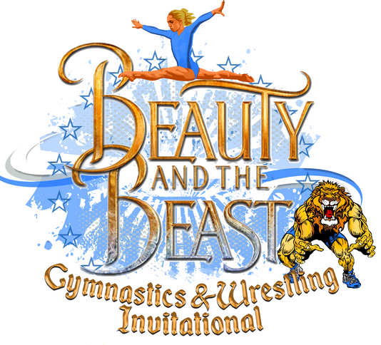

January 19-21, 2019
Rhode Island
Convention Center
1 Sabin St.
Providence, RI 02903

Hosted by:
Dream Big Gymnastics
41 Comstock Pkwy.
Cranston, RI 02921
(401)228-8946
victoria@dreambiggym.com

Dear Business Owner,
At the 2019 Beauty and the Beast Invitational we are expecting
over 1,500 gymnastics and wrestlers, and over 3,000 spectators.
These spectators are active gymnastics and wrestling families living
throughout New England. We are looking for businesses that
would like to be a vendor for this exciting event. This year is our
biggest event to date and our largest venue. With that being said
we want to help local business such as yours to expand beyond
the local market. This is a perfect opportunity to work together as
a business community and expand local commerce. Let’s Dream
Big together! Please fill out this bid form in order to be considered as a vendor at this year’s Invitational. You may send additional information along with this form. Please email all forms to victoria@dreambiggym.com

BEAUTY AND THE BEAST INVITATIONAL - BECOME A VENDOR

Name of Business: ________________________________________________________

Web address: ___________________________

Email: ___________________________________

Phone Number: _________________________

Contact Person: ___________________________

Street Address: ___________________________________________

What type of items will you be selling?
________________________________________________________________________________________________________________
Commission Percentage Offer to Dream Big_______% Minimum Return to Dream Big $150

Have you been a gymnastics meet vendor before? If so, please list your past meet history:
____________________________________________________________________________

