In This Issue
Pg. 1, 2, Pastor’s Corner Pg 7 Church News
Pg 3, 4, 5 Save the Dates Pg 8, 9 Keeping You Informed
Pg 6 Bible Studies & Small Groups Pg 10 Calendar for September 2022
Pg 11 Church Information

This Pastors Corner I would like to discuss what has been happening within the United Methodist Denomination in regard to disaffiliating from the United Methodist Church over differences in the authority of the scriptures and human sexuality in regard to the LCBTQ community specifically ordination and marriage of same sex couples. At the last Special General Conference of the United Methodist Church in St. Louis Missouri in 2019 it was determined that we are not all of one mind on human sexuality so paragraph 2553 was added to the Book of Discipline a link to this paragraph is posted here https://www.umc.org/en/content/book-of-discipline-2553-disaffiliation-over-human-sexuality
Subsequently a process for disaffiliating was created a link to the disaffiliation agreement is here. https://acrobat.adobe.com/link/review?uri=urn:aaid:scds:US:8c0dfb44-af3d-3b19-8dd2-cc372e090300 Since the Conference Trustees were authorized to determine what disaffiliating Churches would have to pay to retain their property some conferences have been very gracious in their terms and others have not been so gracious. Subsequently due to the less gracious conferences a lawsuit has been filed in Florida and North Carolina to obtain fairer terms for disaffiliating churches. The legal group pursuing this lawsuit for Florida and North Carolina churches is the National Center for Life and Liberty every church involved in this lawsuit had to pay $1000.00 for a one-year membership to this group.

Pastor’s Corner continued:
At the crux of the impending disaffiliations is underfunded pensions, this is where some conferences are asking for exorbitant amounts of money in order to allow a church to disaffiliate. In our case here are the numbers for Carson City to disaffiliate:
CARSON CITY UMC
Preliminary Costs of Disaffiliation as of 8-22-2022
Unfunded Pension Obligation $155,100.00
Equity Component* (2x Ministry Shares) $23,798.00
2022 Conference Ministry Shares $5,831.00
2023/2024 Conference Ministry Shares* $17,848.50
2022 District Ministry Shares tbd
2023/2024 District Ministry Shares* tbd
Unpaid Benefit Billings & Health Insurance $0.00
2022 / 2023 Benefit Billings & Health Insurance* tbd
Total Cost of Disaffiliation $202,577.50
* Amounts may change once a final disaffiliation date is determined.
So financially it would be impossible for Carson City UMC to disaffiliate under current financial requirements. Paragraph 2553 sunsets on 12/31/23 and the next General Conference is not scheduled until 2024. There is speculation that at the next General Conference the Protocol for Reconciliation and Grace Through Separation https://www.gracethroughseparation.com/ will not have the votes to pass and there will be no way for a church to disaffiliate from the United Methodist Church and keep their property, but this is human speculation and as God says in Isaiah 55:8-11
“For my thoughts are not your thoughts, neither are your ways my ways,”
declares the Lord. “As the heavens are higher than the earth, so are my ways higher than your ways
and my thoughts than your thoughts. As the rain and the snow come down from heaven,
and do not return to it without watering the earth and making it bud and flourish, so that it yields seed for the Sower and bread for the eater, so is my word that goes out from my mouth: It will not return to me empty but will accomplish what I desire and achieve the purpose for which I sent it.”

And again, it says in Proverbs 19:21 Many are the plans in a person’s heart, but it is the Lord’s purpose that prevails. Or as the Living Bible states in Proverbs 19:21 Man proposes, but God disposes. God has seen Carson City UMC through many dangers, toils and snares and God has not brought us all this far to abandon his faithful ones.

Fall Activities planned for United Women in Faith
- September 12 is the World Thank Offering in the Ambassador’s room. The title is “Embracing Change, Sharing Grace” Word Thank Offering is a program that collects money at a gathering that is sent on to the Conference and upward that eventually goes to support the missions of the United Women in Faith. This is open to any women of the church. Donation boxes are on the table as you enter the sanctuary. Come join us and bring your own bag lunch. Meeting starts at 11am.
- October 3- 10am is the “Me Documentary” Fran, Karen and Wally will
give a brief bio of themselves. This is held in the Women of Faith
room upstairs. All women welcome.
Children’s Ministry
Fall, 2022

Children are encouraged to participate in the fall activities that are about to begin.

Funday Sunday is Sept. 11, at 9:15 am in the Fellowship Hall. Let’s get reacquainted, enjoy some fun activities, and share some yummy snacks.

A.R.K. begins Wednesday, Sept. 14th from 6:30-8:00 pm in Daniels Den.

“Cool Hour” - Sunday School classes begin Sept. 18th at 9:15 am. Children will be learning how to identify the character traits shown by a variety of Bible people in our new curriculum “Reflecting the Son”. Remember, we are looking for a few leaders to rotate Sunday’s as we meet the needs of our teens. Please contact Roberta at 989-584-3629 if interested.

Children’s Church begins Sunday, Sept. 18th at 10:30 am after the scriptures are read during worship.
- November 7- “Come Eat With Us” potluck 5:30 pm Fellowship Hall with music following and brief meeting after. All welcome. Bring a dish to pass and own table service. Drinks will be provided.

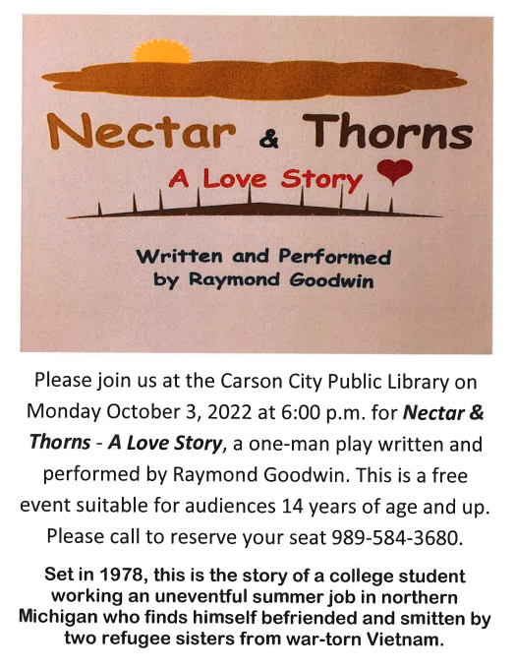
Helping Haiti Heal by WalthaGaye
Saturday, September 24, 2022, the Mason UMC is hosting a Mission Outreach Opportunity. The Executive Director of Soaring Unlimited Inc., Rev. Laura Alexander Elliott, is speaking on how you can help the people of the greater Cap Haitian community to enhance their quality of life and empower them in the areas of medical care, clean water and sanitation, nutrition, housing and education and training for the children, youth, and adults. This project uses many agencies both in the US and Haiti. Learn the latest developments in this troubled country and how the mission is successfully continuing under difficult conditions. Retired Director Dorothy Frederickson will also be there to talk about the Baby Box project.
REGISTRATION forms are on the bulletin board. If you have questions, call WalthaGaye @ 989-640-0238. Deadline to register is Sept. 16th. Lunch is provided.

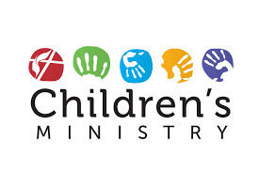
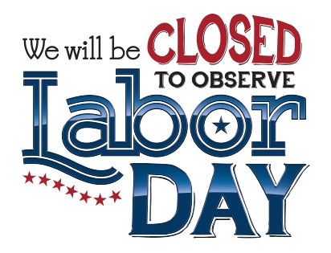

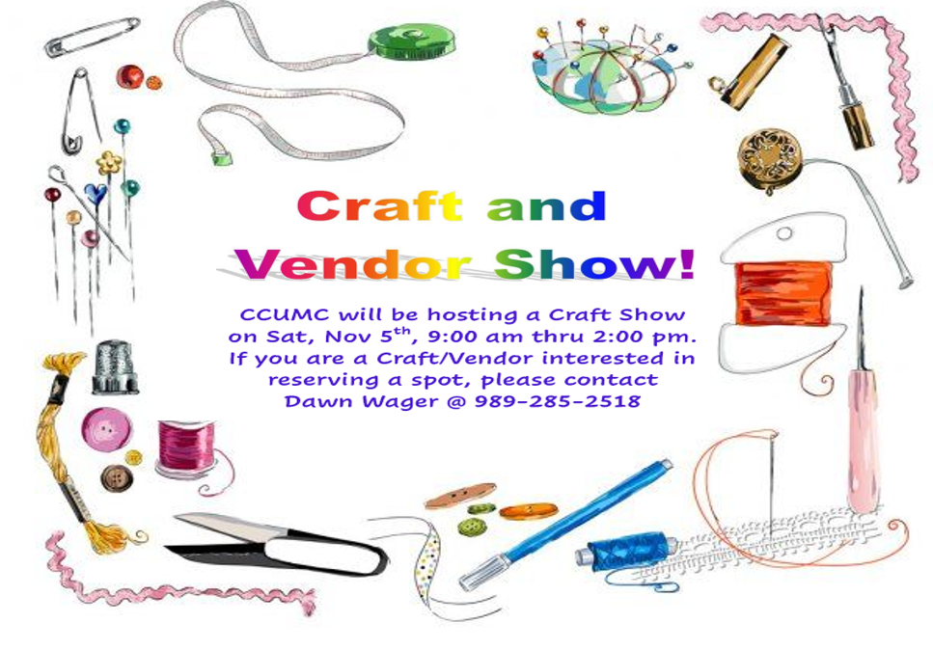

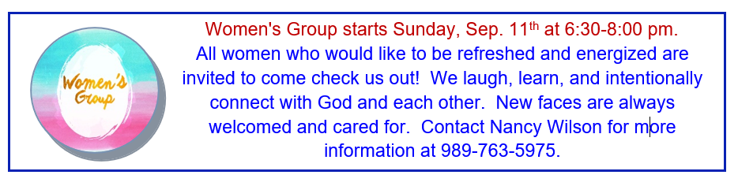
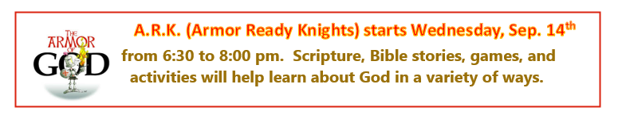
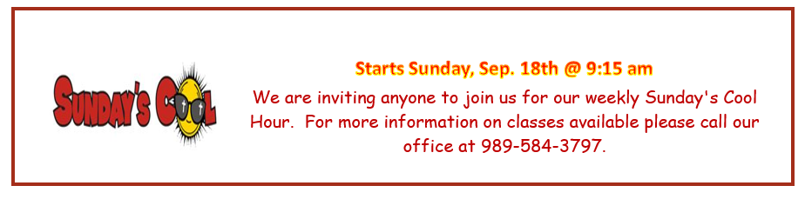
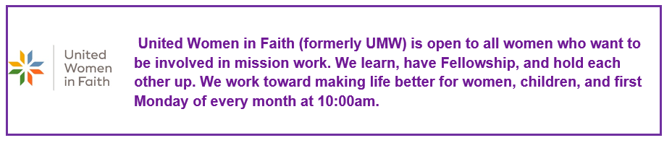
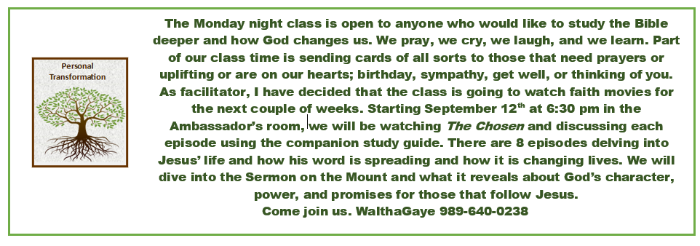

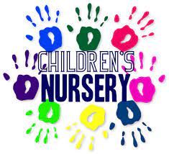
Church Nursery will resume
on Sept. 18th. Volunteers
are needed. Please contact
Roberta Kile at 989-584-3629

Church Elevator Updates:
The elevator at the church is still temporarily out of service and parts will be ordered soon. Once it is up and running, we will notify everyone.

TRANSPORTATION PROGRAM INFO.
The Commission on Aging has a medical transportation where volunteer drivers will take you to your medical appointments, wait until you are done, then bring you back home. The CoA even has a wheelchair van for those people who are in a wheelchair. This program is for people 60 years or older who meet the guidelines. You can call 989-831-7476 to see if you qualify. The transportation program can help you get to a bigger city like Grand Rapids, Lansing, etc. All the CoA volunteers are ready and able to get you safely where you need to go.

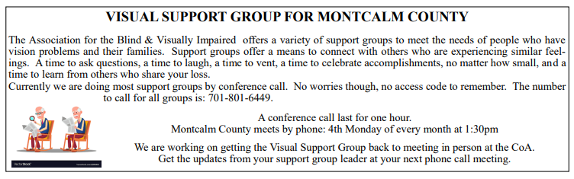

News From our Native American People by WalthaGaye Leavitt

I read an article from the people of the NM Reservation about what they are facing.
Could you live on 7 gallons of water a day? That is all they can get delivered to them
on a given day to use for cooking, bathing, and drinking. In comparison,
a drought-stricken family in California uses 362 gallons. Darlene, one of the water truck drivers, travels 5 days per week to deliver water to families on the vast reservation. The supply must last for 3 weeks until she can get back to them. She fills up 55-gallon drums and other empty containers with fresh and safe water for these 221 isolated families. There are more families in need. One-third of the 50,000 families on this Navajo Reservation do not have access to clean water, one of the highest concentrations of water-poor homes in our country. And a multi-year drought has made the situation worse. For the last few years, the Reservation has received less than the 8 inches it usually gets per year. And the groundwater is so deep that digging wells is impossibly expensive.
If you want to give to St Bonaventure Indian Mission and School the address is PO Box 610 Thoreau, NM 8723-0610

News from MidWest Distribution Center by WalthaGaye Leavitt

Collaboration is integral to what MidWest does. “When we work together much can be accomplished. Our partners help provide humanitarian relief and work with us in domestic, international, and local efforts,” said Chantel Corrie, executive director of MidWest Mission.
Last Friday, August 12 was a prime example of how well-defined partnerships allow for expanded blessings. MidWest Mission staff loaded and shipped a first-time container to Grenada. Food for the Poor is one of MidWest Mission’s long-time international partners. They serve 17 Latin and Caribbean countries and many of the countries have received shipments from us to aid in provision of disaster relief supplies, health, education, and micro-business resources. Operations manager, Brad Walton said he sent Food for the Poor an offer ad one of their two in-country partners in Grenada accepted it due to the variety of items.
Grenada is a small island about two times the size of Washington D.C. It is situated in the southeastern Caribbean. Nearly 40% of the people live in the most inaccessible and drought- prone parts of the island.
The shipment contained 13 bikes, 41# of fabric, 15 electric sewing machines, 5 treadle sewing machines, 155 handmade quilts, 255 little girl outfits, 560 Personal Dignity kits, 560 tubes of toothpaste, 448 Birthing kits,20 walkers, 10 canes, 78 knitted baby sweaters, 55 baby blankets, 1,327 disposable diapers, 548 shovels, flashlights, hammers, and other tools and 5700 sponges. From other donors, there were 4800 hospital gowns, 135 boxes of sanitary wipes, 24,000 cloth face masks, medical supplies, 42 vinyl tarps,405 scrubs, 224 patient gowns, 664 sheets and 40 stacking chairs. Total value $360,711.90
Also- MidWest has sent their 6th shipment to the Ukraine. Included in the shipments were meals, medical supplies, socks, ponchos, underwear, t shirts, soap, and wipes. They put out a plea to make 288,000 rice meals and people stepped up and got them made in time for the container to be packed.

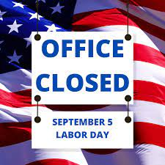

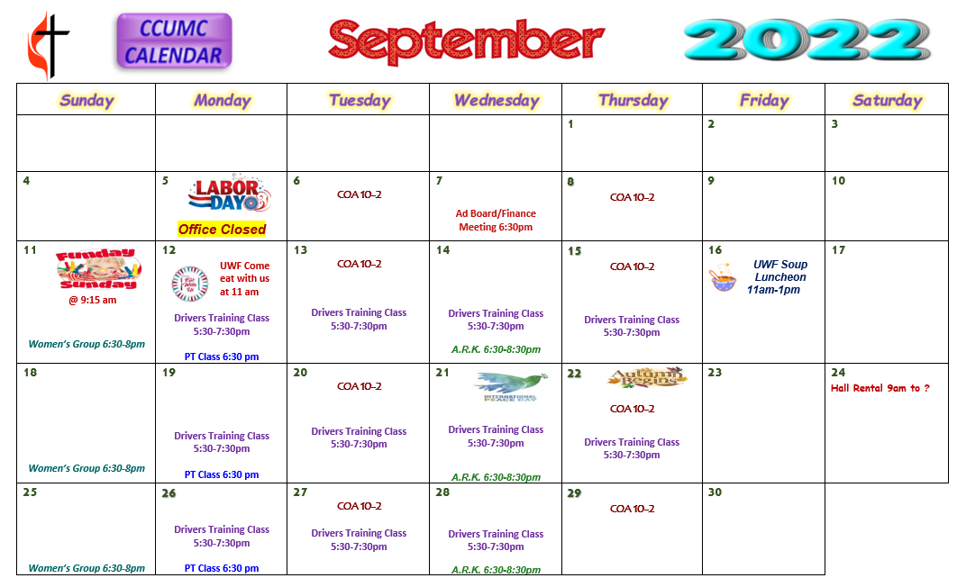
Schedule’s subject to change – contact office for more information”

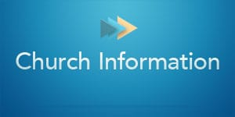
Stay connected! Follow us on:

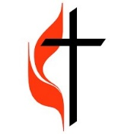
Join Us Each Sunday

Worship Services 10:30 am

(masks are optional)

Carson City United Methodist Church
Phone: 989-584-3797
Email: carsoncityumc@gmail.com
Website: carsoncityumc.com
Office Hours: Monday to Thursday, 9:00 am-Noon
After hours by appointment
Pastor: Ian McDonald (906) 322-5318
Secretary: Bonnie Seaman (989) 763-1674

Online giving available: Website: http://www.carsoncityumc.com/donate.html

Weekly Sunday Bulletin now available on our website
at www.carsoncityumc.com

