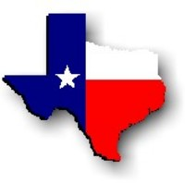Texas History with Mr. Brown Name ____________________ Period _____

Chapter 15: Texas and the Union, Picture Search p. 322 – 335, 3 pts each
Directions: Use the pictures, maps, graphs, Info boxes, and their captions to find the following information.
1) “. . . all persons held as slaves within any State or designated part of a State, the people whereof shall then be in rebellion against the United States, shall be then, thenceforward, and forever free. . . .” Is a quote from the ____________________________________
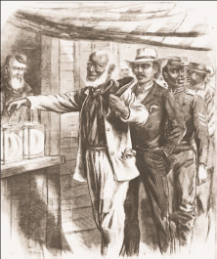
2) Who is the artist that painted Shotguns, Fourth Ward? ________________________________________________
3) What year were slaves emancipated in Texas? ________________
4) What year was Texas readmitted to the U.S.?_________________
5) What year did reconstruction end in Texas? ___________________
6) What is the title of the Harpers weekly picture on p. 323? _________________________
7) What is the Title of the article from the 1865 Newspaper clipping? ______________________________________
8) Juneteenth celebrations were first used to teach _______________________________ about their voting rights.
9) When was Juneteenth declared a State Holiday? ______________
10) _______________________ in Houston was one of the many communities in Texas established by freedmen.
11) Today Freedmen’s town is known as _________________________________________________________________.
12) To better support their families, former slaves had to learn to _________________________________________.
13) ________________________ became a regional education center when a freedmen’s school was established there during Reconstruction.
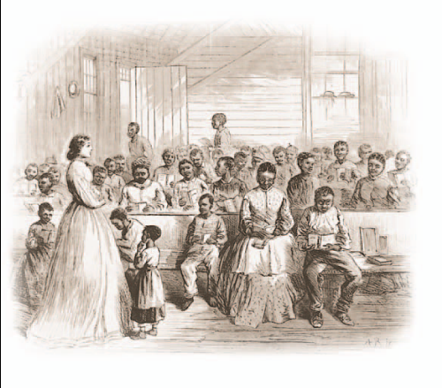
14) Was the Freedmen’s School pictured to the left designed for children or adult students? _______________________________________
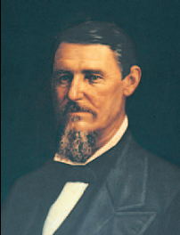
15) After moving to Texas with his family in 1841, ___________________ practiced medicine and law before being elected to the Texas legislature.
16) What office was Throckmorton appointed to after the Civil War? __________________________
17) What was Texan John H Regan’s role in the confederacy? ________________________________
18) _______________________ granted African American Men the right to vote.
19) In what year were African American Men allowed to vote for the first time? ___________________________
20) The legislation that admitted Texas to the Union in 1845 had allowed the state to divide into as many as ____________________ different parts.
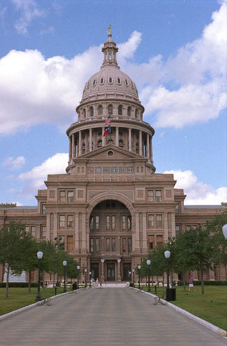
21) List the States for each military district during reconstruction
District 1: ______________
District 2: ______________, ______________
District 3: ______________, ______________, ______________
District 4: ______________, ______________
District 5: ______________, ______________
22) In 1869 Ruby was appointed ___________________________________________________________ at Galveston.
23) As a senator, Ruby introduced several successful bills and helped to organize the first ___________________ ______________________________________________________________________________________________________.
24) If you owned land that was worth $1,500, how much would your property taxes have been in 1866? _______________. Also how much in 1871? __________________
25) During Davis’s administration, the Texas legislature included _________ African American representatives.
26) Which two African Americans served in the Texas Senate? ____________________________________________
27) Name two African Americans who served in the Texas house of representatives: ________________________
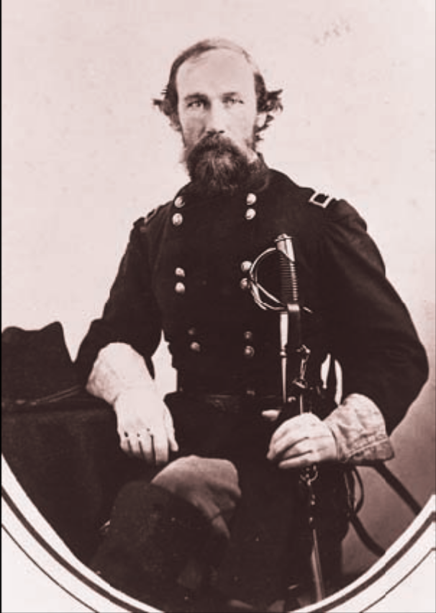
28) Who did Davis loose the 1873 Texas Governors race to? _____________________________
Define the following
29) Martial Law - ________________________________________ __________________________________________________________
30) Districts - _____________________________________________ __________________________________________________________
31) Veto - ________________________________________________ __________________________________________________________
32) Amendment - ________________________________________ __________________________________________________________
33) Civil Rights - __________________________________________ __________________________________________________________
34) Freedman - __________________________________________ __________________________________________________________

