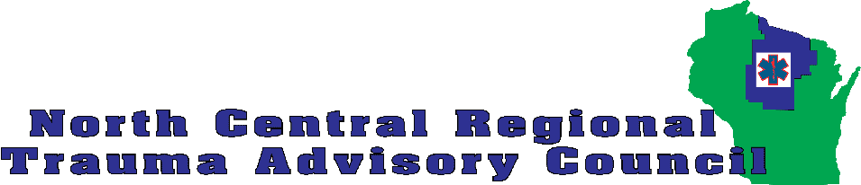
Life Jacket Loaner Station Funding Request
Drowning has been identified as a significant risk for injury and loss of life for the citizens of the North Central region. The Injury Prevention Committee of the North Central Regional Trauma Advisory Council (NCRTAC) is interested in supporting the placement of life jacket loaner stations at boat landings and swimming beaches in the region. The NCRTAC will provide partial or complete funding to organizations that will commit to placement of the loaner station and ongoing maintenance.
Applications are to be sent to RTAC Coordinator Michael Fraley and may be sent by mail (PO Box 23 Woodruff WI 54568) or email (coordinator@ncrtac-wi.org). Applications for funds from our fiscal year ending June 30, 2015 will be considered as received. Projects that are not funded with this fiscal year funds will be considered for the 2015-2016 funds. Deadline for 2015-2016 funds will be October 31, 2015. NCRTAC reserves the right to accept or deny any applications.
Awardees will be provided reimbursement for documented purchases up to the award amount. Proof of purchases and requests for reimbursement must be submitted by July 10, 2015 for 2014-2015 projects and July 10, 2016 for 2015-2016 projects.
The NCRTAC will provide the awardee with available information about life jacket loaner stations including material lists and assembly instructions. If available, the NCRTAC may also arrange for assembly of the loaner station boards through an independent individual that is interested in providing the service.
Submission of this application indicates that:
- The applicant agrees to acquisition of materials, assembly, placement and long-term maintenance of the life jacket loaner station including seasonal storage and placement of jackets, replacement of missing or damaged jackets, and upkeep of the signage and jacket storage boards/bins.
- The applicant will ensure that the life jacket loaner station signage will include the NCRTAC logo and an indication that the NCRTAC was a partner in the project.
- The NCRTAC is immune from any liability related to the board, the placement of the board and any use or misuse of the life jackets.
- At the time the loaner station is to be removed from the site the applicant is responsible for removal and disposition of any materials and jackets.
Organization Name:
Contact Name:
Contact phone:
Contact email:
Organization mailing address:
Proposed life vest loaner location:
Is this a state, county or local park/ boat landing?
Please describe how this location is used by the public. If known please indicate how many swimmers/boaters frequent the area.
Please indicate your plan for maintaining the life vest loaner station.
If partial funding were offered for your project would you be able to obtain other funding to complete the project?

