Southeast FYSPRT Needs Assessment QR Code 9.2022

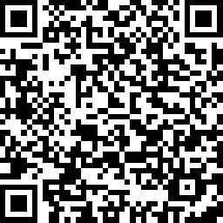

Southeast FYSPRT Needs Assessment Survey Link 9.2022

https://www.surveymonkey.com/r/862RXT9

