Everest Gymnastics Insider 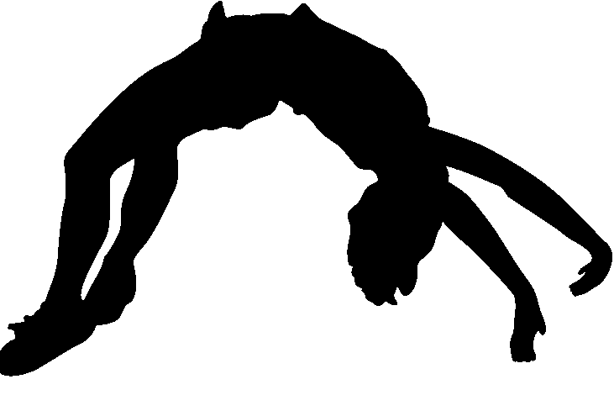
Unleash your child’s potential!

The Start of Something New!
*Trampoline & Tumbling program*
Power tumbling and trampoline is a gymnastics discipline that involves tumbling and trampoline routines that fly to the next level. From basic beginner to advanced and competitive, we are ready to take on this new program at Everest!
We would like to welcome Tony Roberson to the Everest Gymnastics Staff!
Tony has been an Assistant Women’s Gymnastics Coach and Tumbling Instructor since 1999. In 2003 he started his first Trampoline & Tumbling Team in Mount Laurel, NJ. In 16 competitive Tramp & Tumbling seasons, he has coached over 150 State Champions, 61 Regional Champions, and 15 National medalists. Welcome to the Everest Family Tony!
Call for a trial class and/or team evaluation today!

Competitive Cheer Teams
Free Tumbling Clinic and Cheer Team evaluations on 10/3/20 from 3-5pm in Galloway and 10/10/20 from 3-5pm in Mays Landing. Must call to register in advance, absolutely no drop ins will be permitted.

Virtual Learning Hub
We had a great first full week in our virtual learning hubs in Mays Landing and Galloway! Keeping kids on task, signing in to zooms on time, messaging teachers when assignments weren’t posted, the staff was up for the challenge! Our virtual learning hubs take place Monday through Friday 9am-4pm with add-on before and after care. Email us for more information and sign up forms at info@everestgymnastics.com
Tutoring at Everest!
We would like to welcome Mr. Christopher Sheehan to our Everest Family! Coach Chris started working with our campers this past summer and is a kid favorite! Mr. Sheehan is now a teacher in the Lindenwold school district (he was formerly at Hess School in Mays Landing), teaching 5th grade ELA and Social Studies and has offered his amazing tutoring services to our students throughout the school year. He has been teaching elementary through Middle School for 4 years and has been tutoring K-12 for the past 6 years. He has experience with the curriculums for Reading, Writing, Math, Social Studies, Science, Spanish, Test Prep, and SAT prep. He is incredibly patient and wants to help each student grow in their education.
He will be offering individual and small group tutoring, please call for schedule and pricing.

Fall Classes are in full swing
All fall classes are now open. Our amazing instructors are so excited to see our students back in the gym! There are plenty of new safety protocols in effect so please see our website for full details at www.everestgymnastics.com or contact us at 609-748-2186 in Galloway or 609-829-2579 in Mays Landing.

Competitive Gymnastics Teams
Boys and Girls competitive teams in both Mays Landing and Galloway are back at it! From our in-house teams to college gymnasts and 4 year olds to 25 year olds, we are ready to take on this season. Evaluations are ongoing throughout the fall, please call 609-748-2186 or 609-829-2579 for more information.

