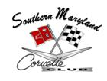

July 14, 2015
(NO MEETING HELD)

- Instead of holding a formal meeting on July, 14, 2015, members gathered at Ruddy Duck, in Piney Point, MD, on Saturday, July 11, 2015, for a casual dinner and social.

*Recorded by: Patrice Hopkins, 2013-2015 SMCC Corvette Club Secretary*

