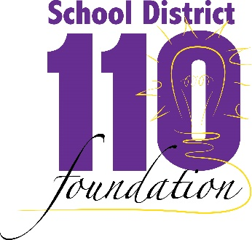

District 110 Foundation
Scholarship for Technical Education

This scholarship will be awarded to a senior who will pursue an education in a technical field. Examples include welding, plumbing, automotive technology, medical assisting, and child development.

NOTE: This application must be typed in order to be considered.

Name:

Address:

Telephone:

Please address each of the following in 1-2 paragraphs:

- How did you become interested in pursuing a technical education?

- What are your educational and career goals for the future?

- How will this scholarship help you to achieve your career goals?

In addition, please provide a letter of recommendation from a teacher you’ve had in the last year or an employer who can attest to your work ethic.

Return application to Waconia High School Guidance Office

