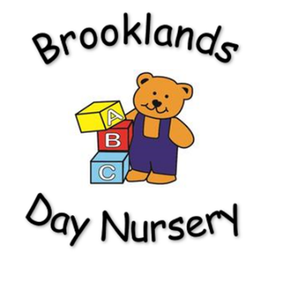
Brooklands Private Day Nursery
Behaviour Policy

Aim: To create a safe and secure environment for all children that promotes and encourages acceptable behaviour and respect for others.
Rationale: Children’s behaviour must be managed effectively and, in a manner, appropriate for their stage of development and particular individual needs.
Managing children’s behaviour:
At Brooklands Nursery, we strive towards managing behaviour by using positive behaviour strategies and language at all times. Within our setting, adults role model good behaviour and promote positive strategies at all times;
- Praising and rewarding good behaviour.
- Encouraging sharing and negotiation skills.
- Helping the children to understand the effects of their behaviour on others.
- Reassuring children that they are always valued as individuals even if their behaviour may sometimes be unacceptable.
- Helping children to challenge bullying, harassment and name calling.
Each day children are reminded of our golden rules;
- Kind hands
- Walking feet
- Kind words
- Look after our toys
- Share and take turns
- Good tidying
- Help others

All of the children receive praise and are rewarded for displaying positive behaviour. Our positive behaviour strategies include; praise, stickers and certificates. Throughout the day children are also encouraged to develop good sitting, looking and listening skills.
All children are individuals as must be respected as such. Unacceptable and unwanted behaviour must be dealt with in a manner appropriate to the individual child.
- Discuss what behaviour is expected of the child.
- Ignore unwanted behaviours by distraction and redirection.
- Do not discuss a child’s behaviour with staff or parents in front of the child.
- ‘The Thinking Square’ MUST only be used as a last resort. This time should be age appropriate and only given for serious aggression or persistent non-compliance. The time on the thinking square should be used for the child and an adult to reflect of the situation and the feelings involved.
- Never humiliate, withhold food, use a naughty chair or aim to damage a child’s self-esteem.
- Bullying in any form will not be tolerated. Staff will respond positively to all parents/carers regarding bullying, and listen to all concerned.
- Corporal punishment or any form of punishment which could have an adverse impact on a child’s well-being MUST not be used. For example; shaking, rough handling, slapping or smacking.
- Physical intervention MUST only be used if it is felt necessary to protect the child, other children or adults. Any incident will be recorded on an incident sheet and the parent informed of such as soon as is reasonably practical.
The role of the parent.
Working closely with parents is vital to ensure consistency when dealing with unwanted behaviour. To enable us to achieve this, information is shared on a daily basis.

The named person.
The named person who is responsible for behaviour management in our setting is the manager. They will access behaviour management training as appropriate and share their skills and knowledge with the staff team. The manager and deputy manager will work closely with other professionals to ensure a support network for the setting e.g. Local Authority, SENDCO. Parents/carers will be consulted and their views taken into account.

All nursery staff are informed of the behaviour management policy at induction, which they are asked to read and sign to confirm their understanding.

This policy will be reviewed every 12 months by management.

