REGULAR MEETING
FEBRUARY 18, 2021

A Public Hearing and the Regular Meeting of the Town Board of the Town of Hampton, County of Washington and the State of New York was held at the Town Hall and via Zoom, 2629 State Route 22A, Hampton, New York on the 18th day of February 2021.

Due to the Corona Virus, occupancy inside the Town Hall is limited at this time. Supervisor O’Brien did provide a link to join the meeting via Zoom.

PRESENT: David K. O’Brien------------Supervisor
Tamme Taran----------------Councilwoman – via Zoom
Donald Sady-----------------Councilman
Andrea Sweeney------------Councilwoman – via Zoom
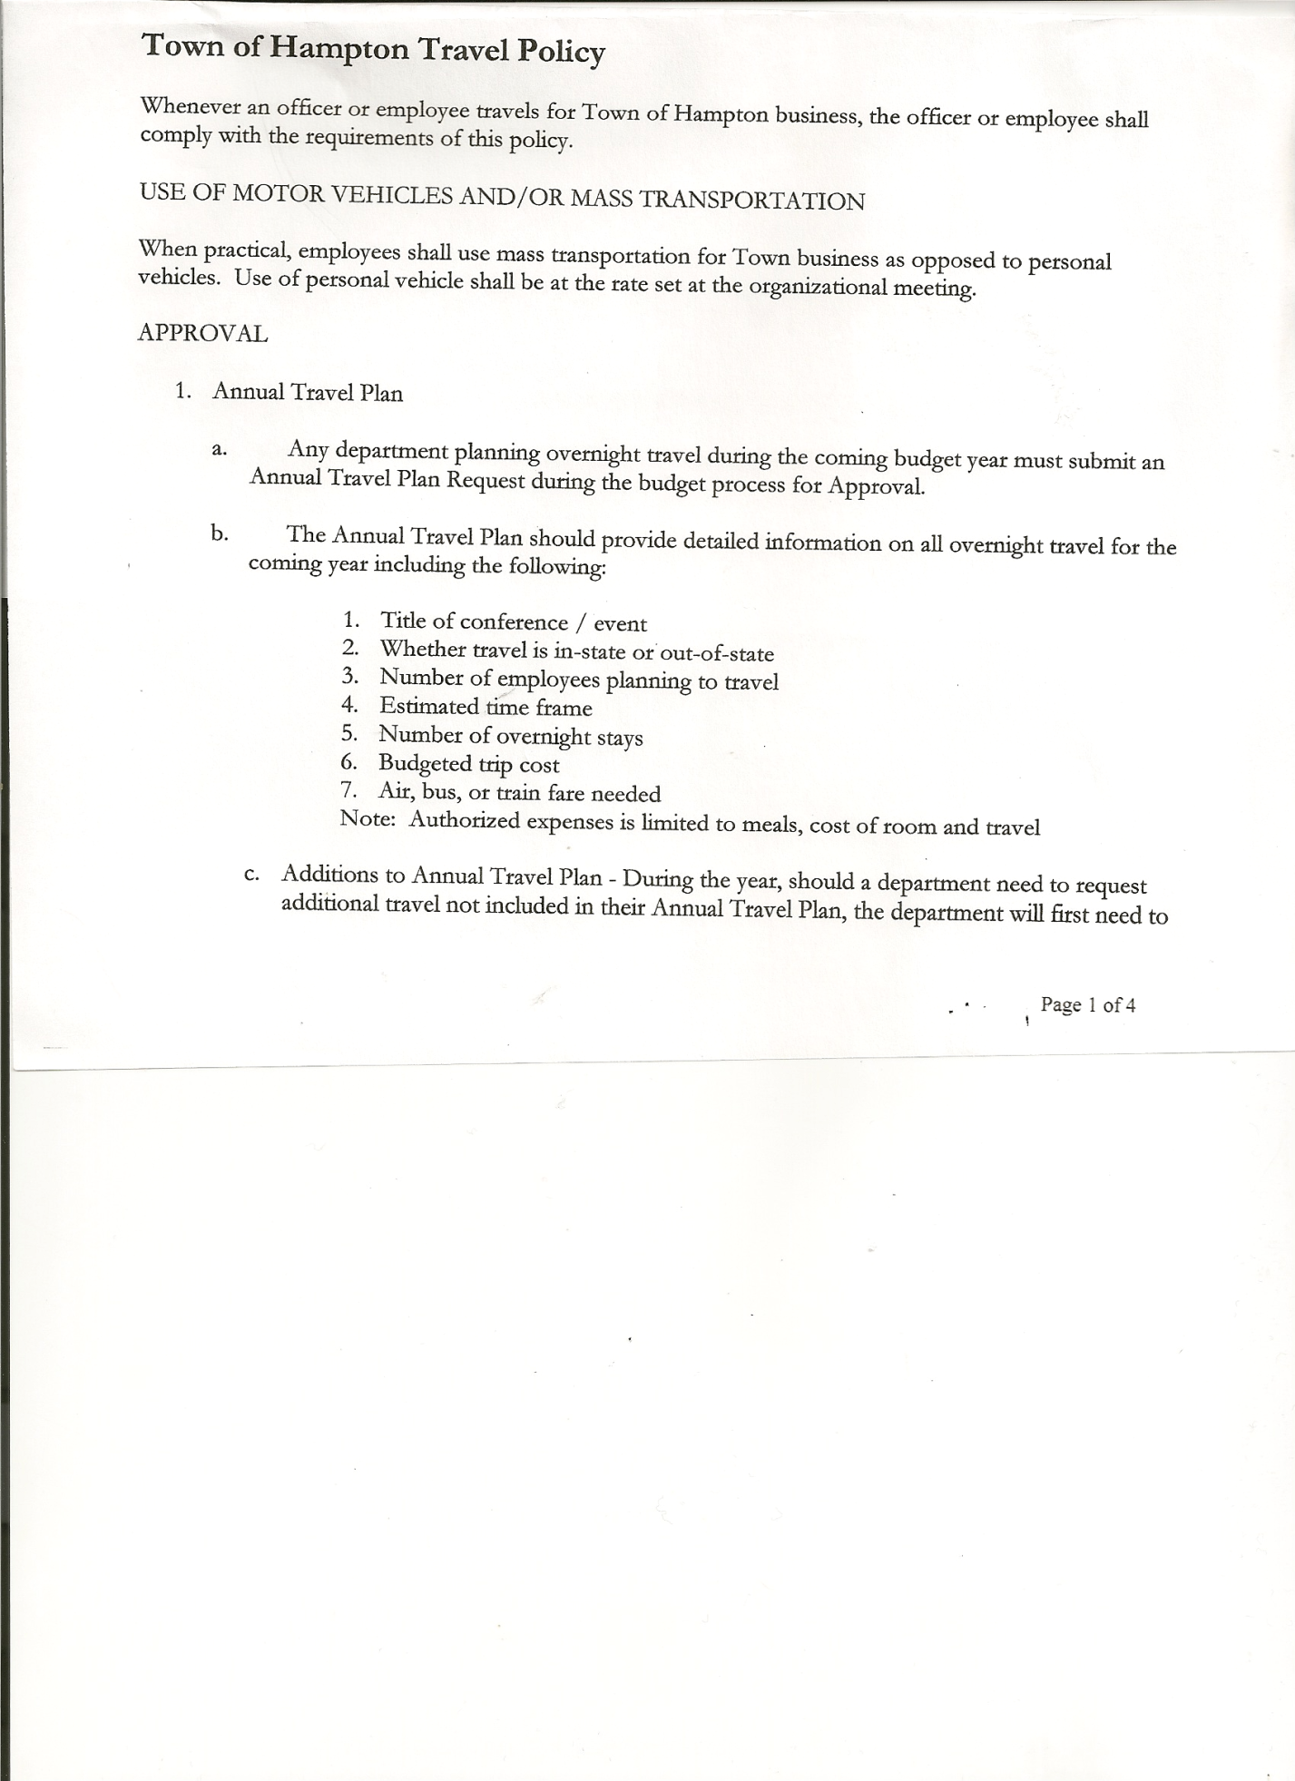
Michael Pietryka------------Councilman
Rebecca Jones---------------Town Clerk
Camilla Shaw----------------Tax Collector/Deputy Town Clerk
Herbert Sady, Jr.-------------Highway Superintendent – via Zoom

Planning Board Member(s): Bonnie Hawley, Chair; Matthew Pratt (via Zoom)

Others present via Zoom: Travis Dean and Artie Pratt

The Public Hearing was called to order by Supervisor O’Brien at 7:18pm

Town Clerk Jones read the Legal Notice of Public Hearing (copy attached), which was published in the Manchester Newspapers (The Granville Sentinel and Whitehall Times) on 2/4/21 and 2/11/21 on proposed Local Law titled “Providing for The Abolition of The Elective Office of Superintendent of Highways and the Creation of the Appointive Office of the Superintendent of Highways of the Town of Hampton.”

A letter was sent to all registered voters with information about the meeting and Public Hearing. Supervisor O’Brien got feedback from 18-20 people prior to the meeting. There were only 2 negative responses. 340 emails were sent and 352 letters. There were no public comments.
Supervisor O’Brien asked three (3) times if there were any comments. Hearing none, the Public Hearing was closed at 7:31pm.
REGULAR MEETING
The Regular Meeting was called to order by Supervisor O’Brien at 7:31pm, followed by the Pledge of Allegiance. Location of Fire Exits were given. Quorum of board members present.

Supervisor O’Brien asked for a moment of silence in memory of Concetto “Junior” Poalino, Sheri Marie Camara Fish, Ernest Petty and Clarence Sweeney (father-in-law of Andrea Sweeney).

RESOLUTION NO. 20-2021
APPROVAL OF THE MINUTES
On a motion of Councilman Sady, seconded by Councilman Pietryka, the following resolution was ADOPTED:
By Roll Call Vote: Supervisor O’Brien AYE
Councilman Sady AYE
Councilwoman Sweeney AYE
Councilman Pietryka AYE
Councilwoman Taran AYE

TOWN BOARD MEETING
FEBRUARY 18, 2021 PAGE 2

RESOLVED, that the Regular Town Board Minutes for January 21st, 2021 are approved.

Larry Carman, Dog Control Officer submitted his report, which was read by Supervisor O’Brien, copy of report is attached.

Camilla Shaw, Tax Collector gave her report – there are about 140 unpaid parcels at this time. $665,000 has been collected. Submitted January 2021 report to the Board. Also submitted Bank Statement to the Board for review and signatures.

Bonnie Hawley, Chair gave Planning Board Report… They met on Wednesday, February 10, 2021. No new business. Old Business: the grant application was sent in on February 2nd. Supervisor O’Brien is the Admin Signatory. No response has been received back yet. March 10th is the next meeting via Zoom.

Herbert Sady, Jr., Highway Superintendent submitted his report, copy of which, is attached.
Received three quotes on the new box for the Tandem, they are as follows:
- Bonnell Industries, Inc…..$40,938.00 (shipping not included)
- Tenco Industries, Inc…….$48,982.35
- Zwack Inc………………..$44,528.00
Following a discussion regarding the above quotes the following resolution was introduced.
RESOLUTION NO. 21-2021
2009 INTERNATIONAL (TANDEM)
On a motion of Councilman Sady, seconded by Councilman Pietryka, the following resolution was ADOPTED:
By Roll Call Vote: Supervisor O’Brien AYE
Councilman Sady AYE
Councilwoman Sweeney AYE
Councilman Pietryka AYE
Councilwoman Taran AYE
RESOLVED, that based on the quotes received for repairs for the 2009 International Tandem, to replace the box, sander and other accessories needed, the Board is authorizing the purchase from Zwack.
Herb also spoke with Deb Donahue about grants for bridges and culverts. The Town would have to pay first, then be reimbursed all but 5% of the cost. There is no cost to have them come and look at the culverts and give recommendations.

SUPERVISOR’S REPORT/ COUNTY UPDATES/ COMMUNICATIONS

RESOLUTION NO. 22-2021
BUDGET AMENDMENTS- HIGHWAY FUND
On a motion of Councilwoman Taran, seconded by Councilman Sady, the following resolution was ADOPTED:
By Roll Call Vote: Supervisor O’Brien AYE
Councilman Sady AYE
Councilwoman Sweeney AYE
Councilman Pietryka AYE
Councilwoman Taran AYE
RESOLVED that, the following Budget Amendments to the Highway Fund are approved:
Increase Appropriated Balance in the amount of $30,987.62
Increase General Repairs CE Account DA5110.4 in the amount of $30,987.62

TOWN BOARD MEETING
FEBRUARY 18, 2021 PAGE 3

RESOLUTION NO. 23-2021
BUDGET AMENDMENTS- GENERAL FUND
On a motion of Councilman Sady, seconded by Councilman Pietryka, the following resolution was ADOPTED:
By Roll Call Vote: Supervisor O’Brien AYE
Councilman Sady AYE
Councilwoman Sweeney AYE
Councilman Pietryka AYE
Councilwoman Taran AYE
RESOLVED that, the following Budget Amendments to the General Fund are approved:
Increase Unexpended Balance in the amount of $12,129.86
Increase Contingent CE Account A1990.4 in the amount of $12,129.86

RESOLUTION NO. 24 -2021
APPROVAL OF SUPERVISOR’S MONTHLY REPORT
On a motion of Councilman Sady, seconded by Councilwoman Taran, the following resolution was ADOPTED:
By Roll Call Vote: Supervisor O’Brien AYE
Councilman Sady AYE
Councilwoman Sweeney AYE
Councilman Pietryka AYE
Councilwoman Taran AYE
RESOLVED that, the Supervisor’s Monthly report be accepted as submitted for JANUARY
12/31/20 1/31/21
ACCOUNT BALANCE RECEIPTS DISBURSEMENTS BALANCE
General Fund $ 37,129.86 $ 216,099.74 $ 12,669.82 $ 240,559.78
Highway Fund $ 55,987.62 $ 2.23 $ 19,818.55 $ 36,171.30
Equipment Reserve $ 54,898.02 $ 2.33 $ 0.00 $ 54,900.35
Fire #1 $ 0.00 $ 0.00 $ 0.00 $ 0.00
Fire #2 $ 0.00 $ 0.00 $ 0.00 $ 0.00
Cemetery $ 1,743.00 $ .18 $ 0.00 $ 1,743.18
Totals $149,758.50 $216,104.48 $ 32,488.37 $333,374.61
All Board Members present signed Supervisor’s Report.

OLD BUSINESS
Broadband Update….The Public Service Commission (PSC) has approved the cable TV Franchise Agreement for Hampton.
Slic Network expects to be done by June or July. They are still working on pole agreements.

Highway Superintendent Position….Elected vs Appointed.
Discussion continued about changing from an Elected Highway Superintendent to an Appointed Highway Superintendent. Mailing will be done to all registered voters in Town. Absentee ballots will be mailed to anyone requesting one.

TOWN BOARD MEETING
FEBRUARY 18, 2021 PAGE 4

RESOLUTION NO. 25 -2021
Introduced by Councilman Donald Sady
who moved its adoption
Seconded by Councilwoman Andrea Sweeney

RESOLUTION AUTHORIZING THE ADOPTION OF LOCAL LAW NUMBER 1 OF 2021 PROVIDING FOR THE ABOLITION OF THE ELECTIVE OFFICE OF SUPERINTENDENT OF HIGHWAYS AND THE CREATION OF THE APPOINTIVE OFFICE OF THE SUPERINTENDENT OF HIGHWAYS OF THE TOWN OF HAMPTON

BE IT RESOLVED by the Town Board of the Town of Hampton (the “Town”), in the County of Washington, on this 18th day of February, 2021, as follows:

WHEREAS, the Town scheduled a public hearing to be held before the Town Board on February 18, 2021 at 7:15 p.m. at the Offices of the Town of Hampton, 2629 State Route 22A, Hampton, NY 12837, to hear all interested parties on a proposed Local Law to abolish the elected office of Highway Superintendent and to create an appointive office of Highway Superintendent; and

WHEREAS, notice of said public hearing was duly posted and then published in the Granville Sentinel and Whitehall Times, the official newspaper of the Town on February 4th and February 11th, 2021, pursuant to and in conformance with the Municipal Home Rule Law; and

WHEREAS, said public hearing was duly held before the Town Board on February 18th 2021 at 7:15 p.m. at the Offices of the Town of Hampton, 2629 State Route 22A, Hampton, NY 12837, and all parties in attendance were permitted an opportunity to speak on behalf of or in opposition to the local law to abolish the elected office of Highway Superintendent and to create an appointive office of Highway Superintendent.

NOW, THEREFORE BE IT RESOLVED by the Town Board of the Town as follows:

Section 1. The Town Board, upon due deliberation of both the Highway Superintendent Appointment Act and the comments presented at the public hearing, finds that the adoption of the same shall be in the best interests of the Town.

Section 2. The Local Law Providing for the Abolition of the Elective Office of Superintendent of highways and the Creation of the Appointive Office of the Superintendent of Highway of the Town of Hampton is hereby adopted as Local Law Number 1 of 2021, a copy of which is attached hereto and made a part hereof.

Section 3. Pursuant to and in accordance with the Municipal Home Rule Law, Local No. 1 of 2021 shall be subject to mandatory referendum at a Special Election on April 20, 2021, whereby Local Law No. 1 of 2021 shall become operative only if approved by the affirmative vote of a majority of the qualified electors of the Town voting upon this proposition.

TOWN BOARD MEETING
FEBRUARY 18, 2021 PAGE 5

Section 4. The Town Clerk is hereby directed to enter Local Law No. 1 of 2021 into the minutes of this meeting and file the same, along with an appropriate abstract, with the Washington County Board of Elections. Upon approval by the electors of the Town, the Town Clerk is directed to file Local Law No. 1 of 2021 with the Office of the Secretary of State of the State of New York.

Section 5. This resolution shall take effect immediately.

DATED: FEBRUARY 18, 2021 Supervisor O’Brien AYE
Councilman Sady AYE
Councilwoman Sweeney AYE
Councilman Pietryka AYE
Councilwoman Taran AYE

The Town Clerk’s report for January 2021 was submitted to the Board. The Town Clerk had Board Members review and sign bank reconciliation statements for the Town Clerk Account and Special Clerk Account dated January 31st, 2021.

RESOLUTION NO. 26 -2021
AUDIT OF CLAIMS
On a motion of Councilman Sady, seconded by Councilman Pietryka, the following resolution was ADOPTED:
By Roll Call Vote: Supervisor O’Brien AYE
Councilman Sady AYE
Councilwoman Sweeney AYE
Councilman Pietryka AYE
Councilwoman Taran AYE
RESOLVED that the bills have been reviewed by the Town Board and are authorized for payment in the following amounts.
General Fund No. 13 through No. 26 $ 6,930.79
Highway Fund No. 16 through No. 27 $ 5,921.04
Total both funds $ 12,851.83

RESOLUTION NO. 27-2021
MEETING ADJOURNED
On a motion of Councilman Sady, seconded by Councilwoman Taran, the following resolution was ADOPTED:
By Roll Call Vote: Supervisor O’Brien AYE
Councilman Sady AYE
Councilwoman Sweeney AYE
Councilman Pietryka AYE
Councilwoman Taran AYE
RESOLVED that the meeting adjourned at 8:34pm.

Respectfully submitted,

Rebecca S. Jones, RMC
Town Clerk

