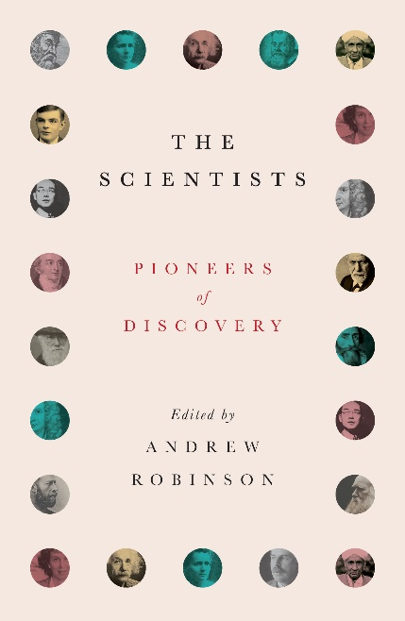
The Scientists: Pioneers of Discovery
Edited by Andrew Robinson

12 January 2023
27 illustrations | £12.99

Forty articles expertly curated by biographer Andrew Robinson provide an unrivalled account of the lives and personalities behind the greatest scientific breakthroughs of all time.

Who made us see the atom, our minds, our planet and the universe afresh?

How did we uncover the mysteries of life on earth? What next?

The theories, discoveries and inventions of scientists have revolutionized our consciousness.

Think of gravity, evolution, relativity, radioactivity and the Big Bang; electric motors, vaccines, nuclear power and computers.

Behind these breakthroughs lie the personal stories of men and women with vision and determination: singular thinkers who defied adversity in their quest for answers.

Now in paperback, this book tells the remarkable lives of the pioneers – from Galileo, Faraday and Darwin, through Pasteur and Marie Curie, to Einstein, Freud and Turing.

Written by an international team of distinguished scientists, historians and science writers, it will intrigue budding scientists; those fascinated by the lives of great individuals; and anyone curious to know how we came to understand the exterior world and the pulse of life within.

Praise for The Scientists:

‘Excellent ... of broad interest to scientists and non-scientists alike’ The Lancet

‘A sampler of the driven, complex, fascinating characters who fomented scientific revolutions’ Nature

Andrew Robinson is the author of twenty-five books in the arts and sciences, including biographies of Albert Einstein, Thomas Young, Michael Ventris and Jean-François Champollion. He holds degrees from Oxford University and the School of Oriental and African Studies, London, has been a Visiting Fellow of Wolfson College, Cambridge, and is currently a Fellow of the Royal Asiatic Society.

