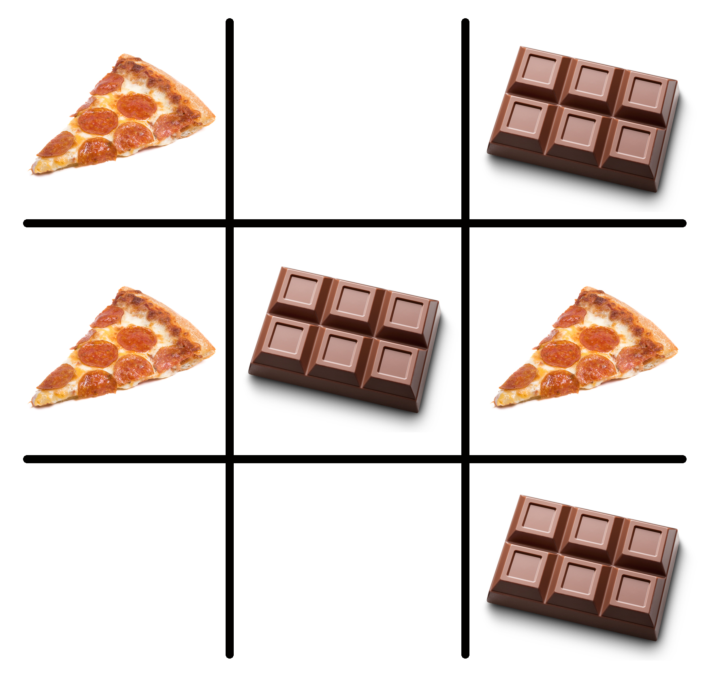

Just part of your comprehensive wellness program. Find out more at www.empowerlinc.com or call a health coach today at 888.882.LINC (5462).



Ubody

aN individualized and effective weight management program

WILL U

BE A

LOSER?