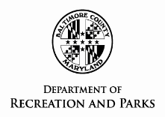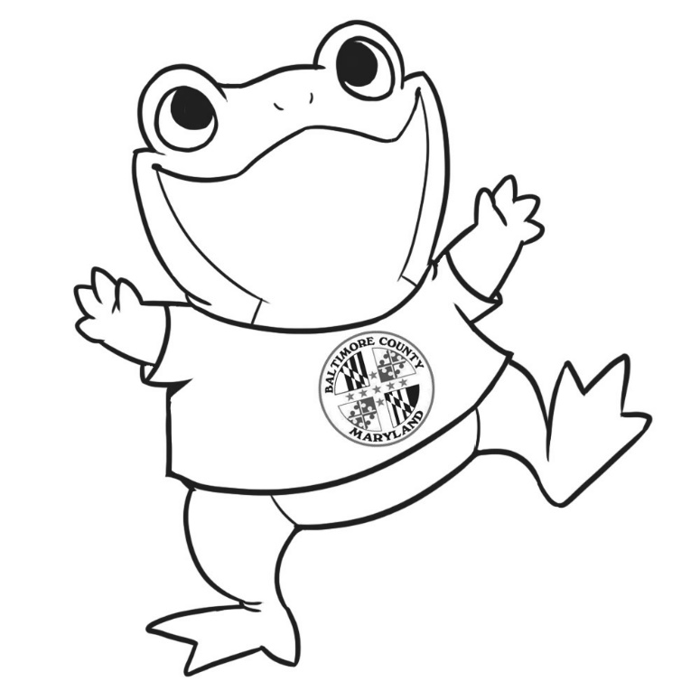

**\* Print your very own** Parker the Frog **and bring with you on your adventures!**

**\* Take a selfie with** PARKER **at a Baltimore County Park to be eligible for a prize.**

**\* Prizes awarded to the participant whom visits the most Baltimore County Parks each month and submits a selfie to Parker@baltimorecountymd.gov.**

**\* One entry is valid per park per e-mail address.**

**\* Include *#inmyownparkyard* when sharing to social media to add to the fun!**

Should you require special accommodations (i.e. sign language interpreter, large print, etc.) please give as much notice as possible by calling the Recreation Office at 410-887-5194 or the Therapeutic Office at 410-887-5370 (voice) or 410-887-5319 (TT/Deaf).

In accordance with any current public health guidelines, please practice **\*Social Distancing\*** and **wear a mask (**when social distancing is not possible) whenever you are enjoying Baltimore County’s Parks.

Presenting…

**Parker the Frog!**

How many Baltimore County Parks has **PARKER** explored?

That is up to **YOU!**