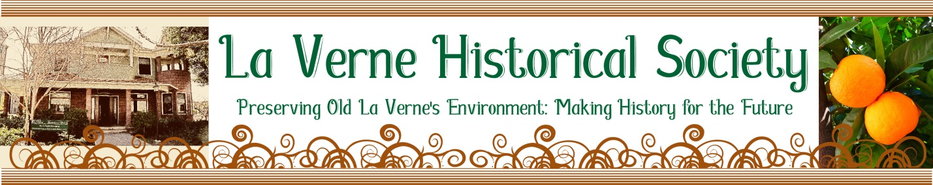

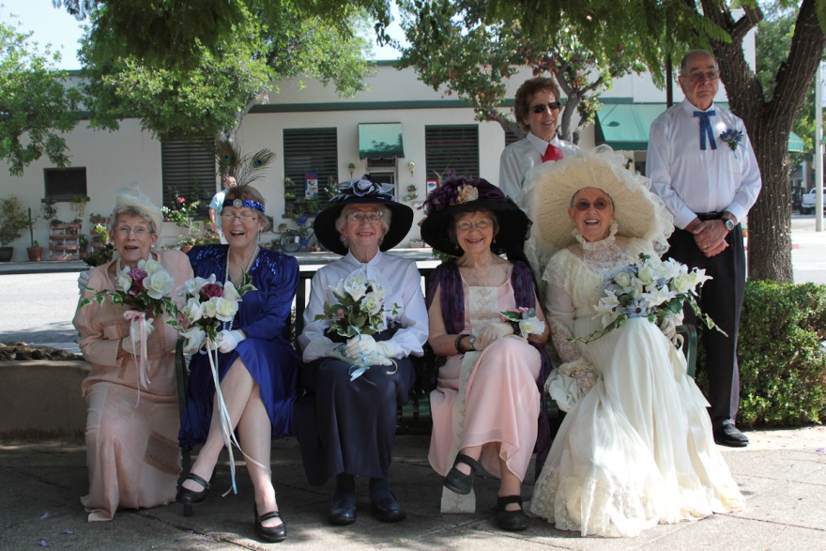
On August 19th, 2017, the LVHS, City of La Verne, & Hillcrest Thespians re-enacted the “Mock Wedding of Miss Lordsburg and Mr. La Verne.” In this photo, the bride (Letha Ressler) is accompanied by four of her six attendants (L to R: Gail Pellettera, Athena Pogue-Nasmyth, Harriett Harthorn, Paula Stanley) and the sign-bearers Lois and Louis LeBrun. Come to the LVHS Member and Community Meeting on October 9th, 2017 at 7:00pm to see a slide show of the re-enactment. Come join us at the Hillcrest Meeting House for a slide show & refreshments.

August Heatwave….LVHS Fun!
We had a “Hot Time in the Old Town Tonight” when Miss Lordsburg “married” Mr. La Verne on August 19th in a celebration of the 100th anniversary of the name change of our city. We had great attendance for this event that took place on Third and “D” Streets. Mayor Don Kendrick officiated as the “Justice of the Peace” and the audience waved “Lordsburg/La Verne pennants” and joined in with choral refrains. Special thanks go to Maria Wortham, who supervised costuming and wrote the script for the event and Skip Clague, Hillcrest Thespian Director, who put the actors through their paces. Chris Gendreau, owner of Chase’s Restaurant in La Verne, hosted our reception. Nothing Bundt Cakes provided sweet “bundtletts” to enjoy at the post-wedding reception celebration. Look for the LVHS Newsletter at the end of September with more wedding photos.

The LVHS hosted its annual Oldtimer’s Potluck Picnic at Heritage Park on Saturday, August 26th. Tours of the Weber House and tractor rides around the property. It was fun to catch up with LVHS friends.

September… the Party Continues!
What’s happening in September? Don’t forget to sign up to visit the Weymouth Treatment Plant on Tuesday, September 26th. Check the attached guidelines and sign up by September 19th. There will be an open house/reception on September 30th, hosted by Ed and Susan Hume, owners of the newest bronze marker designated house on 2607 Third Street. See the attached invitation for party particulars.

October…Weather Cools, LVHS Remains and Hottest Ticket in Town!
October will bring our fall Member and Community Meeting on October 9th at 7:00pm. Watch for a fall LVHS Newsletter and draft of the 2017-2018 calendar arriving at the end of September.

Sherry Best
Sherry Best, LVHS President

“Preserving Old La Verne’s Environment, Making History for the Future.”

