The Weekly Coach Don Jacobs Radio Show
Each week during the Scottsboro High School football season, 1050 WWIC will feature a 30-minute preview show with head coach Don Jacobs. The show will be presented LIVE from KC’s BBQ at County Park in Scottsboro Thursday nights from 6:00-6:30pm. Sponsorship includes (2) ads in each program and (8) ads throughout the week, Monday-Friday, 6am-6pm through the season.

Weekly Net Investment: Call for Information

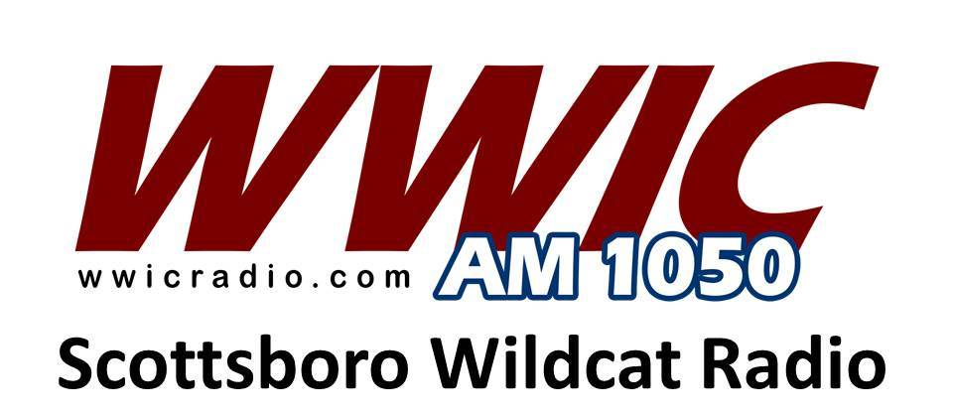

Scottsboro Wildcat Football
(Game Broadcasts)
This sponsorship includes (10) ads per week for the 2019 season schedule and possible playoff games. Four of the ads will be aired within the game broadcast each Friday night and the remaining six ads will be aired throughout the week, Monday through Friday during the same period.

Weekly Net Investment – Call for Information

Scottsboro Wildcat Football 2019
This sponsorship of Scottsboro Wildcat football on 1050 WWIC and WWIC-Radio-Dot-Com includes the following on Friday nights:
1 – ad in each Coaches Show Program
1 – ad in each Pre-Game Show before game
1 – ad in each Post-Game Show after game
2 – ads in High School Scoreboard Show
Ads in ESPN Radio College Game Day programming on Saturday’s during CFB season.

Monthly Investment: Call for Information

2019 Scottsboro Wildcat Football Schedule
8/23/19 – Fall Jamboree vs. Sylvania
8/30/19 – at Fort Payne Wildcats
9/6/19 – at Ardmore Tigers (Region)
9/13/19 – Guntersville Wildcats (Region)
9/20/19 – at East Limestone Indians (Region)
9/27/19 – North Jackson Chiefs
10/4/19 – at Madison County Tigers (Region)
10/11/19 – Arab Knights (Region)
10/18/19 – at Madison Acad. Mustangs (Region)
10/25/19 – Brewer Patriots (Region)
11/1/19 – Hartselle Tigers

Greg Bell – WWIC Radio (256-599-2433)

