PUBLIC HEARING/ REGULAR MEETING
DECEMBER 16, 2015
A Public Hearing and the Regular Meeting of the Town Board of the Town of Hampton, County of Washington and the State of New York was held at the Town Hall, 2629 State Route 22A, Hampton, New York on the 16th day of December, 2015.

PRESENT: David K. O’Brien------------Supervisor
Tamme Taran--------------- Councilwoman
David Jensen-----------------Councilman
Donald Sady-----------------Councilman
Andrea Sweeney------------Councilwoman
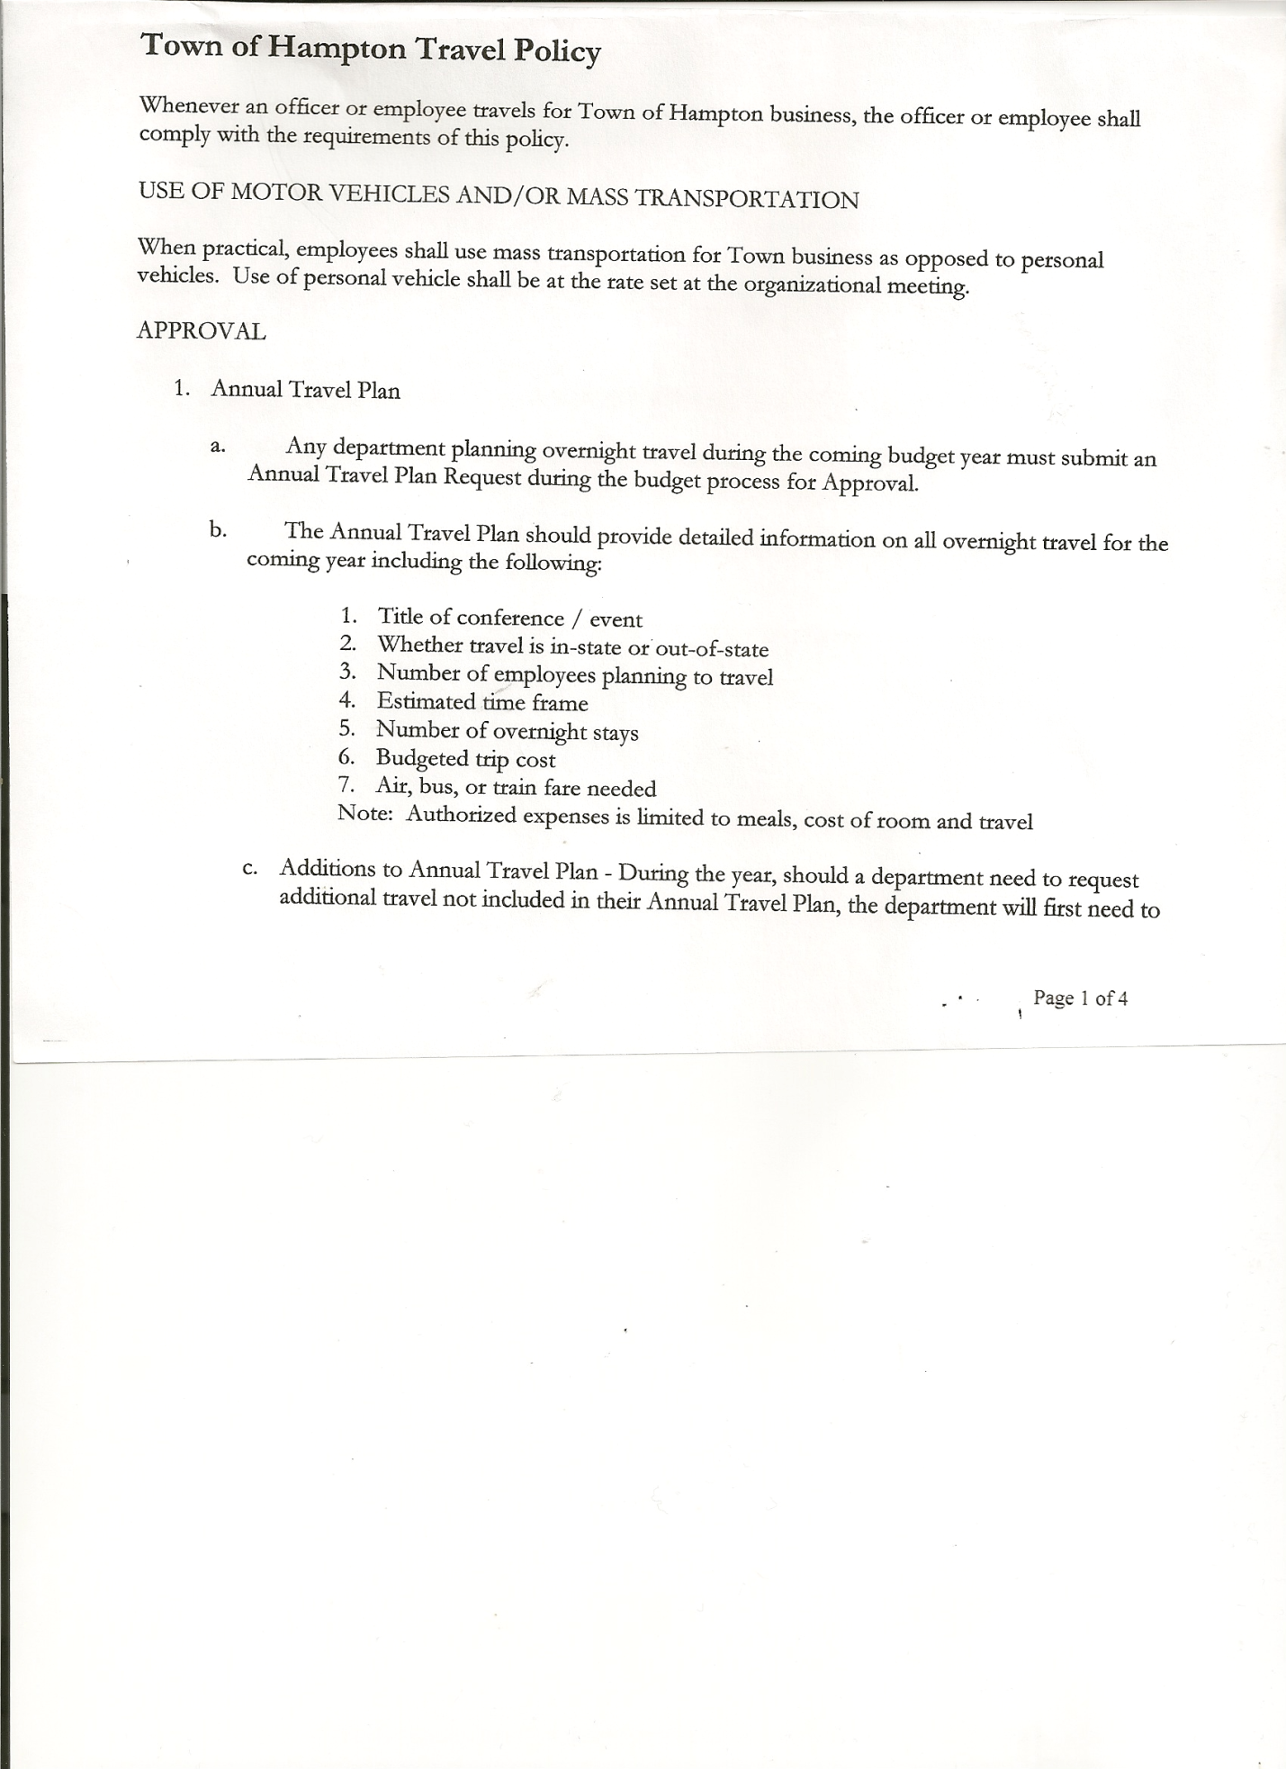
Rebecca Jones---------------Town Clerk
Camilla Shaw----------------Tax Collector/Deputy Town Clerk
Herbert Sady, Jr.-------------Highway Superintendent

Planning Board Members: Bonnie Hawley, Chair; Joe Hatfield and Dianne Sofia

Also present: See attached list

The Public Hearing was called to order by Supervisor O’Brien at 7:00pm.
Legal Notice of Public Hearing was read by Town Clerk Jones regarding the Town of Hampton’s Cemeteries.

Supervisor O’Brien opened the Public Hearing for discussion. Hampton Flats (Burdick) Cemetery could be for either full burial or cremation, whereas the Warren Cemetery and Miller Cemetery would be for cremation only.
Matthew Pratt…inquired about how much research was done to make sure there weren’t any graves already there
Supervisor O’Brien/Councilwoman Taran responded…no old records can be found in regards to the open space/Charlie King, Funeral Director has also looked over the space, no stones, no corner points, no depressions in the soil.
Bonnie Hawley….supportive…thought it was a nice to do for those residents that wanted to be buried in their hometown
Leonard Reed….questioned the liability issue
Supervisor O’Brien stated the board would need to set up a Cemetery Association, establish rules and regulations
Councilman Sady…..asked who would do the digging/who would cover that cost and would the maintenance schedule of mowing and trimming need to be changed?
Supervisor O’Brien stated it would be part of the funeral cost thru the funeral director
Joe Hatfield…asked if there would be a deed/survey of cemetery lots
Supervisor O’Brien responded that there would be a plot plan, layout of cemetery, deed and a register will be kept
All persons desiring to be heard, having been heard, the Public Hearing was closed at 7:40pm

REGULAR MEETING
The Regular Meeting was called to order by Supervisor O’Brien at 7:40pm followed by the Pledge of Allegiance. Locations of Fire Exits were given.

Washington County Small Business Award… was awarded to Pattie’s Patch, Route 4, Hampton and a Happy 50th Anniversary to Lenny and Linda Reed on December 18th.

TOWN BOARD MEETING
December 16, 2015 PAGE 2

RESOLUTION NO. 85-2015
APPROVAL OF THE MINUTES
On a motion of Councilman Sady, seconded by Councilwoman Taran, the following resolution was ADOPTED: Ayes 5 O’Brien, Taran, Jensen, Sady, Sweeney
Nays 0
RESOLVED, that the Regular Town Board Minutes for November 18th, 2015 are approved.

Larry Carman, Dog Control Officer submitted his report, which was read by Supervisor O’Brien, copy of report is attached for 11/15/15-12/12/15. Supervisor O’Brien also handed out the cost comparisons of other towns and what they pay for dog control.

Camilla Shaw, Tax Collector-bills are being printed at the County and will be mailing out the end of December. Board members signed and dated bank reconciliation statement dated November 30th, 2015.

Planning Board Report…. Bonnie Hawley, Chair gave the report
- Bonnie, Dianne, Joe & Ed attended training in Hudson Falls for 4 hours
- Next Planning Board Meeting will be December 22nd, 2015 @7:00pm at the Town Hall

Herbert Sady, Jr., Highway Superintendent submitted his report, copy of which, is attached.

RESOLUTION NO. 86-2015
APPROVAL OF SUPERVISOR’S MONTHLY REPORT
On a motion of Councilman Sady, seconded by Councilwoman Sweeney, the following resolution was ADOPTED : Ayes 5 O’Brien, Taran, Jensen, Sady, Sweeney
Nays 0
RESOLVED that the Supervisor’s Monthly report be accepted as submitted for NOVEMBER 2015
10/31/15 11/30/15
ACCOUNT BALANCE RECEIPTS DISBURSEMENTS BALANCE
General Fund $ 62853.68 $ 4438.51 $ 11955.63 $ 55336.56
Highway Fund $ 84694.83 $ 3.39 $ 12541.46 $ 72156.76
Equipment Reserve $ 100200.33 $ 4.12 $ 0.00 $100204.45
Fire #1 $ 17017.23 $ .80 $ 0.00 $ 17018.03
Fire #2 $ 2377.00 $ 0.00 $ 0.00 $ 2377.00
Totals $267143.07 $ 4446.82 $ 24497.09 $247092.80

All Board Members present signed Supervisor’s Report.

TOWN BOARD MEETING
December 16, 2015 PAGE 3

RESOLUTION NO. 87-2015

MOTION BY: Councilwoman Taran
SECONDED BY: Councilman Jensen

TITLE: RESOLUTION FOR THE USE OF THE BURIAL GROUNDS AT THE HAMPTON FLATS CEMETERY, THE MILLER CEMETERY, AND
THE WARREN CEMETERY

BE IT RESOLVED by the Town Board (the “Board”) of the Town of Hampton (the “Town”), in the County of Washington, on this 16th day of December, 2015, as follows:

WHEREAS, by resolution of the Town Board dated October 21, 2015, the Town of Hampton recognized and accepting the following public cemeteries commonly known as Hampton Flats Cemetery, Hooker Cemetery, Miller Cemetery, and Warren Cemetery and in doing so assumed the control and maintenance of the same; and

WHEREAS, by the same resolution, where space is available, the Town Board of the Town of Hampton approved the opening of the following public cemeteries commonly known as Hampton Flats Cemetery, Hooker Cemetery, Miller Cemetery, and Warren Cemetery for uses once again as burying grounds; and

WHEREAS, the Miller Cemetery, the Warren Cemetery and the Hampton Flats Cemetery all have available burial plots and there is public demand for the opening of these cemeteries once again for public burials; and

WHEREAS, pursuant to NYS Town Law section 290, the Town Board of the Town of Hampton is desirous of laying out burial lots in the aforementioned cemeteries, designating available plots, and offering for sale those available burial lots; and

WHEREAS, all monies realized from the sale of burial lots shall be paid over to the town to be retained as a separate fund to provide for the care and maintenance of the cemetery.

NOW, THEREFORE BE IT RESOLVED by the Town Board as follows:

RESOLVED, the Town Board, upon due deliberation hereby finds that the following cemeteries shall be opening to public burials: Hampton Flats Cemetery, Miller Cemetery, and Warren Cemetery; and be it further

RESOLVED, the Town Board hereby finds that the burial lots located at Hampton Flats Cemetery, Miller Cemetery, and Warren Cemetery shall be located and recorded in the Washington County Clerk’s Office, with available burial lots being identified thereon; and be it further

TOWN BOARD MEETING
December 16, 2015 PAGE 4

RESOLVED, the Town of Hampton shall sell and convey those certain burial lots in the referenced cemeteries upon a resolution of a majority of the Town Board approving the same and at such time authorize the Supervisor to execute the necessary deeds and transfer documents; and be it further

RESOLVED, the sale of burial lots shall be performed on a first-come first-serve basis for a fee to be established by resolution of the Town Board of the Town of Hampton; and be it further

RESOLVED, the fee for a burial lots where the burial plot is to be used for burying cremated remains shall be Two Hundred Dollars ($200.00) and the fee for a burial lot to be used for burying remains shall be Five Hundred Dollars ($500.00); and be it further

RESOLVED, all monies realized from the sale of burial lots shall be paid over to the town to be retained as a separate fund to provide for the care and maintenance of the cemetery; and be it further

RESOLVED, that any funds received in trust for the perpetual care of private burial lots will be held as trust funds subject to the terms and conditions contained therein; and be it further

RESOLVED, the Town Board may by resolution from time to time adopt rules and regulations to control and regulate the sale, maintenance, and operation of the public cemeteries of the Town of Hampton; and be it further

RESOLVED, this resolution shall take effect immediately.

DATED: December 16, 2015 Supervisor David O’Brien AYE
Councilwoman Tamme Taran AYE
Councilman David Jensen AYE
Councilman Donald Sady AYE
Councilwoman Andrea Sweeney AYE

Received signed contracts back from Hampton Fire Department and Fair Haven Fire Department.

NEW BUSINESS: The following items need to be reviewed:
- Current Policies
- Dog Law
- Local Law 2 of 1991 (Subdivision Law)
- Highway Employees Hours of Operation Law

The Town Clerk’s report for November 2015 was submitted to the Board. The Town Clerk had Board Members review and sign bank reconciliation statements for the Town Clerk Account and Special Town Clerk Account dated November 30th, 2015.

TOWN BOARD MEETING
December 16, 2015 PAGE 5

RESOLUTION NO. 88-2015

AUDIT OF CLAIMS
On a motion of Councilwoman Sweeney, seconded by Councilwoman Taran the following resolution was ADOPTED Ayes 5 O’Brien, Taran, Jensen, Sady, Sweeney
Nays 0
RESOLVED that the bills have been reviewed by the Town Board and are authorized for payment in the following amounts.
General Fund No. 150 through No. 161 $ 2283.37
Highway Fund No. 112 through No. 119 $ 4913.41
Total both funds $ 7196.78

On a motion of Councilwoman Taran, seconded by Councilwoman Sweeney, the meeting adjourned at 8:05pm. All in favor Aye.

Respectfully submitted,

Rebecca S. Jones, RMC
Town Clerk

