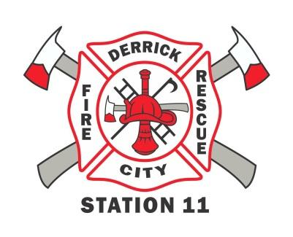
Derrick City Volunteer Fire Department
“Feel the Burn” (in COLOR)
5K Run and Walk
February 27th, 2019

Dear Potential Sponsor:

Derrick City Volunteer Fire Department will be hosting its annual “Feel the Burn” 5K Run/Walk on August 10th, 2019. It will be in COLOR! The event will be held at the Derrick City Volunteer Fire Department at 451 Derrick Road with open registration starting at 8AM. All proceeds of the race will support Derrick City Volunteer Fire Department. Specifically, funds raised will be used towards the purchase of a new fire engine.

We are asking you to support this year’s event by monetary donation. Attached, you will find the form to be filled out with the amount of your donation, your name, your business (if applicable), and your contact information. We ask that donations be made no later than July 29th so that we can get our shirts made and make sure that you are recognized as a sponsor.

Any contribution made to the Derrick City Volunteer Fire Department is greatly appreciated. If you wish to be a 2019 sponsor please fill out the section below and return it with your donation. For your tax purposes, our Pennsylvania Tax I.D. number is 25-6056755. For more information about us or opportunities to support our non-profit (503-C) organization you can visit us at www.dcvfd.com.

Thank you!

Sierra Campbell
Vice President/EMT-B/FF
Derrick City “Feel the Burn” (IN COLOR) 5K Walk/Run Donation Form:

Please complete and mail to: Derrick City Volunteer Fire Department, P.O. Box 58, Derrick City, PA 16727, ATTN: Sierra Campbell. Checks can be made out to Derrick City Volunteer Fire Department. Thank you again!

Donor First Name Last Name Business Name

Street Address City State Zip

E-mail (if applicable) Phone Amount donated/Signature

