FALL 2018

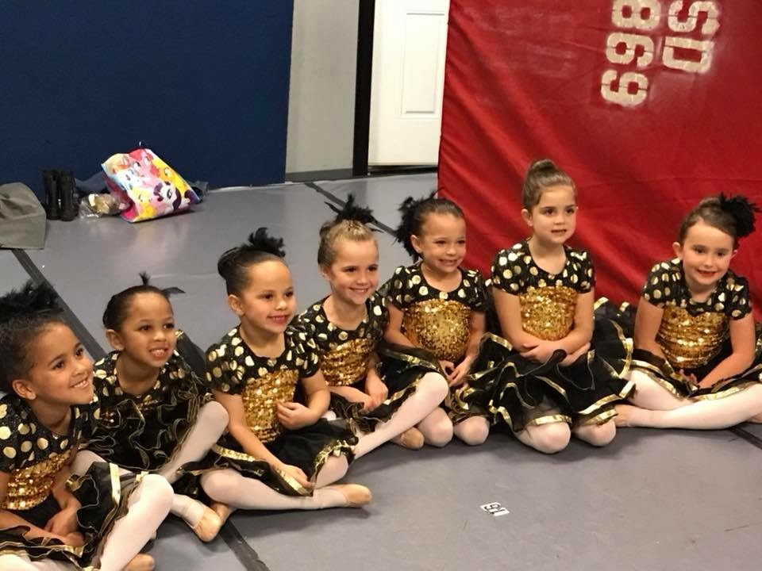

Fall classes will be online by May 19th & summer classes are online now. It is time to start a new dance year. Look through our classes and see what fun we are going to have as we begin our 20th season as Next Step Dance.

**RECITAL 2018**

**EVERYBODY DANCE NOW**

**This year we have separated our recital into mini shows for your convenience.**

**1:00pm Our Tiny Steppers (2-4)**

**1:45pm Competition Showcase**

**2:30pm Tumble Students**

**3:00pm Lion King Ballet**

**3:45pm Main Show**

**Everybody Dance Now**



**Don’t forget your favorite dancer on recital day! Order forms for recital flowers can be picked up at the front desk.**

C:\Users\Stephanie\Pictures\Microsoft Clip Organizer\j0416014.wmfC:\Users\Stephanie\Pictures\Microsoft Clip Organizer\j0416014.wmfC:\Users\Stephanie\Pictures\Microsoft Clip Organizer\j0416014.wmf

**#student of the month** C:\Users\Stephanie\Pictures\Microsoft Clip Organizer\j0416014.wmf

***OUR SENIORS***

**Congratulations**

**to our graduating seniors:**

**\*Kailey Baez\***

**\*Alonnah Murphy\***

**\*Carly VanDewark\***

**#nsdSummerSizzle**

**Don’t forget, July is the month to SIZZLE with Next Step Dance. Try something new or continue to work in your favorite class. This is a fun 4-week session that will add something extra to each class. You don’t want to miss out on the FUN! This is also a great time to schedule a private with one of our teachers to work on something specific you would like to master…..turns, back handspring, flexibility, or just some quality one on one time for a critique. NSD instructors love to work helping each individual student become the best they can be! Register by May 19th you get to Spin & Win!**



C:\Users\Stephanie\Pictures\Microsoft Clip Organizer\j0416014.wmf C:\Users\Stephanie\Pictures\Microsoft Clip Organizer\j0416014.wmf

Steppin’ into May/June 2018 with Next Step Dance

[**www.thenextstepnc.com**](http://www.thenextstepnc.com)

**7712 Sossamon Lane, NW Concord, NC 28027 (704) 786-7837 nsdcalendar@gmail.com**

**OPEN HOUSE!**

Time to think about summer activities and fall 2018! Have a friend or relative interested in dance? Have a younger sibling that will be old enough for our Tiny Steppers program? Find out schedules and all the important stuff at our Open House on Saturday, May 19, 2018 from 10:00am-1:00pm. There will be classes to tryout and informational sessions to learn more about Next Step Dance and what is happening with us for the rest of 2018.

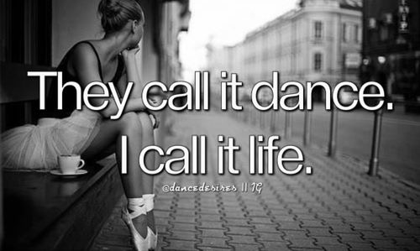

**SAVE THE DATE** C:\Users\Stephanie\Pictures\Microsoft Clip Organizer\j0416014.wmf

May 19th –10:00am-1:00pm

Open House-Register for Fall & Summer

May 28th- Memorial Day Studio Closed

June 15th- Dress Rehearsal

June 16th- Dance Recital

June 25th -Summer Camps begin

July 2nd- Summer classes begin

July 4th- Harrisburg 4th of July Parade

**REMEMBER TO JOIN US ON**

**Facebook, Twitter, & Instagram!**