**WELCOME TO HOLY SPIRIT**

**LUTHERAN CHURCH**

A Member of the Evangelical Lutheran Church in America, New Jersey Synod

1220 Bayshore Rd., Villas, NJ 08251

609-886-2414

holyspiritlutheran@comcast.net

holyspiritvillas.com

facebook.com/holyspiritvillas

Vicar Vince Piekarski can be contacted at any time through call or text at

412-225-0287 or through email at vpie8282@gmail.com.

**FIFTH SUNDAY AFTER EPIPHANY**

**SUNDAY, FEBRUARY 9TH, 2025**

**10:30AM WORSHIP SERVICE WITH HOLY COMMUNIO****N**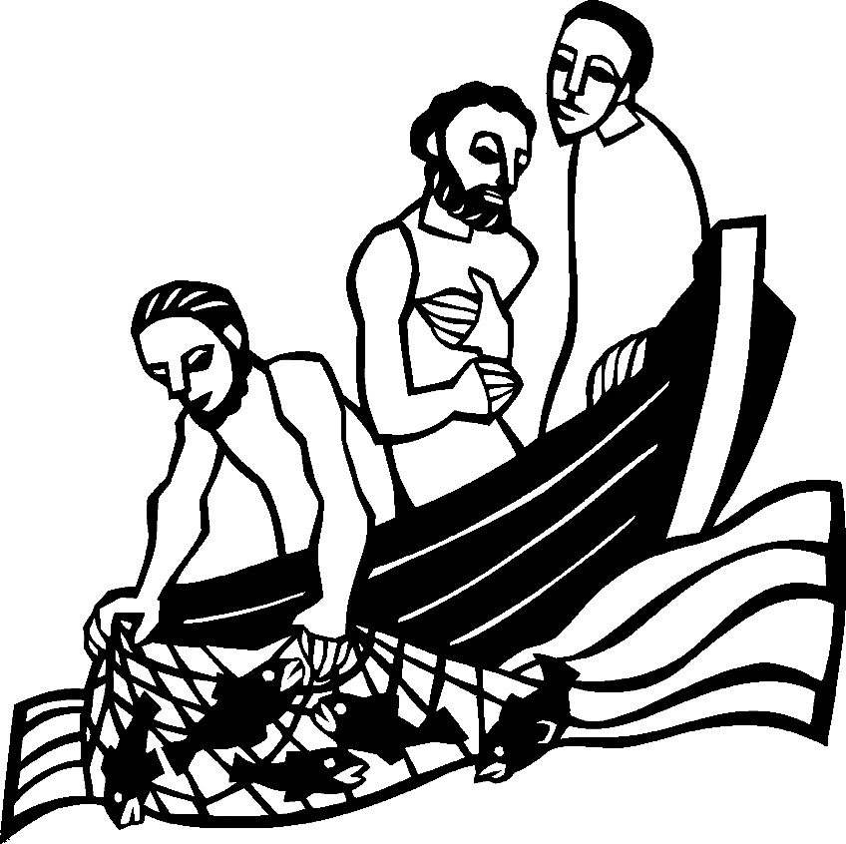



We, the Evangelical Lutheran Church of the Holy Spirit, are People of God, who

are called by the Holy Spirit to pray, worship, joyfully proclaim Jesus Christ,

and compassionately witness and serve others in Christian Love.

**AN ESPECIALLY WARM WELCOME TO OUR VISITORS**

We are glad that you joined us for Worship today! Thank you for enriching our time together! We would like to get to know you better, and we would like for you to get to know us better too. Brochures, welcome gifts, prayer shawls, Bibles, and other items are available at our welcome areas. Church members are happy to show you around and share about our ministries. Please don’t hesitate to speak up and ask questions. Please make sure you sign-in on our clipboard on the podium in the lobby.



We continue conducting our Worship Services in coordination with our Conference Call. Join us at our # 657-390-7423. If that does not allow you to gain access, please utilize our other # 701-802-5170 and access code 8221190, then hit the # key. You may need to dial 1 first, depending on your phone plan. After you log-in, please announce your name. Feel free to talk with others until we start our service.

**ARE YOU INTERESTED IN CANDLE MEMORIALS?**

Candles cost $10 each, and can be dedicated in memory of someone.

The Sign-up sheets are located on the bulletin board between the church offices.

Please feel free to see Vicar Vince with any questions.

**SANCTUARY CANDLE**

February’s is given to the Glory of God & in memory of

CLAIRE MILLER by Jean, Phil, & Bob Zimmerman.

**ALTAR CANDLES**

February’s are given to the Glory of God & in memory of

OLAF & REGINA by Carol Amundsen.

**CONFERENCE CALL CHECK-IN**

(Roll Call and Attendance)

**WELCOME & ANNOUNCEMENTS**

(Offered by Vicar, Assistant, and Congregation.)

**INTRODUCTION**

A. The fifth Sunday after Epiphany continues to highlight unlikely instruments and

circumstances appointed to reveal God’s glory. “Who will go for us?” God asks. A

person of unclean lips, a former persecutor of the church of God, and three

fishermen who couldn’t catch a thing. More surprising still, perhaps, is that we are

also called.

**PRELUDE**

(Music offered by our Organist before the start of our Worship Service.)

**Trumpet Tune**

**CHIMES**

(Music offered by our Organist before the start of our Worship Service.)

**Softly and Tenderly Jesus is Calling**

V. We invite you to stand if you are able.

**CONFESSION & FORGIVENESS**

(All may make the sign of the cross, the sign that is marked at baptism.)

V. Blessed be the holy Trinity, ☩ one God,

our creator,

our protector,

our wellspring of life.

**C. Amen.**

V. Trusting that God receives our words and the meditations of our hearts,

let us confess our sin.

(Silence is kept for reflection.)

V. Merciful God,

**C. you speak blessing and compassion into the world.**

**Forgive us for the ways we act**

**with judgment, cruelty, or indifference.**

**We ignore the needs of our neighbors;**

**we resist your call to oppose injustice;**

**we give in to scarcity and fear;**

**we assume the worst about one another.**

**Cleanse us from our faults**

**and release us from their grasp.**

**Show us your lovingkindness.**

**Restore our hearts and repair your world,**

**that we may live in Christ’s ways.**

**Amen.**

V. God proclaims these words of assurance:

“Do not fear, for I have redeemed you.

I have called you by name. You are mine.”

In ☩ Christ, you are forgiven.

In the Spirit, you are made free.

Refreshed by the waters of mercy,

live anew as beloved children of God.

**C. Amen.**

(We invite you to remain standing if you are able.)



**GATHERING HYMN**

(We invite you to sing along with the music offered by our Organist.)

Lutheran Book of Worship—Green Book

**165—Holy, Holy, Holy**



**APOSTOLIC GREETING**

V. May the grace of our Lord Jesus Christ, the love of God,

and the communion of the Holy Spirit be with you all.

**C. And also with you.**

**KYRIE**

V. In peace, let us pray to the Lord.

**C. Lord, have mercy.**

V. For the peace from above, and for our salvation, let us pray to the Lord.

**C. Lord, have mercy.**

V. For the peace of the whole world, for the well-being of the church of God,

and for the unity of all, let us pray to the Lord.

**C. Lord, have mercy.**

V. For this holy house, and for all who offer here their worship and praise,

let us pray to the Lord.

**C. Lord, have mercy.**

V. Help, save, comfort, and defend us, gracious Lord.

**C. Amen.**

**HYMN OF PRAISE**

C:\Users\vpie8\Downloads\LBW Setting Two Glory (Melody).tif



**PRAYER OF THE DAY**

V. The Lord be with you.

**C. And also with you.**

V. Let us pray,

Most holy God, the earth is filled with your glory, and before you angels and

saints stand in awe. Enlarge our vision to see your power at work in the world,

and by your grace make us heralds of your Son, Jesus Christ, our Savior and

Lord.

**C. Amen.**

V. We invite you to be seated for our Readings and Psalm.

**FIRST READING**

Through a vision in the temple, the eighth-century prophet Isaiah is called by God

to announce judgment against Israel. Aware of his sinfulness and shortcomings,

Isaiah is initially hesitant. But when God calls, Isaiah responds, “Here am I; send

me!”

R. Our First Reading is from the 6th Chapter of Isaiah (Verses 1-8 [9-13]).

R. 1 In the year that King Uzziah died, I saw the Lord sitting on a throne, high and

lofty, and the hem of his robe filled the temple. 2 Seraphs were in attendance

above him; each had six wings: with two they covered their faces, and with two

they covered their feet, and with two they flew. 3 And one called to another and

said,

  “Holy, holy, holy is the Lord of hosts;

  the whole earth is full of his glory.”

4 The pivots on the thresholds shook at the voices of those who called, and the

house filled with smoke. 5 And I said, “Woe is me! I am lost, for I am a man of

unclean lips, and I live among a people of unclean lips, yet my eyes have seen

the King, the Lord of hosts!”

6 Then one of the seraphs flew to me, holding a live coal that had been taken

from the altar with a pair of tongs. 7 The seraph touched my mouth with it and

said, “Now that this has touched your lips, your guilt has departed and your sin is

blotted out.” 8 Then I heard the voice of the Lord saying, “Whom shall I send, and

who will go for us?” And I said, “Here am I; send me!” [9 And he said, “Go and

say to this people:

  ‘Keep listening, but do not comprehend;

  keep looking, but do not understand.’

  10 Make the mind of this people dull,

   and stop their ears,

   and shut their eyes,

  so that they may not look with their eyes

   and listen with their ears

  and comprehend with their minds

   and turn and be healed.”

  11 Then I said, “How long, O Lord?” And he said,

  “Until cities lie waste

   without inhabitant,

  and houses without people,

   and the land is utterly desolate;

  12 until the Lord sends everyone far away,

   and vast is the emptiness in the midst of the land.

  13 Even if a tenth part remain in it,

   it will be burned again,

  like a terebinth or an oak

   whose stump remains standing

   when it is felled.”

  (The holy seed is its stump.)]

R. This is the Word of the Lord.

**C. Thanks be to God.**

**PSALM**

R. Our Responsorial Psalm is from 138th Psalm.

**C.** **I will bow down toward your holy temple.** (Ps. 138:2)

R. 1 I will give thanks to you, O Lord, with my whole heart;

   before the gods I will sing your praise.

  2 I will bow down toward your holy temple and praise your name, because of your

steadfast love and faithfulness;

   for you have glorified your name and your word above all things.

**C. I will bow down toward your holy temple.** (Ps. 138:2)

R. 3 When I called, you answered me;

   you increased my strength within me.

  4 All the rulers of the earth will praise you, O Lord,

   when they have heard the words of your mouth.

  5 They will sing of the ways of the Lord,

   that great is the glory of the Lord.

  6 The Lord is high, yet cares for the lowly,

   perceiving the haughty from afar.

**C. I will bow down toward your holy temple.** (Ps. 138:2)

R. 7 Though I walk in the midst of trouble, you keep me safe;

   you stretch forth your hand against the fury of my enemies;

your right hand shall save me.

  8 You will make good your purpose for me;

   O Lord, your steadfast love endures forever;

do not abandon the works of your hands.

**C. I will bow down toward your holy temple.** (Ps. 138:2)

**SECOND READING**

Paul delivers in a nutshell the story of the gospel that was given to him. In the

lineage of the Christian faith, we have received the good news of God’s love from

generations of believers before us, and we continue to tell this story to the world.

R. Our Second Reading is from the 15th Chapter of 1st Corinthians (Verses 1-11).

R. 1 Now I want you to understand, brothers and sisters, the good news that I

proclaimed to you, which you in turn received, in which also you stand, 2 through

which also you are being saved, if you hold firmly to the message that I

proclaimed to you—unless you have come to believe in vain.

3 For I handed on to you as of first importance what I in turn had received: that

Christ died for our sins in accordance with the scriptures 4 and that he was buried

and that he was raised on the third day in accordance with the scriptures 5 and

that he appeared to Cephas, then to the twelve. 6 Then he appeared to more

than five hundred brothers and sisters at one time, most of whom are still alive,

though some have died. 7 Then he appeared to James, then to all the apostles.

8 Last of all, as to one untimely born, he appeared also to me. 9 For I am the least

of the apostles, unfit to be called an apostle, because I persecuted the church of

God. 10 But by the grace of God I am what I am, and his grace toward me has

not been in vain. On the contrary, I worked harder than any of them, though it

was not I but the grace of God that is with me. 11 Whether then it was I or they,

so we proclaim and so you believed.

R. This is the Word of the Lord.

**C. Thanks be to God.**

V. We invite you to stand if you are able, and I invite you to announce the Gospel

Acclamation with me.

**GOSPEL ACCLAMATION**

**C. Alleluia. Jesus says, Follow me, and I will make you fish for people. Alleluia.**

(Matt. 4:19)

**GOSPEL READING**

Jesus’ teaching of God’s word has begun to draw great crowds. For Simon,

James, and John, Jesus’ teaching inspires hospitality, then obedience, and then

risk. After Jesus’ creative power is revealed, fear and amazement leads these

three fishermen to leave everything behind to become apostles.

V. The Holy Gospel According to Luke, the 5th Chapter (Verses 1-11).

**C. Glory to you, O Lord.**

V. 1 Once while Jesus was standing beside the Lake of Gennesaret and the crowd

was pressing in on him to hear the word of God, 2 he saw two boats there at the

shore of the lake; the fishermen had gotten out of them and were washing their

nets. 3 He got into one of the boats, the one belonging to Simon, and asked him

to put out a little way from the shore. Then he sat down and taught the crowds

from the boat. 4 When he had finished speaking, he said to Simon, “Put out into

the deep water and let down your nets for a catch.” 5 Simon answered, “Master,

we have worked all night long but have caught nothing. Yet if you say so, I will let

down the nets.” 6 When they had done this, they caught so many fish that their

nets were beginning to burst. 7 So they signaled their partners in the other boat to

come and help them. And they came and filled both boats, so that they began to

sink. 8 But when Simon Peter saw it, he fell down at Jesus’s knees, saying, “Go

away from me, Lord, for I am a sinful man!” 9 For he and all who were with him

were astounded at the catch of fish that they had taken, 10 and so also were

James and John, sons of Zebedee, who were partners with Simon. Then Jesus

said to Simon, “Do not be afraid; from now on you will be catching people.”

11 When they had brought their boats to shore, they left everything and followed

him.

V. This is the Gospel of the Lord,

**C. Praise to you, O Christ.**

(We invite you to be seated.)

**SERMON**

(Delivered by Vicar Vince Piekarski.)

(Following the Sermon, we invite you to stand if you are able.)



**HYMN OF THE DAY**

(We invite you to sing along with the music offered by our Organist.)

Lutheran Book of Worship—Green Book

**242—Let the Whole Creation Cry**

**APOSTLES’ CREED**

V. God has made us his people through our Baptism into Christ. Living together in

trust and hope let us confess our faith together using the Apostles’ Creed.

**C. I believe in God, the Father almighty,**

**creator of heaven and earth.**

**I believe in Jesus Christ, God’s only Son, our Lord,**

**who was conceived by the Holy Spirit,**

**born of the Virgin Mary,**

**suffered under Pontius Pilate,**

**was crucified, died, and was buried;**

**he descended to the dead.**

**On the third day he rose again;**

**he ascended into heaven,**

**he is seated at the right hand of the Father,**

**and he will come to judge the living and the dead.**

**I believe in the Holy Spirit,**

**the holy catholic church,**

**the communion of saints,**

**the forgiveness of sins,**

**the resurrection of the body,**

**and the life everlasting. Amen.**



**PRAYERS OF INTERCESSION**

(The prayers are prepared locally for each occasion.)

V. With the Spirit of Christ shining upon us, let us boldly pray for the church, the

world, and all of creation.

(A brief silence.)

A. God of surprising abundance, you call your people to enter deeply into the world.

Equip us to respond to your call, gather up what we have, and offer it to all. God

of grace,

**C. hear our prayer.**

A. God of creation, provide protection from the elements and other hazards to all

whose work brings them outside: for fishers, ranchers, line workers, and

construction crews. Guide us to live carefully alongside the wonders of the land

and waters. God of grace,

**C. hear our prayer.**

A. Open the hearts of all leaders, especially those who serve in the armed forces,

that they respond to their commission with wisdom and patience. Ensure that all

who serve are kept safe in body, mind, and spirit. We pray for an end to all war

and armed conflict. God of grace,

**C. hear our prayer.**

A. Fill with your compassionate presence all who are suffering from addiction,

mental illness, injury, or illness of any kind; especially:

Betty Lang (Church Member)

BettyAnn Rich-White (Church Member)

Chip Hand (Church Member)

Lynn Bargstadt (Church Member)

Sharon Ford (Church Member)

Carol Amundsen (Church Member)

Kim McGinley (Church Member)

Marie Hand (Church Member)

Frank Ford (Church Member)

Blanche Cameron (Church Member)

Eric Dishman (Church Family)

Joan Sommerman (Church Family)

Arleen Kinka (Church Family)

Megan Pratz (Betty Lang’s Friend)

Patty Cioce (Betty Lang’s Friend)

Carla Wagner (Betty Lang’s Family)

Beth & Bill Knapp (Betty Lang’s Family)

Bill Kanass (Betty Lang's Family)

Ed Borse (Betty Lang’s Friend)

Kali Poe (Betty Lang's Family)

Linda Dressic (Carol Detweiler's Family)

Suzie Clark (Rose Lang's Friend)

Evy (Betty Lang's Friend)

Cindy Irana (Betty Lang’s Friend)

Ed Watson (Betty Lang's Friend)

Francis Clock (Dianna DeNote’s Family)

Andrew Hudak (Rose Lang’s Friend)

Fred Lang (Betty Lang’s Family)

Viena Murtha (Bob Fritsch’s Friend)

Sharon Waicus (Skip & Bonnie Millard's Friend)

Karen O'Brien (Paul Bowker's Friend)

Dustin Irizzary (Mary Melnicoff's Family)

Joan Brown (Betty Lang's Friend)

Donna Bradley (Betty Lang's Friend)

Theresa Marioti (Betty Lang's Friend)

The Bryan Family (Wanda Bryan's Family)

Ernie Kinzler (Marie Hand & Doreen Kinzler’s Family)

Craig Brearey (Judy Brannan & Mary Melnicoff's Friend)

Sarah Dutton (Frank & Sharon Ford's Family)

Christina McNasby (Fran Green’s Family)

The Kinkson Family (Judy Brannan's Friends)

Mark Stephen Dennis (Diana DeNote's Family)

Dellie Valcourt (Skip & Bonnie Millard's Family)

Joyce (Betty Lang's Family)

Hannah (Betty Lang's Family)

Donna Lee (Betty Lang's Friend)

Bill Lodge (Skip & Bonnie Millard's Friend)

Patrick & Denise Brannan (Judy Brannan's Family)

Ron Anderson (Bill Kelly's Friend)

Jerry P (Wanda Bryan's Friend)

Pat Labrae (Kathy Poehler's Friend)

Bud Brearey (Judy Brannan & Mary Melnicoff's Friend)

Mary Skain (Kathy Poehler's Friend)

Bill Rand (Wayne & Eleanor Rand's Family)

Kevin Naylor (Vicki Rinier's Friend)

Robert Chaplin (Mary Melnicoff's Friend)

Jack Wieckouski (Theresa & Kim McGinley's Family)

Rick (Carol Amundsen's Friend)

Vera (Carol Amundsen's Friend)

Carolyn Santarpio (Bob Fritsch's Friend)

Cathy Hines (Rose Lang's Friend)

Ken Mortensen (Del McKenna's Family)

Harry (Judy Brannan's Friend)

Janet K (Philomena Noak's Friend)

Michael Hart (Diana DeNote's Friend)

Rocco Leonard DeNote (Diana DeNote's Family)

Spencer Oditt (Butch Poehler's Family)

Julie Schlereth (Diana DeNote's Friend)

Al Singer & Family (Frank & Sharon Ford's Friends)

Sherri Lynn (Bob Fritsch's Friend)

John Bannco (Bob Fritsch's Friend)

Nancy Pazarinie (Bob Fritsch's Family)

Makayla Wollaver (Kathy Poehler's Friend)

Arthretta Crandell (Heather & Vicar Vince Piekarski's Friend)

Mary Pat Parsons (Vicki Rinier's Friend)

Jane & Paul Eiben (Rose Lang's Friend)

​ Lou & Jean Marcucci (Wayne Rand's Friend)

Joe DiMassimo (Judy Brannan & Mary Melnicoff's Friend)

Vivian (Mesher Family Member)

Tommy Stanford (Sue Waltz's Family)

Audrey McAlister (Sue Waltz's Family)

Joe Waltz (Sue Waltz's Family)

(Additional Names Added Prior to the Worship Service.)

A. Draw helpers to their side so that they find relief from their burdens. God of grace,

**C. hear our prayer.**

A. Call our faith communities to do marvelous things. Bless the labor and efforts of

this congregation, that we may be a sign of your presence in the world. God of

grace,

**C. hear our prayer.**

A. We thank you for those who have courageously gone before us in the faith. May

we too show a deep trust in you throughout our lives. God of grace,

**C. hear our prayer.**

(Here other intercessions may be offered.)

V. Watch over all of us who are worried and suffering, and especially those whose

names we now say aloud or hold within our hearts (extended pause).

V. God of grace,

**C. hear our prayer.**

V. We entrust our prayers to you, O God, in the sure and certain hope that your

promise is revealed among the people.

**C. Amen.**

**SHARING OF THE PEACE**

V. May the peace of the Lord be with you always.

**C. And also with you.**

V. Let us share God’s Peace with one another.



(Please remain in your pews and offer the sign of peace with a peace sign or wave.)

V. We invite you to be seated.

**ANTHEM**

(Special Music for Everyone to Enjoy.)

**Lord, You Have Come to The Lakeshore**

**OFFERING**

V. We now worship God with our tithes and offerings, wine and bread for use in holy

communion, and monetary gifts to support our ministry for service in God’s name.

Our Ushers will be around to your pews to pass the Offering Plates.

(Ushers come forward to get the Offering Plates from the Assistant.)

(Vicar and Assistant prepare the Altar for Communion.)

**OFFERING SONG**

(We invite you to sing along with the music offered by our Organist.)

Evangelical Lutheran Worship—677

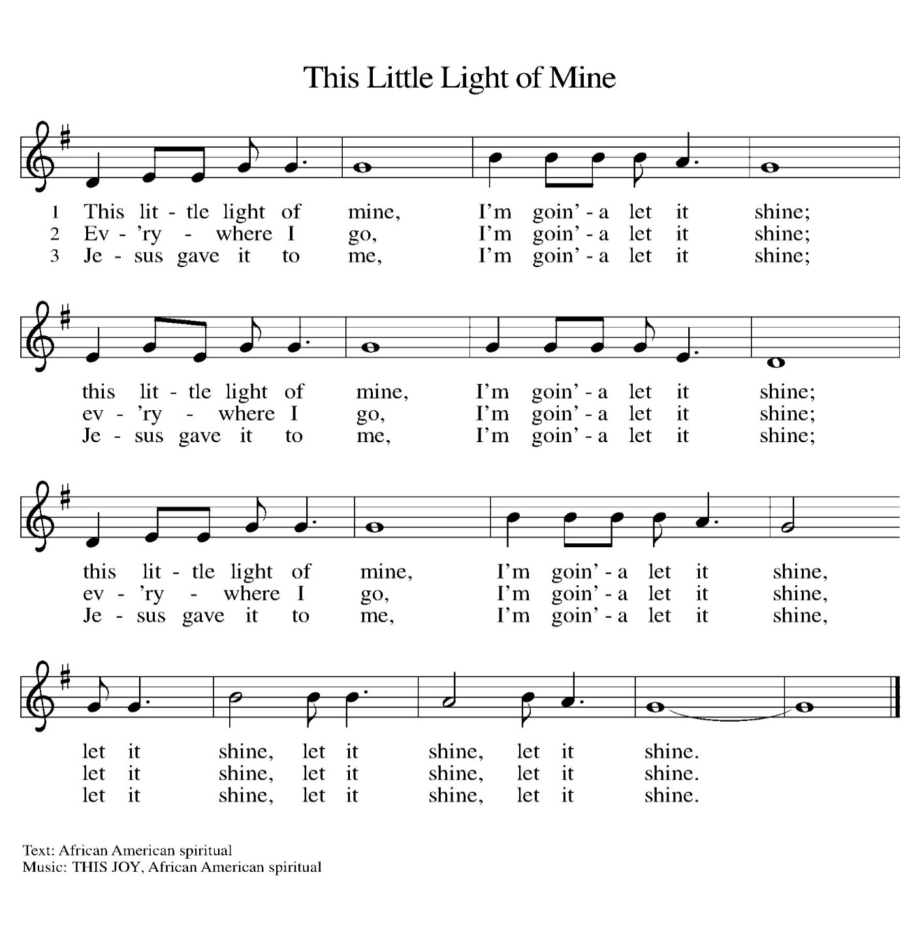

(Usher(s) brings the Tithes and Offerings up front to the Assistant.)

V. We invite you to stand if you are able.

**OFFERING PRAYER**

V. Let us pray,

God of grace, your love reaches to the heavens,

and your abundance to the depths of the seas.

Bless what we offer to your service:

our gifts, our abilities, and our hearts.

Let us overflow with gratitude and generosity,

now and always.

**C. Amen.**

**GREAT THANKSGIVING**

V. The Lord be with you.

**C. And also with you.**

V. Lift up your hearts.

**C. We lift them to the Lord.**

V. Let us give thanks to the Lord our God.

**C. It is right to give him thanks and praise.**

V. It is indeed right and salutary that we should at all times and in all places offer

thanks and praise to you, O Lord, holy Father, through Christ our Lord; who rose

beyond the bounds of death and, as he promised, poured out your Spirit of life

and power upon the chosen disciples. At this the whole earth exults in boundless

joy. And so, with the Church on earth and the hosts of heaven, we praise your

name and join their unending hymn:

**SANCTUS**

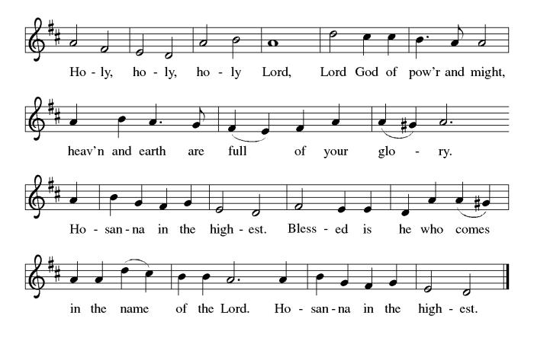

**THE EUCHARISTIC PRAYER**

V. Blessed are you, Lord of heaven and earth, in mercy for our fallen world you gave

your only Son, that all those who believe in Him should not perish, but have

eternal life. We give thanks to you for the salvation you have prepared for us

through Jesus Christ. Send now your Holy Spirit into our hearts that we may

receive our Lord with a living faith as He comes to us in His holy supper.

**C. Amen. Come, Lord Jesus.**

V. In the night in which he was betrayed our Lord Jesus took bread,

he gave thanks; broke it, and gave it to his disciples, saying:

*Take and eat; this is my body, given for you.*

*Do this for the remembrance of me.*



V. Again, after supper, He took the cup, he gave thanks,

and gave it for all to drink, saying:

*This cup is the new covenant in my blood,*

*shed for you and for all people for the forgiveness of sin.*

*Do this for the remembrance of me.*



**THE LORD’S PRAYER**

(We ring the bell throughout the Lord’s Prayer at all services to

invite those in the community to join in praying the Lord’s Prayer.)

V. May we now join with one another and pray together as Jesus has taught us.

**C. Our Father, who art in heaven, hallowed be thy name, thy kingdom come,**

**thy will be done, on earth as it is in heaven. Give us this day our daily**

**bread; and forgive us our trespasses, as we forgive those who trespass**

**against us; and lead us not into temptation, but deliver us from evil. For**

**thine is the kingdom, and the power, and the glory, forever and ever.**

**Amen.**

**LAMB OF GOD**

**C:\Users\Vince and Heather\Downloads\Lamb of God, ELW Setting Four (Melody).tif**

V. We invite you to be seated.

**HOLY COMMUNION**

V. Communion here is pretty simple, and all who believe in Jesus Christ are

welcome at this very table. We utilize bread (or wafers), and we also have the

option of individually wrapped gluten free wafers. We have pre-filled red wine or

white grape juice cups in the Communion Tray to choose from.

The Usher will offer the option to leave your pew, and you can proceed forward

on the right side of the aisle to the steps between the Communion Rail. Following

Communion, please process back on the left side of the aisle and place your

empty cups in the basket before returning to your pew. Children who have not

had their First Communion instruction, and adults who do not wish to receive

Communion, are welcome to come forward and give me a sign to obtain a

special blessing.

If you are unable to leave your pew for health or other related reasons, please

inform the Usher of your desire to remain in your pew and have us come to you.

**INVITATION TO COMMUNION**

V. The joy of the Lord is our strength.

Come, eat this meal of gladness.

**C. Amen.**

(Distribution of Holy Communion)

**COMMUNION HYMN**

(Please enjoy various music offered by our Organist during your

quiet time, prayer, and reflection following Holy Communion.)

(Vicar and Assistant remove Communion Vessels from the Altar.)

V. Let us stand as we are able.

**POST COMMUNION BLESSING**

V. May the body and blood of our Lord Jesus Christ strengthen us and keep us

always in His grace.

**C. Amen.**

**POST COMMUNION CANTICLE**





**PRAYER AFTER COMMUNION**

A. Let us pray,

Nourishing God,

at this table you have refreshed us

with holy gifts of food and drink.

Strengthen us for service,

and send us out to embody your good news

of liberation and healing for the sake of the world.

In the name of Christ we pray,

**C. Amen.**

**BLESSING**

V. The Spirit of the triune God

☩ bless you with joy,

anoint you with compassion,

and send you in love.

**C. Amen.**

(We invite you to remain standing if you are able.)



**SENDING HYMN**

(We invite you to sing along with the music offered by our Organist.)

With One Voice—Blue Book

**752—I, the Lord of Sea and Sky Here I Am, Lord**

(Assistant extinguishes the Altar Candles half way through the Sending Hymn.)

(Vicar processes out once the Altar Candles have been extinguished.)

(We invite you to be seated.)

**BIRTHDAYS, ANNIVERSARIES,**

**& ADDITIONAL ANNOUNCEMENTS**

(Offered by Assistant and Congregation.)

**BIRTHDAYS**

12th Frank Ford

12th Allison Hopkins

12th Ed Cox

13th Randy Yarwasky

14th Philomena Noak

**ANNIVERSARIES**

None

**DISMISSAL**

A. Go in peace. Live in hope.

**C. Thanks be to God.**

**POSTLUDE**

(Music offered by our Organist as we depart following our Worship Service.)

**With Trumpets and Horns**





**LICENSES & EXPIRATION DATES**

Worship Service Content is used via permission through Augsburg Fortress Liturgies Annual License #SB144368. The next Subscription Renewal Date is 2/28/2025.

Our Hymns and Worship Music are used via permission through CCLI One License #11327166. The next Subscription Renewal Date is 1/31/2026.



**SUNDAY SCHOOL & CONFIRMATION**

The Program went through a bit of a restructuring process. Most of the young folks that have been attending over the years have now made it to the age in which they will be preparing for Confirmation. As a result, Vicar Vince spoke with a few Pastors and reviewed various curriculum and programs for this. “Here We Stand” is a program that will allow our young folks to go through a 2-year process while focusing on the Bible and Luther’s Small Catechism. We will continue the program on **Sundays from 9-10AM**. Of course, there still will be snacks, games, arts & crafts, and other fun things. See Heather, Bonnie, & Vicar Vince for more information.

**WORSHIP MINISTRY**

The most important thing we do each week is gather together as God's people to worship. God is the center and focus of everything we do. Participating in worship is active. Liturgy means the work and actions of the people gathered. Everything we do during the week to prepare for worship, and everything we do as we assist in leading worship is important. We are thankful for all the wonderful work being done. If you are interested in any position let Vicar Vince know so a training can be set-up.

Sign-up sheets are located on the bulletin board between the church offices.





2025 will bring about several new things and changes, but one thing is for certain, we will be meeting as a Congregation for our Annual Meeting. We will pray, discuss and review things, answer questions, and vote on a new budget **TODAY, Sunday, February 9th** following our Worship Service. Please make sure you attend.

**COFFEE HOUR**

The Women of the Church will host the next monthly Coffee Hour

**TODAY, Sunday, February 9th,** following our Annual Congregational Meeting.

Please see Judy or Kathy for more information.

**BIBLE STUDY & FAITH DISCUSSIONS**

​​​​​Bible Study & Faith Discussions was started in order to focus on various readings,

books, Bible verses, people of faith, and other general topics. Group Members offer

various points of view while reviewing the Bible and various aspects of faith while

being respectful and supportive of each other. Join us on **Tuesdays at 6PM**.

**FOOD PANTRY & COMMUNITY DELIVERIES**

**Open every Thursday**, and the **last Saturday of every month**, from **10AM to 1PM**. 85 people were served in January. 85 people were served in 2025. Donations can be dropped in the basket in the Narthex, placed in the outdoor drop-box by the Church Office door, placed in the money jug in the back of the Church, mailed into the Church Office, or placed in the Offering Plate. Volunteers are needed each week. Sign-up sheets are located on the bulletin board between the church offices.

If you have questions or need training see Heather, Vicar Vince, or Bonnie.

|  |  |  |
| --- | --- | --- |
| **Thursday, 2/13** | **Thursday, 2/20** | **Saturday, 2/22** |
| Garnet & Cathie | Tori & Cathie | Vicki & Bonnie |

Our local North Cape May Acme & Big Lots provide us with Expiring Soon, Recently Expired, and Slightly Damaged Foods & Items weekly. Kathy helps those in need by delivering items each Saturday in the community. Kathy then brings leftover items to the Church for church members in need, and those who visit the food pantry during the week. Additional items are then taken over to the Branches Outreach in Rio Grande. A special thanks to all who donate, pray, and help in any way!

**BULLETIN ENTRY DEADLINE**

The Bulletin is Printed on **Thursdays** during Church Office Hours. Changes need to be submitted to Vicar Vince or Heather no later than **Thursday by 4PM**. Thank you!

**CHURCH OFFICE**

Open **Thursdays from 6PM to 8PM** to serve the Congregation, the Community,

and to continue handling the business of the Church. Feel free to stop in to talk,

pick-up or drop off something, pray in the Sanctuary, or for whatever reason.

**DONATION STATION**

Get on the train and place all purchased items in the specified project donation bins located on the counter by the front doors. See Heather for more information.



**COMMUNITY RESOURCE DAY**

The 3rd Annual Community Resource Day will be hosted by Tabernacle United Methodist Church, at 702 Seashore Rd, Cape May, on **Saturday, February 15th, 2025, from 10AM—2PM**. There will be 75+ Social Service focused organizations available for you to get information from and get connected with. Please consider coming to check things out. For more information see Vicar Vince.



Did you ever look forward to sitting around a fire in the church yard hanging out with some folks, enjoying s’mores, and studying scripture? We will shift this Fellowship time to **Soup & Scripture** and be **indoors** following the holidays. **Join us on Saturday, February 15th, at 6PM**. Ask Heather or Vicar Vince for information.

**PREACHING AT BROOKDALE**

Vicar Vince will be Preaching at Brookdale Senior Living in Cape May Court House **TODAY, Sunday, February 16th, at 1PM**. Holy Communion will follow the service.

**CHURCH COUNCIL**

Share your comments, concerns, questions, or joys with one of our Church Council Members who can bring them back to our meetings. Visitors are always welcome to attend and listen to what is going on in and around the church. Join us In- Person or on our Conference Call at our next Meeting on **Tuesday, February 18th, at 6PM**.



Our 75th Anniversary will be occurring this year! The Synod has been contacted, and we have been placed on the Bishop’s Calendar for **Sunday, October 19th**. This congregation is a legacy that we have all lived in and through over all of these years, or maybe just for a short time. However, it is a legacy that we hope and desire to continue to carry on and move forward for those people that will be able to gather and worship with us and following us as well. We are the church carries a strong mentality with it, and it does not just mean within these very walls. We need to celebrate those 75 years of being part of this community, and all that has led up to the very start of this church body as well. I encourage you all to start thinking how we are going to celebrate this legacy as we begin preparations at our first **Committee Meeting on Sunday, February 23rd, following our Worship Service**.

**CHURCH DIRECTORY**

The 2024 Church Directory is by the Church Office on the bookshelves. We continue to keep it updated throughout the year. Undoubtedly, we probably missed a few changes, and have made a few errors. The printed church directories have spaces for changes in information, new people’s information, notes, and your favorite Bible verses. If you have any changes or updates, please make it a point to inform the Church Office to keep us most up to date. **Our New 2025 Church Directory will be made available to everyone by the end of February**.

**ANNUAL SHORE MISSION DISTRICT MEETING**

In preparation for the upcoming NJ Synod Assembly, and the electing of a new Bishop, we will be meeting to answer questions, prepare, and prayer. We will be meeting at Zion Lutheran Church in Egg Harbor City on **Saturday, March 1st, from 10AM-12Noon.** Feel free to ask Vicar Vince more information about this.

**WOMEN OF THE CHURCH**

The Women of The Church will be taking time off during the Winter months and

their next monthly meeting will be held on **Monday, March 3rd, at 6PM**.

New members are always welcome to attend! Contact Judy for more information.

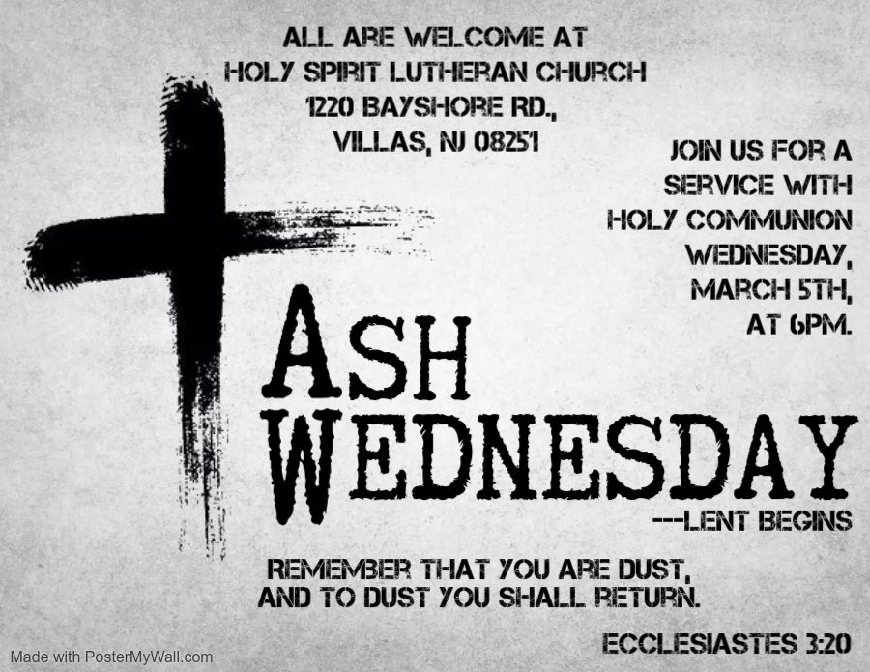

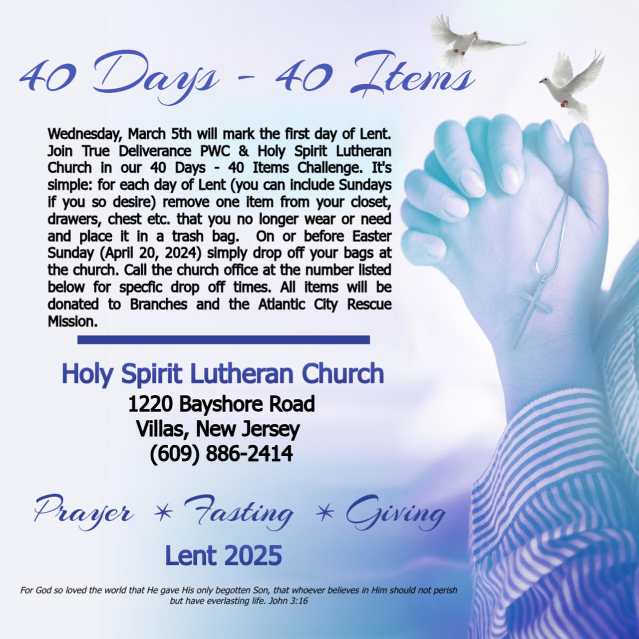

**NEWSLETTER**

Information, stories, pictures, and committee reports for our seasonal publication can be submitted to Vicar Vince in-person or via email at vpie8282@gmail.com. The deadline for all entries for the Spring Publication is **Sunday, March 16th**.

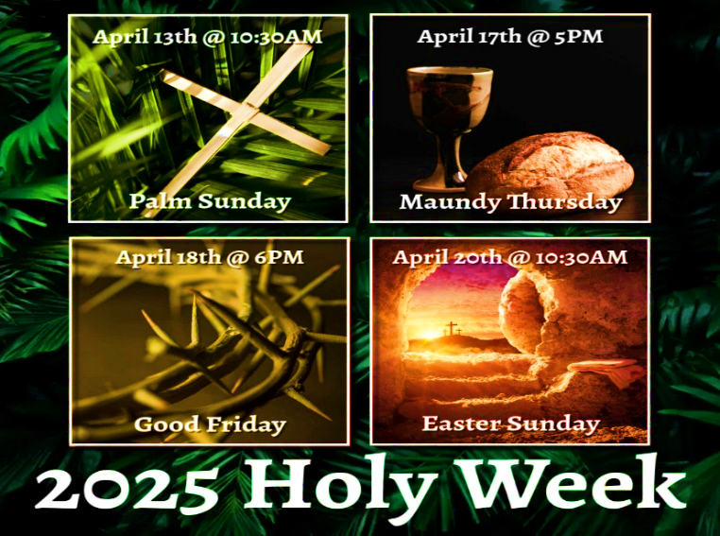

**37TH NJ SYNOD ASSEMBLY**

Behold! I Make All Things New. (Revelation 21:5) Assembly will transition from a one to a three-day event due to the election of a new Bishop, and other business. Vicar Vince is looking for two other church members to be able to attend the event. We will be at the Hilton East Brunswick Hotel - 3 Tower Center Blvd, East Brunswick, from **Thursday, June 5th to Saturday, June 7th**. Online registration opens in February, and the **deadline for registration is April 21st**. Synod Council has designated funds to cover most of the costs for attending with the hope that relieving the financial burden of attendance will prompt all congregations to send a full contingent of voting members. Voting Member: $25 (includes Friday evening banquet) / $50 (after April 21st). Rooms have been blocked for the NJ Synod. Rates are $179 per night. **Hotel deadline is May 22nd**. Reach out to Vicar Vince with any questions.

**TAKING FAITH HOME**

Vicar Vince was introduced to Milestones Ministries weekly guides for faith-filled studies and conversations through a Seminary class. A decision was made to pass these along to you. If you missed a week, or lost your insert, check our website for past issues. Feel free to ask questions and provide feedback to Vicar Vince.

**HOME COMMUNION MINISTRY**

A Minister is available if you have a loved one, or if you desire services. We look forward in sharing the Word and Holy Communion! Please inform Vicar Vince, Kathy, or the Church Office so plans can be made for visits.

**PRAYER LIST**

Our Prayer List continues to lengthen and we realize the important need for prayers and healing. Sometimes the unfortunate result is that someone has passed away, and the words “The Family & Friends of” appear before someone’s name. However, sometimes we forget names are still on the list and their health has improved or the they are no longer struggling, and they can be removed. Please share the good and bad stories as we continue to pray for strength and healing. Names can be added or removed from the list on the clipboard in the Narthex prior to the Worship Service, by calling the church office, or addressing it on the Conference Call. Please let us know the relation to the person(s) you listed so we can be more mindful with our prayers. Names will stay on the list until removed by the person(s) who requested prayer.

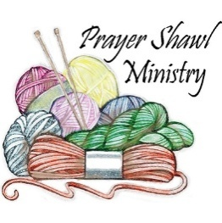

Prayer Shawls, Lap Quilts, Scarves, and other items have been made with love. Blessed items are located in the Narthex, and are free for anyone. Members of the group continue working at home on new stitches and patterns. We are blessed to be able to continue collecting new items. We have a donation station of yarn and other items located in the Narthex. You can find some new supplies for your next creation!

**FAVORITE HYMNS**

Carol is willing to play some of your favorite hymns for the Prelude & Postlude each Sunday during our Worship Service. Feel free to let her know of your suggestions.

**INTERESTED IN BECOMING A NEW MEMBER**

Have you been attending our church for a while? Have you just recently returned to church after being away for a bit? Maybe you transitioned from another church,

or just started to recently attend our church. We are glad to have you, and would love to have you as a member of our Congregation. See Vicar Vince for more info.

**BAPTISM**

We are a church whose unity is in Jesus Christ, who gathers us around word and water, wine and bread. Baptism is a significant part of our faith journey as we come from the baptismal waters to live a new life as children of God. Our baptism sets us out on a lifelong journey that is characterized by our relationship to God, our relationship to our faith community, our relationships in our community and the wider world. Living our baptismal covenant means living a life of growth in the faith practices of discipleship. Please see Vicar Vince for more information.

**FIRST COMMUNION**

Although no particular age for first communion is prescribed by The Use of the Means of Grace, one guideline is offered. Because admission to the Sacrament is by invitation of the Lord to the baptized, "baptized children begin to commune on a regular basis at a time determined through mutual conversation that includes the pastor/vicar, the child, and the parents or sponsors involved, within the accepted practices of the congregation.” Each congregation is encouraged to ask the question of readiness for first communion, establish their own policies regarding age and practice, and accompany that practice with catechesis appropriate to the age of the communicant. If anyone has questions, please see Vicar Vince.



New books are added to our library from time to time. Several are borrowed and read and exchanged. Who knows, you might find one particularly interesting and share that with someone as well. Reading is a great way to pass spare time, learn, and explore. You may find some fresh ideas for prayer, ways to grow more spiritually, ways to grow closer to God, or some opportunities to understand our faith more. Visit the library between the church offices and see what books are there!

We also have a hidden extended library located in Vicar Vince’s office on the large green shelves. There are Bibles of various translations, books from his personal collection, books inherited from Pastor Leah, movies, past Bible Study Curriculums, and so much more. Feel free to ask Vicar Vince to be able to check things out!

**TITHES, OFFERINGS, & ENVELOPES**

2025 Offering Envelopes are available. Please see Heather if you have not received yours, or would like to have some. For we do indeed worship God with our tithes and offerings. We hear this in scripture, “Each of you must give as you have made up your mind, not reluctantly or under compulsion, for God loves a cheerful giver.”

(2 Corinthians 9:7) Feel free to drop your envelopes in the offering plate, mail them to the church, or drop them off in the locked mailbox. Thanks for your continued support in the mission of our church, its ministries, the NJ Synod, and other needs!

**ED GREEN CAPITAL IMPROVEMENT FUND**

We continue raising money for unforeseen costs or repairs.Kathy sells Wawa Tickets for $6, the donation bin is in the back of the church, and we have our Annual Church Rummage Sale. Thanks for your continued donations, prayers, and support!

**PROPERTY USE**

​​​​​Do you know anyone interested in utilizing our Fellowship Hall for a Party or Event?

It is a suggested $50 refundable security deposit, and $250 for facility use. There is no alcohol or games of chance permitted due to ELCA policy. Please contact Vicar Vince or the Church Office with questions, for info, or to reserve a date and time.

**VICAR APPOINTMENT ON MARCH 19TH, 2023**

A Memorandum of Understanding on the Matter of Pastoral Appointment

In Theological Education for Emerging Ministries (TEEM) Candidacy

TO: Congregation Council, Holy Spirit Lutheran Church, Villas

FROM: The Rev. Tracie L. Bartholomew, Bishop, New Jersey Synod

Dear Brother and Sisters in Christ,

This memorandum is in support of your discussions with Vincent Piekarski as pastor of Holy Spirit, Villas. Because this is not the usual pattern for completing the educational and candidacy requirements for ordination, it is my hope that this memorandum will both provide guidelines and engage in conversation with those who are invested in this process.

I would say at the outset that because Vincent is an outstanding candidate for the Ministry of Word and Sacrament, we will all want to do whatever is necessary to assure that his placement serves the mission of the church in the best possible fashion.

The following notes reflect my own understanding of this matter:

(1) The appointment for Vincent will begin on April 1, 2023. At this time, Vincent

will assume all responsibilities of a regularly called pastor, including presiding at

the Sacrament of Holy Communion and Baptism at Holy Spirit, Villas.

(2) A pastoral appointment in the TEEM process is an option for completing

seminary educational requirements and the steps of the candidacy process.

Upon completion of the candidacy process and seminary education, the

candidate may receive and accept a call to ordained ministry from the

congregation where the appointment is being served.

(3) This appointment is jointly supervised by the Office of the Bishop and the TEEM

pastor’s seminary. A mentoring relationship with a local pastor is required for the

length of this appointment.

(4) The synod of candidacy origin will be responsible for the approval process.

(5) Upon approval for ordination, the congregation would be expected to extend a

call to the pastoral appointee.

(6) Compensation for the TEEM pastor will be according to the guidelines of the New

Jersey Synod. All normal forms of compensation should be in place for the term

of the appointment, including stipulation that base salary and housing shall be in

accord with synod guidelines for first call at time of ordination.

(7) The ELCA Portico benefit plan for lay persons in full-time church service should

be used for the pastoral appointee up to the time of ordination, whereupon the

benefit package is to be converted to the plan for ELCA clergy.

(8) A decision for Pastoral Appointment is made with the agreement of a synod and

its candidacy committee, and the ELCA, normally represented by the regional

staff person of each in consultation with the seminary and its Director for

Contextual Education.

(9) Pastoral Appointment in a TEEM Candidacy is an option that is to serve the

mission of the Church in a particular and vital way and is not to be viewed or

used as a means to circumvent the normal candidacy process and/or first call

placement process.

In the specific case of Vincent, the New Jersey Synod remains responsible for the candidacy and approval process, and has agreed to this proposal for Appointment at Holy Spirit, Villas.

Continued blessings to both Holy Spirit and Vincent Piekarski as you embark on this journey of mutual ministry. As partners in ministry, we walk with you and rejoice in this new relationship.

**VICAR VINCE’S DAY OF REST**

A day of rest can have physical, mental, and spiritual benefits. “Mittwoch,” German for mid-week, or Wednesday, is the day that Vicar Vince will use to recharge and do some other things. Please do not hesitate to reach out if there is an emergency!

**VICE PASTOR UPDATE**

Pastor William Hodgetts continues to attend our monthly Church Council Meetings. Pastor William continues to provide Supervision and Direction for Vicar Vince.

**JERSEY JOTTINGS**

Jersey Jottings is a weekly e-newsletter that connects our synod together with weekly prayer, upcoming events, synod and churchwide activities, mission stories, congregational activities, and more. You can also sign up by going to https://www.njsynod.org/stay-connected and filling out the form! You can also get the app on your smartphone in the Apple App Store or on Google Play on your android.

**TRUE DELIVERANCE PRAISE & WORSHIP CENTER**

Reverend Maria Brooks and True Deliverance Praise & Worship Center utilize our facilities from 1-4PM on Sundays. TDPWC helps with the Food Pantry and hosts or assists with other events throughout the year. TDPWC hosts a Prayer Line on Mondays, Thursdays, & Fridays at 5PM on their Conference Call # 1-657-390-7957.

**WHAT IS THE EVANGELICAL LUTHERAN**

**CHURCH IN AMERICA (ELCA)?**

The ELCA was formed in 1987 by the merger of three Lutheran Church bodies –

the ALC (American Lutheran Church), the LCA (Lutheran Church in America),

and the AELC (Association of Evangelical Lutheran Churches).

To learn more, go to the ELCA's website at www.elca.org.

**WHAT IS THE NEW JERSEY SYNOD?**

The New Jersey Synod is a geographical grouping of Evangelical Lutheran Church in America (ELCA) congregations that share the mission and ministry of the Church on the New Jersey territory. It is one of 65 synods in the ELCA. The NJ Synod is comprised of 146 congregations, which include over 45,000 baptized members.

|  |  |
| --- | --- |
| **2025 FINANCIAL STANDING** | |
| **JANUARY INCOME** | $4,385.00 |
| **JANUARY SPENDING** | $8,733.03 |
| **JANUARY GAIN OR (LOSS)** | ($4,348.03) |
| **2025 INCOME** | $4,385.00 |
| **2025 SPENDING** | $8,733.03 |
| **2025 GAIN OR (LOSS)** | ($4,348.03) |
| **ED GREEN CAPITAL IMPROVEMENT FUND** | $11,844.55 |
| **FOOD PANTRY FUND (SOCIAL MINISTRY)** | $12,831.50 |
| **CD** | $25,494.25 |

**CHURCH STAFF & VOLUNTEERS**

**VICAR, BIBLE STUDY & FAITH DISCUSSIONS,**

**EVENTS, NEWSLETTER, & WEBSITE**

Vicar Vince Piekarski

**VICE PASTOR**

Pastor William Hodgetts

**ORGANIST & PIANIST**

Carol Amundsen

**CHURCH COUNCIL PRESIDENT**

Mary Melnicoff

**CHURCH COUNCIL VICE PRESIDENT**

Judy Brannan

**CHURCH COUNCIL TREASURER**

Bonnie Millard

**CHURCH COUNCIL SECRETARY**

Vicki Rinier

**CHURCH PROPERTY**

Frank Ford & Wayne Rand

**CHURCH OFFICE, SUNDAY SCHOOL, & FOOD PANTRY**

Heather Piekarski

