May 2007
G S P C I News
Newsletter for the German Shorthaired Pointer Club of Indiana

President – Ron Ferris (317) 326-1212, ferronhaus@hotmail.com V.P. – Andy Giegold (260) 357-3606, pgiegold@locl.net
Secy/Treas – Donna Conley (765) 345-7172, timcon@indy.net Editor – Lisa Stovall (270) 691-6283, mflkstovall@omuonline.net
www.gspcindiana.org

December 2005

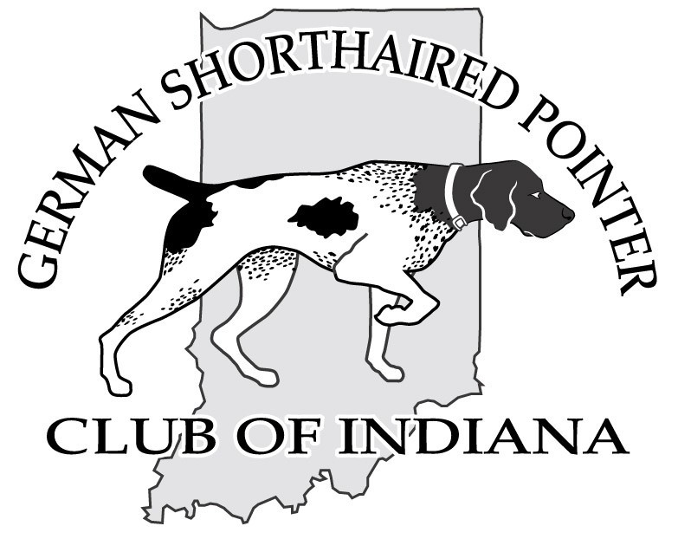

President’s Message

It has been a busy and successful spring for your club. Following a very successful BSTS in Feb, the spring activities began with a fun hunt and training session in March at the Barnes Hunting Preserve in Edinburg. 11 teams of 2 members and 2 dogs harvested 53 pheasant. The team of Weber & Marsh edged Troup & Prikosovich by .10pts to win 1st at the event. Lots of pre hunt test and NAVDA training was accomplished by several members.
The spring hunt test held the following week at GVCC saw some wet weather on Sat. a.m. following excellent temp and dryer conditions Sat. p.m. and all day Sunday. A high percentage of the dogs qualified and the judges saw a very high quality set of master dogs run. 6 braces of masters were among the best set of masters one could have imagined. (See the hunt test report for a complete listing.)
The NSS show in Ft. Mitchell couldn’t have been more flattering for the Ind. GSP club! Christy, Christen and Doug Featherston put on a hospitality hour which turned into hours on Tuesday evening that topped anything the national had ever seen and set a bench mark for the future that will be difficult for anybody to top. The club owes Christy, Christen and Doug a huge thank you for their efforts! You had to be there to believe it!
Judges & national members also convened at the club suite for socializing, food and drinks on two other evenings during the show. The breakfast served the morning of the show sponsored by IN GSP, was also extraordinary. Many great compliments were given to the IN group during specialty week.
Team Montgomery Creek and Gary Marlin participated in the BOW demos at Lafayette the 1st week of May and were well received by the DNR and the ladies.
A directors meeting and general membership meeting will be held Sat. June 9th at 1:00pm at the Town & Country Animal Hospital. As usual everyone is invited to attend. The main topics will be planning and setting dates for the summer picnic and for summer training session. Birds will be becoming available about the middle of June.
The fall hunt test dates are Sept 29th and 30th at GVCC. Anyone who has an area available to hold training sessions is encouraged to contact one of the directors so we can help arrange the event in your area.
Membership will be advised by email of any and all future events taking place.
Just a Reminder: Any breeder who has not paid their dues within a week of receiving this newsletter will be removed from the IN GSP website. Please encourage anyone you know who hasn’t paid there dues to send them to Donna Conley.
Any suggestions or comments for improving your club are always welcome. I know summer is a very busy time for everyone but it’s nice to put aside some time to join with your fellow members and your dogs to just relax and have some fun with your four legged companion.
Good training and have a great summer.

Ron Ferris

GSPCIN Calendar of Events:
June 9th – Directors & General Membership Meeting – 1pm at Town & Country Animal Hospital
September 29 & 30th – Fall Hunting Tests - GVCC

GSPC of IN Welcomes our newest members:

Please join me in welcoming these new GSPC of IN members: Keith Bradfield from Paris IL, Joseph Eicher from Spencerville IN, Randy Hall from Kinston NC, Robert Hicks from Carmel IN, Mike King from West Alexandria OH, James NewKirk

GSPC of IN Spring Hunting Tests

Spring rain showers were not enough to dampen the spirits of the dogs, handlers, judges, hunt-test committee, or hard working volunteers @ the GSPC INDIANA Spring Hunt Test.
Despite a wet Saturday, and fog delayed Sunday start, it was a great weekend from start to finish.
We were host to dogs & handlers not just from here in Indiana, but from Illinois, Kentucky, Tennessee, South Carolina, Ohio, Michigan, Wisconsin, & even as far away as Ontario Canada…. !
A big “THANK YOU” to all who helped out & made this a huge success for the Club!

Qualifiers:

Saturday March 31st 2007
Masters:
Shooting Starr's Go Go Gadget ( Gadget ) | GSP | M | Tony Libertore
Everedi's Auburn Navigator SH (Nav ) | Vizsla | M | Greg Jennings
Thunderhead's Electric Lady (Carmen) | GSP | F | Ron Stott
Seniors:
No Qualifiers

Juniors:
GiGi Von Lan-Hof (GiGi) | GSP | F | John Small
Rijaro's Whistlin' Dixie ( Dixie ) | GSP | F | Chris Sarkowski
Gratz Von Greta (Greta) | GWP | F | Gary Miles
Wind River's PC's Urban Legend ( Legend) | GSP | M | Keith Bradfield
River Bottom's Ann ( Marty) | GSP | F | Gary Schmaltz
Pointsetter Fiona of Shiloh (Lexi) | Gordon | F | Gary Austin
Harris Creek Lily (Lily) | GSP | F | Frieszell
Abbie Radar QuickBarker ( Abbie) | GSP | F | Jeremie Barker
Casino's Nestle Quick (Ness) | GSP | F | James Newkirk
R C Walters Mayer ( Walter ) | GSP | M | Randy Hall
Tanari's Magic Moment (Maverick) | Pointer | M | Mary Myers
Ben's Bird Dog Named Cow ( Cow ) | GSP | F | Ronald D Knox
Casino's High Plaines Drifter (Gingus) | GSP | M | Randy Hall

Sunday April 1st 2007
Masters:

Seniors:
Tolkabelle Eschenholz Go Max CDX,FDX (Max) | Brittany | M | Arnold R.B. Esche
Thunderhead's Electric Lady (Carmen) | GSP | F | Ron Stott
Thunderhead's Mighty Morgan (Morgan) | GSP | M | Dave Dulak
Marsport Watson Gilchrist SH ( Watson) | Brittany | M | Jeff Gilchrist
Thunderhead's Mighty Brute ( Brutus) | GSP | M | Ron Stott
Shooting Starr's Go Go Gadget ( Gadget ) | GSP | M | Tony Libertore
No Qualifiers

Juniors:

B.O.W Camp: by Tim Conley

On May 5th, the GSPC INDIANA was well represented @ our first invitation to the B.O.W. camp that was held in Lafayette. Alan Montgomery, Gary Miles, Gary Marlin, Steve Hammond, Lisa Cleveland, Casie Conley, Tim Conley, & several Hard Hunting GSPC Indiana Shorthairs, traveled to Ross Camp, then on to Purdue University Wildlife Area, to host a Chukar Hunt for 11 members of the “Becoming an Outdoor Women” organization, who signed up for this opportunity.
The camp was @ maximum capacity this year with the limit of 150 Outdoor Women attending. Participants enroll in advance into a wide variety of activities with class sizes ranging from 10 –15 students per class. We were just over full with 11 outstanding students in our class.
Our Volunteers, both human & Canine, were warmly welcomed by the students. .
All but a couple of the students were successful @ harvesting at least one Chukar!
It sounds like this will become another annual event to look forward to as events @ the camp are rated by the participants, & used to plan next year’s camp. The GSPC INDIANA scored a perfect 5 from all 11 participants, and we have already been invited back for next year’s camp!

http://www.uwsp.edu/cnr/bow/
http://www.in.gov/dnr/outdoorwoman/workshops/index.html

Pictures from the B.O.W Camp (taken by Gary Marlin):
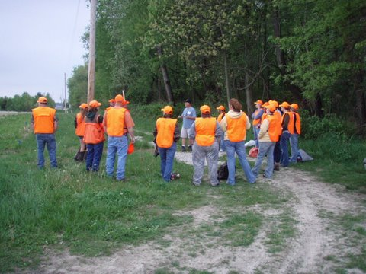
NMK'S Heart & Spirit JJJ ( Heart) | GSP | F | Johnny Johnston
Classic Make-Hers Mark (Marcia) | Vizsla | F | Brooke Counts
Wind River's PC's Urban Legend ( Legend) | GSP | M | Keith Bradfield
Casino's Nestle Quick (Ness) | GSP | F | James Newkirk
Harris Creek Lily (Lily) | GSP | F | Frieszell
Wind River's PC's Zig Zag Zoey (Zoey ) | GSP | F | Keith Bradfield
R C Walters Mayer ( Walter ) | GSP | M | Randy Hall
Ben's Bird Dog Named Cow ( Cow ) | GSP | F | Ronald D Knox
Abbie Radar QuickBarker ( Abbie) | GSP | F | Jeremie Barker
Knox's Big Fooled Boomer ( Boomer) | GSP | M | Ronald D Knox
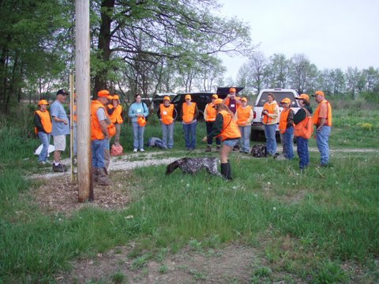
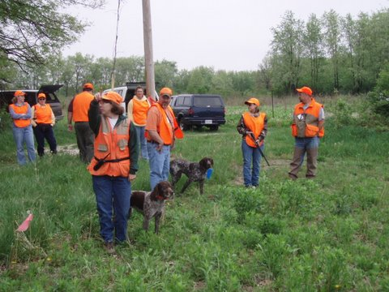
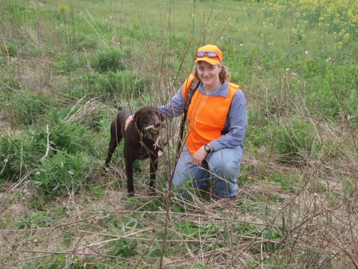

B.O.W. History and Program Description
Becoming an Outdoors-Woman (BOW) means becoming more competent, more confident, and more aware. BOW is an outdoor skills program that offers women a chance to grow. 20,000+ women attend BOW events every year.
More than 80 weekend-long workshops are held all across North America annually. The workshops introduce women to a variety of activities equally balanced between hunting and shooting, fishing, and non-harvest sports like canoeing and camping. Participants choose from a list of over 20 activities.
The program began in 1991, offered through the University of Wisconsin-Stevens Point. The first workshop, held at Treehaven Field Station near Tomahawk, filled to capacity with over 100 participants. This successful program, founded by Dr. Christine Thomas, has become popular in more than 40 states, several Canadian provinces and New Zealand.
“The growth of BOW means we are reaching more women and providing them with a venue to learn not just outdoor skills, but also more about themselves,” says Assistant Director Peggy Farrell. “Women all across the country have told us, ‘BOW has changed my life.’ That’s a powerful endorsement telling us the program is even bigger than learning how to set up a tent or tie a fly.”
BOW program coordinators are also expanding to offer “Beyond BOW” events that include actual pheasant, turkey or deer hunts, guided fly fishing, caving excursions, sea kayaking, horse packing trips and more. The Beyond BOW concept was spurred on by requests from women who wanted to take the next step in learning following their BOW experience. For example, Farrell says, “BOW might teach a woman how to shoot a shotgun. After that where can she go to learn more specifically about pheasant hunting? A Beyond BOW pheasant hunt can fill that need.”
In March 2003 and again in 2004, BOW took a jaunt over the ocean to offer a Beyond BOW in the Bahamas. Participants learned snorkeling, ocean kayaking, deep-sea fishing, and more on this island adventure. We've organized and hosted two trips to Alaska, one to Hawaii, and a wilderness trip to Wyoming.
Specialty programming like BOW and Beyond BOW have become successful due in large part to important on-going research related to women and outdoor activities conducted at the University of Wisconsin Stevens Point College of Natural Resources.
With the help of funding provided by U.S. Fish and Wildlife Service, National Shooting Sports Foundation, Wisconsin Environmental Education Board, and other organizations, BOW launched several projects that assessed the needs, attitudes and participation of women in outdoor activities.
BOW Director Diane Lueck focused recent research on examining ways to better welcome women with disabilities to outdoor recreation. “We know that women who attend BOW workshops gain self-confidence and self-esteem in addition to outdoor skills,” says Lueck. “We want to make sure women in underrepresented groups are included in this unique program.”
BOW welcomes women from all backgrounds to enjoy camaraderie with other women in a supportive, non-competitive learning environment. Participants span the ages of 18 to 80+. In addition to learning new activities, BOW participants are also treated to a variety of evening entertainment including outdoor clothing fashion shows, bird shows featuring live hawks and owls, outdoor storytelling, raffle prizes, and more.
BOW workshops are generally held at camps or resorts. Participants stay in heated cabins or lodges that may be rustic, but have basic modern amenities including hot showers. Meals are provided and cooked by the camp staff. The focus for the weekend is learning in a comfortable atmosphere.
The workshops begin around noon on Friday. Fun remains the watch word from start to finish during three days of camaraderie with like-minded women!

GSPCIN Happenings and Brags

CH. FieldFine Time Is On My Side (Duke) became a new champion at 16months of age. He is owned by Debbie Moline and he is her first show dog ever.

FieldFine Lights Camera Action (Diva) won best bred by exhibitor at the National Specialty owned by Debbie Moline and Dorothea Hand and Dot Simberlund

At the Dock Dog Competition held during the Ft. Wayne Vacation Boat Show, Mieka Josaun Muh Muh die Kuh JH, owned by Tim and Carrie Ryman, placed 2nd in the Novice Class on Friday and placed 3rd in the Novice Class on Saturday

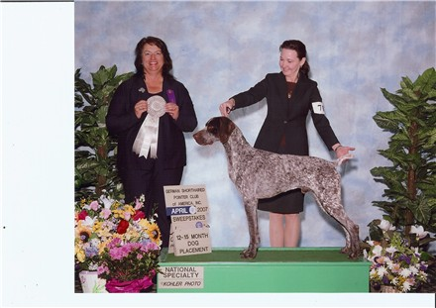
Sure Point Wing Commander (pictured above) owned, bred and loved by Ron and Sharon Fitzpatrick was honored with a Fourth Place in the 12 to 15 Month Sweepstakes Class at the Nationals in Fort Mitchell, KY this April. This was a very exciting moment because Sharon was handling Major and this was her first placement at the Nationals. Message from Sharon to all of you thinking about trying conformation - "If I can do it, you can do it!"

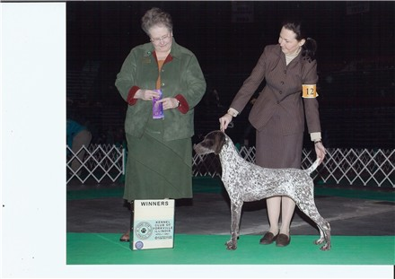
White River Sure Point Pizzazz (pictured above) owned by Ron and Sharon Fitzpatrick and Char Rutar was awarded Winners Bitch on April 7th at the KC of Yorkville for 2 points. Zea was also honored with a Fourth Place in the 6 to 9 Month Sweepstakes Class at the Nationals in Fort Mitchell, KY this April.

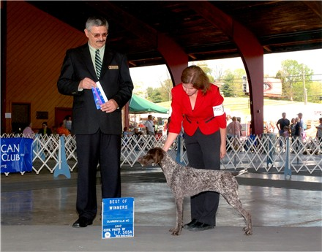
Wannapoints Uptown Girl, a.k.a. Zoey (pictured above), owned by Holly Kelley, Emma Stovall and Lisa Stovall, earned the first leg of her Junior Hunter title at the Weimaraner Club of Greater Louisville Hunt Test on March 25th she then earned two more legs towards her Junior Hunter title April 14th & 15th at the GSPCA Hunting Test held in conjunction with the NSS. Zoey is handled in the field by Michael Stovall. Then at the Clarksville KC show on April 28th, Zoey (handled by Lisa Stovall) was Winners Bitch and Best of Winners earning her first conformation point.

Wannapoints Let Freedom Ring...aka Jake...bred & owned by Lisa and Michael Stovall earned the first leg of his Junior Hunter title at the Weimaraner Club of Greater Louisville Hunting Test on March 25th, he then earned two more legs towards his Junior Hunter title April 14th & 15th at the GSPCA Hunting Test held in conjunction with the NSS.

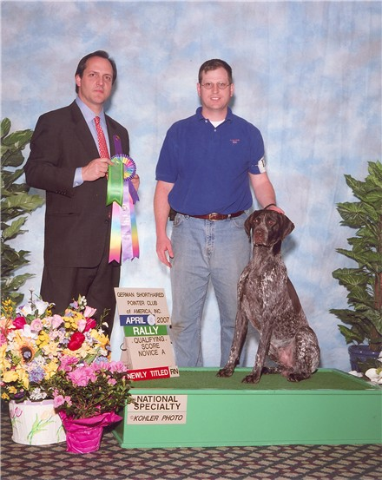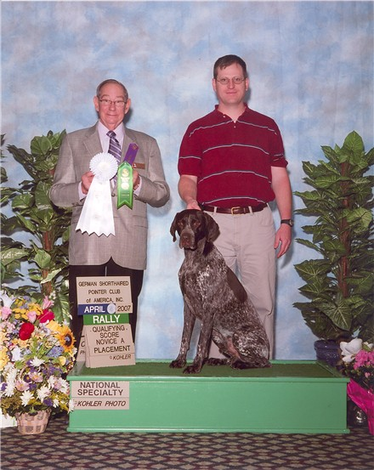
AKC/UKC/UCI National BA/ UCI International Champion White River WP AllMale Revue JH RN NRD CGC, otherwise known as Chip (pictured above), owned by Lisa & Michael Stovall and Char Rutar, earned the third and final leg of his Rally Novice title on April 18th at the GSPCA NSS, he then went on to place 4th in the Rally Novice A class with a score of 92 at the obedience trial held on Thursday, April 19th. Chip was handled by Michael Stovall. Chip’s new RN title along with his CH and JH qualifies him for the GSPCA VC certificate.

AKC/UCI International Champion Foxgloves Mad About You JH RN NRD TT CGC, a.k.a. Maddie (pictured below left), owned by Lisa & Michael Stovall, earned the third and final leg of her Rally Novice title and placed 3rd in the Rally Novice A with a score of 94 on April 19th at the GSPCA NSS, handled by Michael Stovall. Maddie’s new RN title along with her CH and JH qualifies her for the GSPCA VC Certificate.
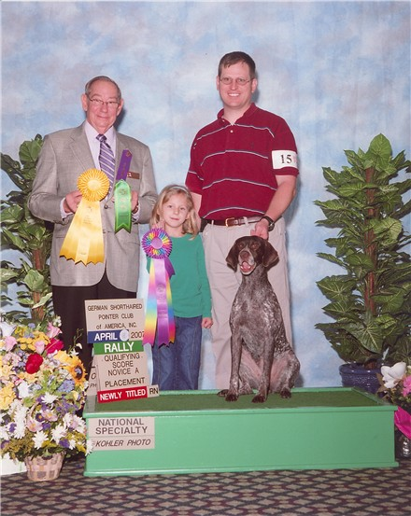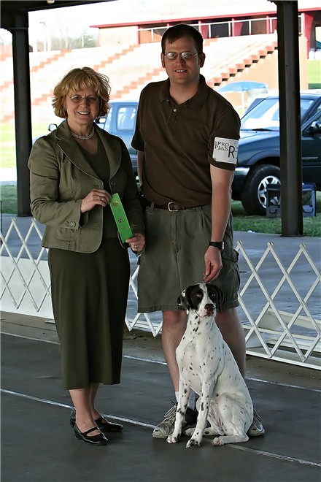
Wannapoints Sweet Delilah Jane (Delilah, pictured above right) bred & owned by Lisa & Michael Stovall earned a qualifying score of 91 in Rally Novice A at the Clarksville KC show on April 28th. This was Delilah's first time ever in competition.

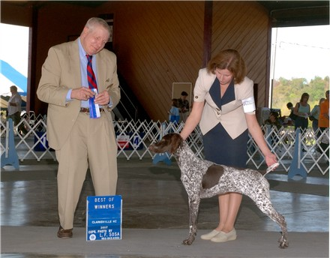
Wannapoints MelloYello Delite (Mia, pictured above) bred & owned by Lisa & Michael Stovall was Winners Bitch and Best of Winners at the Clarksville KC show on April 29th. Then at the Jackson TN Dog Fanciers Association on May 20th, Mia was Winners Bitch Best of Winners and Best of Breed.

GSPC of IN Whelping Box

Feather Hills Kennel is accepting deposits for the Fall 2007 breeding of VC Shooting Starr's GoGo Gadget and Shooting Starr's Ostara please contact Kim Libertore at 812-365-2689 for more information.

Ron Ferris has 2 litters of puppies for a total of 21 pups. Imported Arielle vom Ahrenfeld (D1,S1,HZP1,VGP1,JGHV,HD,Frei, OFA excellent) x Emanual vom Steinwitten(D1,AZP1,HD0,HN,FW:V) whelped 15 pups 4-27-07. 11 males & 4 females. This is a DKV litter & will be registered in Germany and in the AKC. Should produce outstanding field dogs as well as show quality pups. All are liver/white. Cydney vom Lakota Kove(JH,D1,FW:V1,HD Frei) and imported Arko vom Gerstener Weh (SH,D1,FW:V1, OFA excellent) whelped 6 pups 5-4-07 1-black/white male, 2-black/white females and 3 liver/white males. These should be great field and water dogs with tremendous drive and nose. The liver and whites may well be show quality also.

Editor’s closing note:
As always, I welcome your contributions for consideration for the newsletter. Please send me your happenings & brags, litter announcements, informative articles, trivia tidbits, pictures, or anything else that you would like to see included in the newsletter. My email address is mflkstovall@omuonline.net , or phone 270-691-6283. Thanks, Lisa

