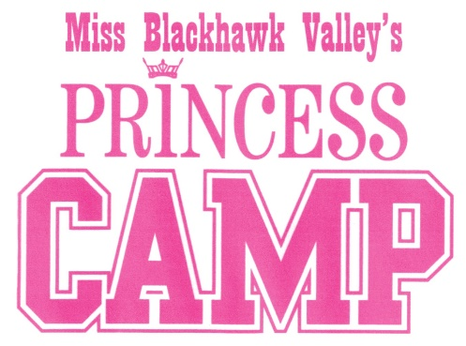
Miss Blackhawk Valley’s Princess Mentoring Program Waiver and Agreement of Indemnity
In consideration of permitting the undersigned ("Indemnitor") to participate in various venues for the purpose of the year-long mentoring program during the pageant, Indemnitor hereby agrees with the Miss Blackhawk Valley Scholarship Program and staff as follows:
1. Indemnitor agrees to indemnify and hold harmless owners and aforementioned pageant and its and their agents and servants, from and against any and all claims, actions, damages, liability and expense in connection with loss of life, personal injury and/or damage to property arising from or out of any occurrence in, upon or at the licensed are by Indemnitor and other Indemnitor and any other occupant or user of all or any part of licensed area, and its and their agents, servants contractors, and employees, if any action or proceeding is brought against Owner or Pageant listed or its or their agents to defend such actions or proceeding at its own expense by counsel satisfactory to owner,
2. It is agreed that neither Owner nor Pageant listed nor its and their agents and servants shall be liable to Indemnitor or to the occupant or user of all or any part of the Licensed area for theft, loss or damage to its and their property in the licensed area cause thereof and even though the same may have been caused or resulted in whole or in part by or from the negligent act or omission of owner or pageant listed or its or their claims against owner and pageant listed and its and their agents and servants with respect thereto.

Princess Name, Printed

Signature of Parent or Legal Guardian Date

Revised 7/27/22

