#class of the month C:\Users\Stephanie\Pictures\Microsoft Clip Organizer\j0416014.wmf

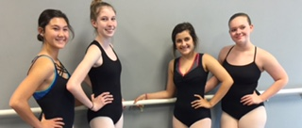

***BALLET CLASSES***

The class every dancer needs. The difference between technique and choreography is ballet!

OPEN HOUSE

Thursday, January 4th

4:00-7:00pm

To welcome the 2018 season we have to do something REALLY BIG!

Come in on this day and register for 2018 and we can help you pick classes to try before you make a final decision if you are unsure what your dancer may want to take.

This is a great opportunity for any friends or family to visit and receive information about our 2018 season. And as always if they sign up YOU get a referral credit on your account!

Please share this opportunity with anyone you know.

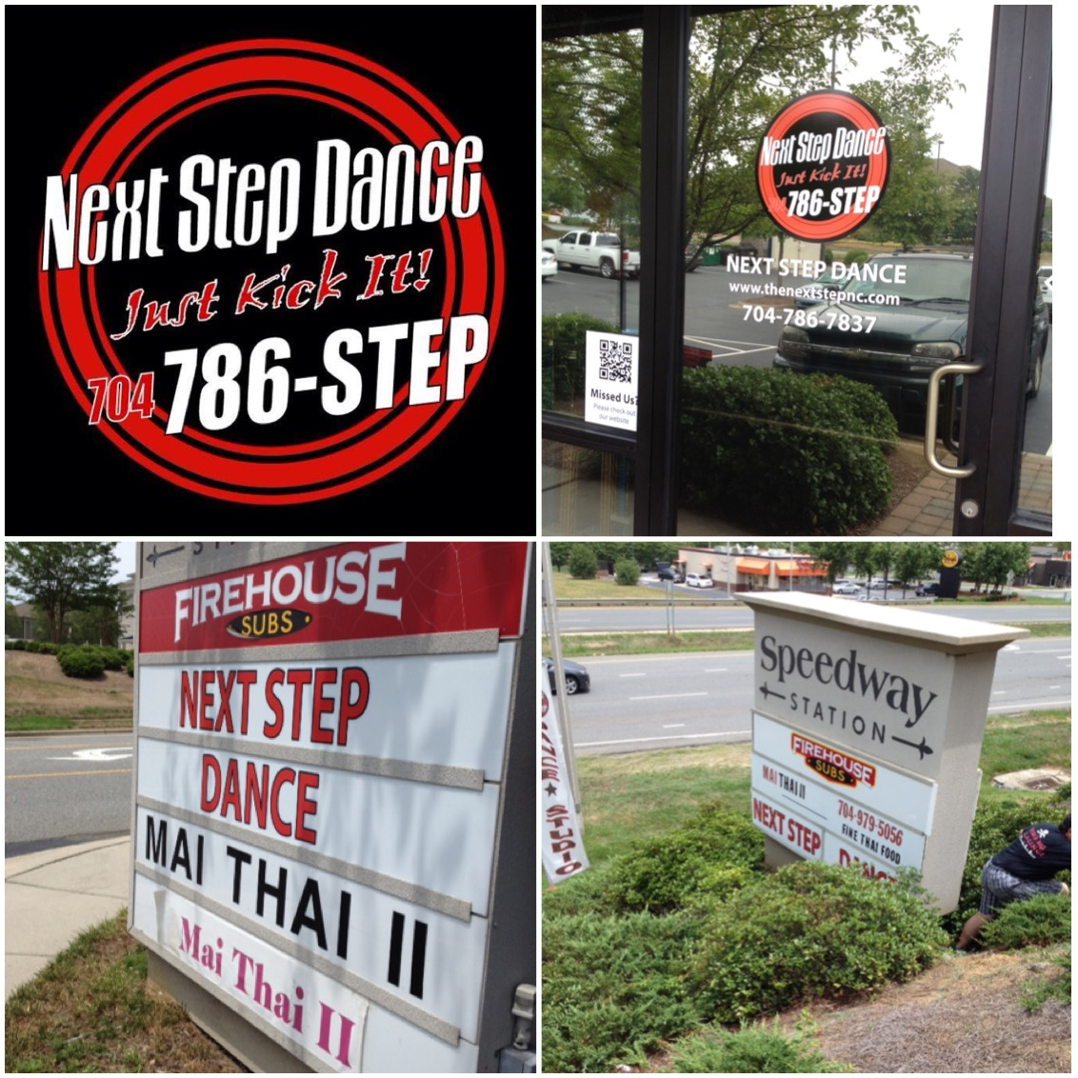

C:\Users\Stephanie\Pictures\Microsoft Clip Organizer\j0416014.wmfC:\Users\Stephanie\Pictures\Microsoft Clip Organizer\j0416014.wmfC:\Users\Stephanie\Pictures\Microsoft Clip Organizer\j0416014.wmf

INSPIRATION C:\Users\Stephanie\Pictures\Microsoft Clip Organizer\j0416014.wmf

Be Fearless in the Pursuit of what sets your Soul on Fire.

#motivation

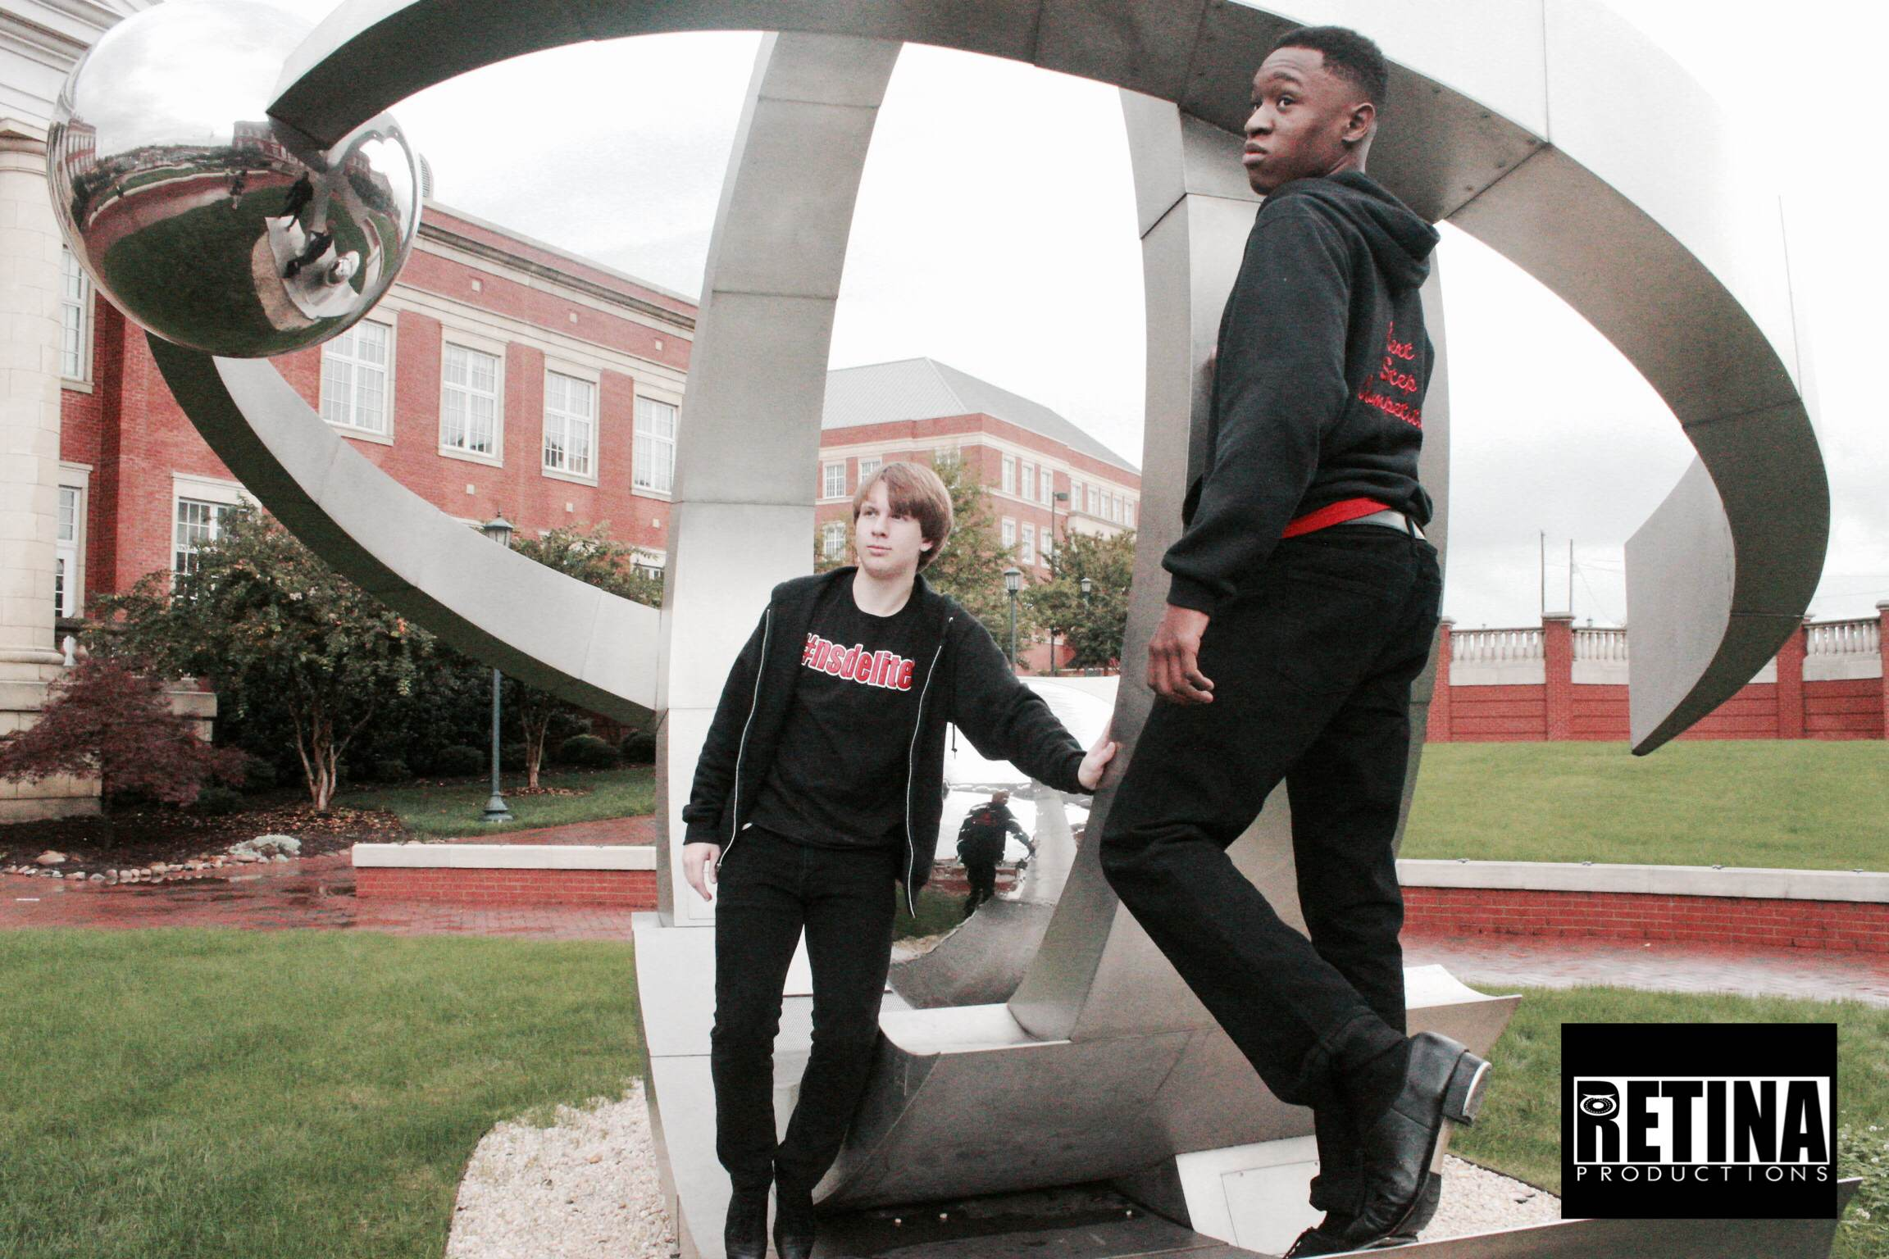

**BALLET 2018**



**THE LION KING**

Each year we select a ballet for our annual recital. This year we chose The Lion King! All of our ballet students, ages 5-18 participate in this fun adaption of the movie (DVD) they know and love. If your younger student has not had the opportunity to view, please make that an assignment for the Thanksgiving break! Telling a story is always exciting both for the students and the audience. See you in the animal kingdom☺ Remember our recital is Saturday, June 16, 2018 with dress rehearsal on Friday, June 17, 2018. Both are at Jay M. Robinson High School, 300 Pitts School Road, SW, Concord, NC 28027.

C:\Users\Stephanie\Pictures\Microsoft Clip Organizer\j0416014.wmf C:\Users\Stephanie\Pictures\Microsoft Clip Organizer\j0416014.wmf

Steppin’ into NOVEMBER 2017 with Next Step Dance

[**www.thenextstepnc.com**](http://www.thenextstepnc.com)

**7712 Sossamon Lane, NW Concord, NC 28027 (704) 786-7837 nsdcalendar@gmail.com**

DANCE MASTERS OF AMERICA

November 17th-19th, 2017

Greensboro, NC

Miss Teresa, Miss Melissa, and Miss Nora are members of Dance Masters of America and are attending the DMA Convention for further training as they do every year. Remember you never stop learning, pass it on……

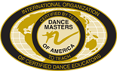C:\Users\Stephanie\Pictures\Microsoft Clip Organizer\j0416014.wmf

SAVE THE DATE C:\Users\Stephanie\Pictures\Microsoft Clip Organizer\j0416014.wmf

11/01 ButterBraid pick-up 7:00pm

11/15 Costume payment due

Closed for Thanksgiving-

11/20-11/23

GIFTS FOR THE SEASON

It is always the season for gifts. Check out our jackets, shirts, and other dancewear for a great gift that will be worn all year!