Congestive Heart Failure in Dogs
As an emergency specialist, I often see both dogs and cats presenting to the emergency room due to congestive heart failure (CHF). CHF can be caused from several different types of diseases, and ultimately results in failure of the heart to pump blood throughout the body effectively. When pump failure occurs, it results in blood backing up into the lungs and fluid accumulation in the body. Fluid most commonly accumulates in three locations:
- Directly in the lungs (i.e., pulmonary edema)
- In the space surrounding the lungs (i.e., pleural effusion)
- In the abdomen (i.e., ascites)
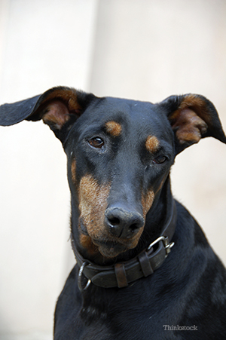
Causes of congestive heart failure in dogs
There are several causes for congestive heart failure in dogs. Some causes may be congenital or inherited (where the dog was born with the heart defect), while some causes can be prevented.
Congenital defects include:
- Subaortic stenosis (SAS)
- Tetralogy of Fallot
- Ventricular septal defects (VSD)
- Persistent ductus arteriosis (PDA)
As these defects are inherited, dogs diagnosed with these problems should be spayed or neutered to prevent further spread of this defect.
Sometimes, inherited heart disease may not show up for several years or late in life. One particular type includes chronic valvular heart disease (CVHD), which results in leaky heart valves. CVHD is more commonly seen in Cavalier King Charles Spaniels, miniature poodles, and smaller breeds of dogs. With this type of heart disease, veterinarians often hear a loud heart murmur with a stethoscope (meaning that the blood flow through the heart sounds abnormal).
If your dog is diagnosed with a heart murmur, consultation with a cardiologist for an ultrasound of the heart (i.e., echocardiogram), chest x-rays, and heart monitoring (i.e., electrocardiogram) is generally recommended.
In larger dogs, CHF is typically due to dilated cardiomyopathy (DCM), where the heart muscle becomes to dilated and weak. This is more commonly seen in Doberman pinschers, Irish wolfhounds, and giant breed dogs. With DCM, a heart murmur may not always be detected with a stethoscope.
CHF may be seen due to abnormal heart arrhythmias. This is most commonly seen in Boxers (right arrhythmiogenic cardiomyopathy).
Lastly, some types of heart disease are potentially preventable, including heartworm infection. (Learn more about heartworm prevention with Beware the Bug.)
Symptoms of congestive heart failure in dogs
Clinical signs of CHF include:
- Constant panting
- Coughing, especially at night
- Exercise intolerance (e.g., getting tired easily on a walk)
- An increased respiratory rate (> 40-60 breaths per minute)
- Difficulty breathing
- Noisy breathing
- Blue colored gums (indicating severe difficulty with breathing)
- A distended abdomen
- Coughing of blood
- Collapse
- Acute death
Treatment of congestive heart failure in dogs
If you notice any of these signs, bring your dog to your veterinarian or emergency veterinarian immediately for life-saving care. Treatment for CHF includes:
- Oxygen therapy
- Medications to remove the fluid from the body (i.e., diuretics)
- Medications to make the heart beat more efficiently (e.g., pimobendan, digoxin)
- Medications to treat the heart arrhythmias
- Heart monitoring (i.e., electrocardiogram)
- Blood pressure medication (e.g., enalapril, benazepril, etc.)
- Blood pressure monitoring
- Symptomatic supportive care
- Sometimes, removal of fluid from the chest cavity or abdomen (via a procedure called a thoracocentesis or abdominocentesis) may be necessary.
With aggressive supportive care, some dogs can do well. However, with CHF, treatment is aimed at preserving quality life. While long-term medications are necessary for dogs that have gone into CHF, the medications do not cure the heart disease. Owners have to be aware that ultimately, end-stage CHF may develop, requiring humane euthanasia.
When in doubt, the sooner your dog is diagnosed with a heart abnormality, the sooner it should be assessed to help prevent the development CHF. Some dogs can live with cardiac disease for years, if it’s controlled with heart medication to make their hearts beat more efficiently. When in doubt, evaluation by a board-certified cardiologist is recommended!
If you have any questions or concerns, you should always visit or call your veterinarian -- they are your best resource to ensure the health and well-being of your pets.

