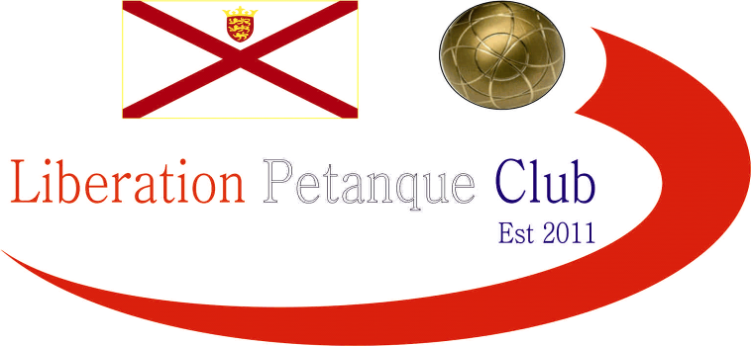

Winter 2020 / 21 Season
Charity Christmas Doubles Open
Saturday 6th December 2020
15 teams entered this year’s competition helping raise money towards Jersey Children’s Charity, this means we have now raised £807 this year despite having less entries than last year.
Five rounds of matches were played before the top eight went through to the quarter finals.
In round one, there were three matches won by just one point. Title holders Matt Pinel & Mark Nicol just got over the line against experienced duo Gary Cowburn & Wendy Ritzema 13 – 12. This was the score for Colin Myers & Keith Pinel against Mike Fennel & Ralph Morin. Andrew & Lorna won by one point but with a score of 12 – 11 against Kevin Daly & Vanessa Nash.
Big wins for Geoffroy Buffetrille & Laurent Pellaton as they overcame Graham Taylor & Margaret Robinson 13 – 0 and Callum & Jean Stewart won 13 – 3 against Daniel & James Villalard.
Round 2 saw Gavin Scott & James Rondel hit the ground running after a bye in the first round won easily against Andrew & Lorna 13 – 1 whilst big winners in round 1 Geoffroy & Lauren lost to Callum & Jean 13 – 12. Colin & Keith kept up the pace with a 13 – 5 win over Matt Buesnel & Toby Northern.
Jake Romeril & Ross Payne got off the mark with a win over Gary & Wendy as did Daniel & James over Graham & Margaret.
Round three saw champions Matt & Mark win easily over Gavin & James 13 – 3, this was the case for Matt & Toby with a 13 – 5 win over Kat Stewart & Paul Bell as well as Kevin Daly & Venessa Nash 13 – 4 over Daniel & James.
Unfortunately, Graham & Margaret lost 13 – 0 again to Alex & Cassie Stewart. The was also a surprise second loss in a row for Geoffroy & Laurent against Andrew & Lorna and Callum & Jean lost their first match against Colin & Keith 13 – 1.
Round four saw Alex & Cassie hand out successive 13 – 0, this time to Kevin & Vanessa and a big win again for Matt & Toby 13 -2 over Andrew & Lorna whilst Gavin & James just got over the line against Daniel & James in an awfully close match.
On the very last end Mike & Ralph beat Geoffroy & Laurent 13 – 12 to knock them out of the tournament and then withdrew from the competition before the final round!
Matt & Mark made it four from four wins a with over previou8sly undefeated Colin & Keith.
With all to play for in Round 5 some good matches. However, Geoffory & Laurent got their second win only because of a bye finishing a disappointing 13th with the lowest BHN of 8.
Alex & Cassie ended with just two wins (both 13 – 0!) after a loss to Callum & Jean in a family affair. This result though meant Callum & Jean qualified in seventh place.
Despite having already qualified Matt & Toby had a bye after Mike & Ralph’s withdrawal to end on four wins and finish in third placemaking the knockout stages in successive years.
Ross & Jake lost to Matt & Mark, but this did not stop them finishing fourth with Matt & Mark ending on five wins from five to top the rankings.
Colin & Keith beat Gavin & James to finish second, but the latter still qualified with three wins in sixth place. Kat & Paul bell went through with three wins after a bye following Graham & Margaret pulling out after round four finishing fifth place and Daniel & James made the knockout stages for the first time after beating Andrew & Lorna 13 – 7.

Quarter Finals
Ranked 1st Matt Pinel & Mark Nicol v Daniel & James Villalard Ranked 8th
Ranked 2nd Keith Pinel & Colin Myers v Callum & Jean Stewart Ranked 7th
Ranked 3rd Matt Buesnel & Toby Northern v Gavin Scott & James Rondel Ranked 6th
Ranked 4th Jake Romeril & Ross Payne v Kat Stewart & Paul Bell Ranked 5th
Well, there was not really any close matches in the quarter finals as expected Matt & Mark made light work of Daniel & James who had a great tournament.
Jake & Ross were playing well and won comfortably 13 – 5 against Kat & Paul with Gavin and James also hitting form with a 13 -6 win over 2019 runners up Matt & Toby. Callum & Jean winning 13 – 8 to also make the semi-finals.

Semi Finals
Ranked 1st Matt Pinel & Mark Nicol v Jake Romeril & Ross Payne Ranked 4th
Ranked 7th Callum & Jean Stewart v Gavin Scott & James Rondel Ranked 6th
Unlike the Quarter finals, both Semi finals were won by just one point as Matt & Mark breathed a huge sigh of relief after getting over the finishing line 13 – 12 after Jake & Ross blew the lead and chances to win. The match between Callum & Jean and Gavin & James went nowhere near the distance with the latter just edging it 9 - 8.
Callum & Jean won the third place play off against Ross & Jake 13 – 9 for a great tournament.
This final was an awfully close match but as often is the case a few miss fires here and there can mean all the difference and this was the case here as Gavin’s usual good form slightly deserted him with Matt & Mark retaining their title with a 13 – 11 win.
Thank you to all those who helped organise, played, and donated on the day your support was amazing for a great Charity.
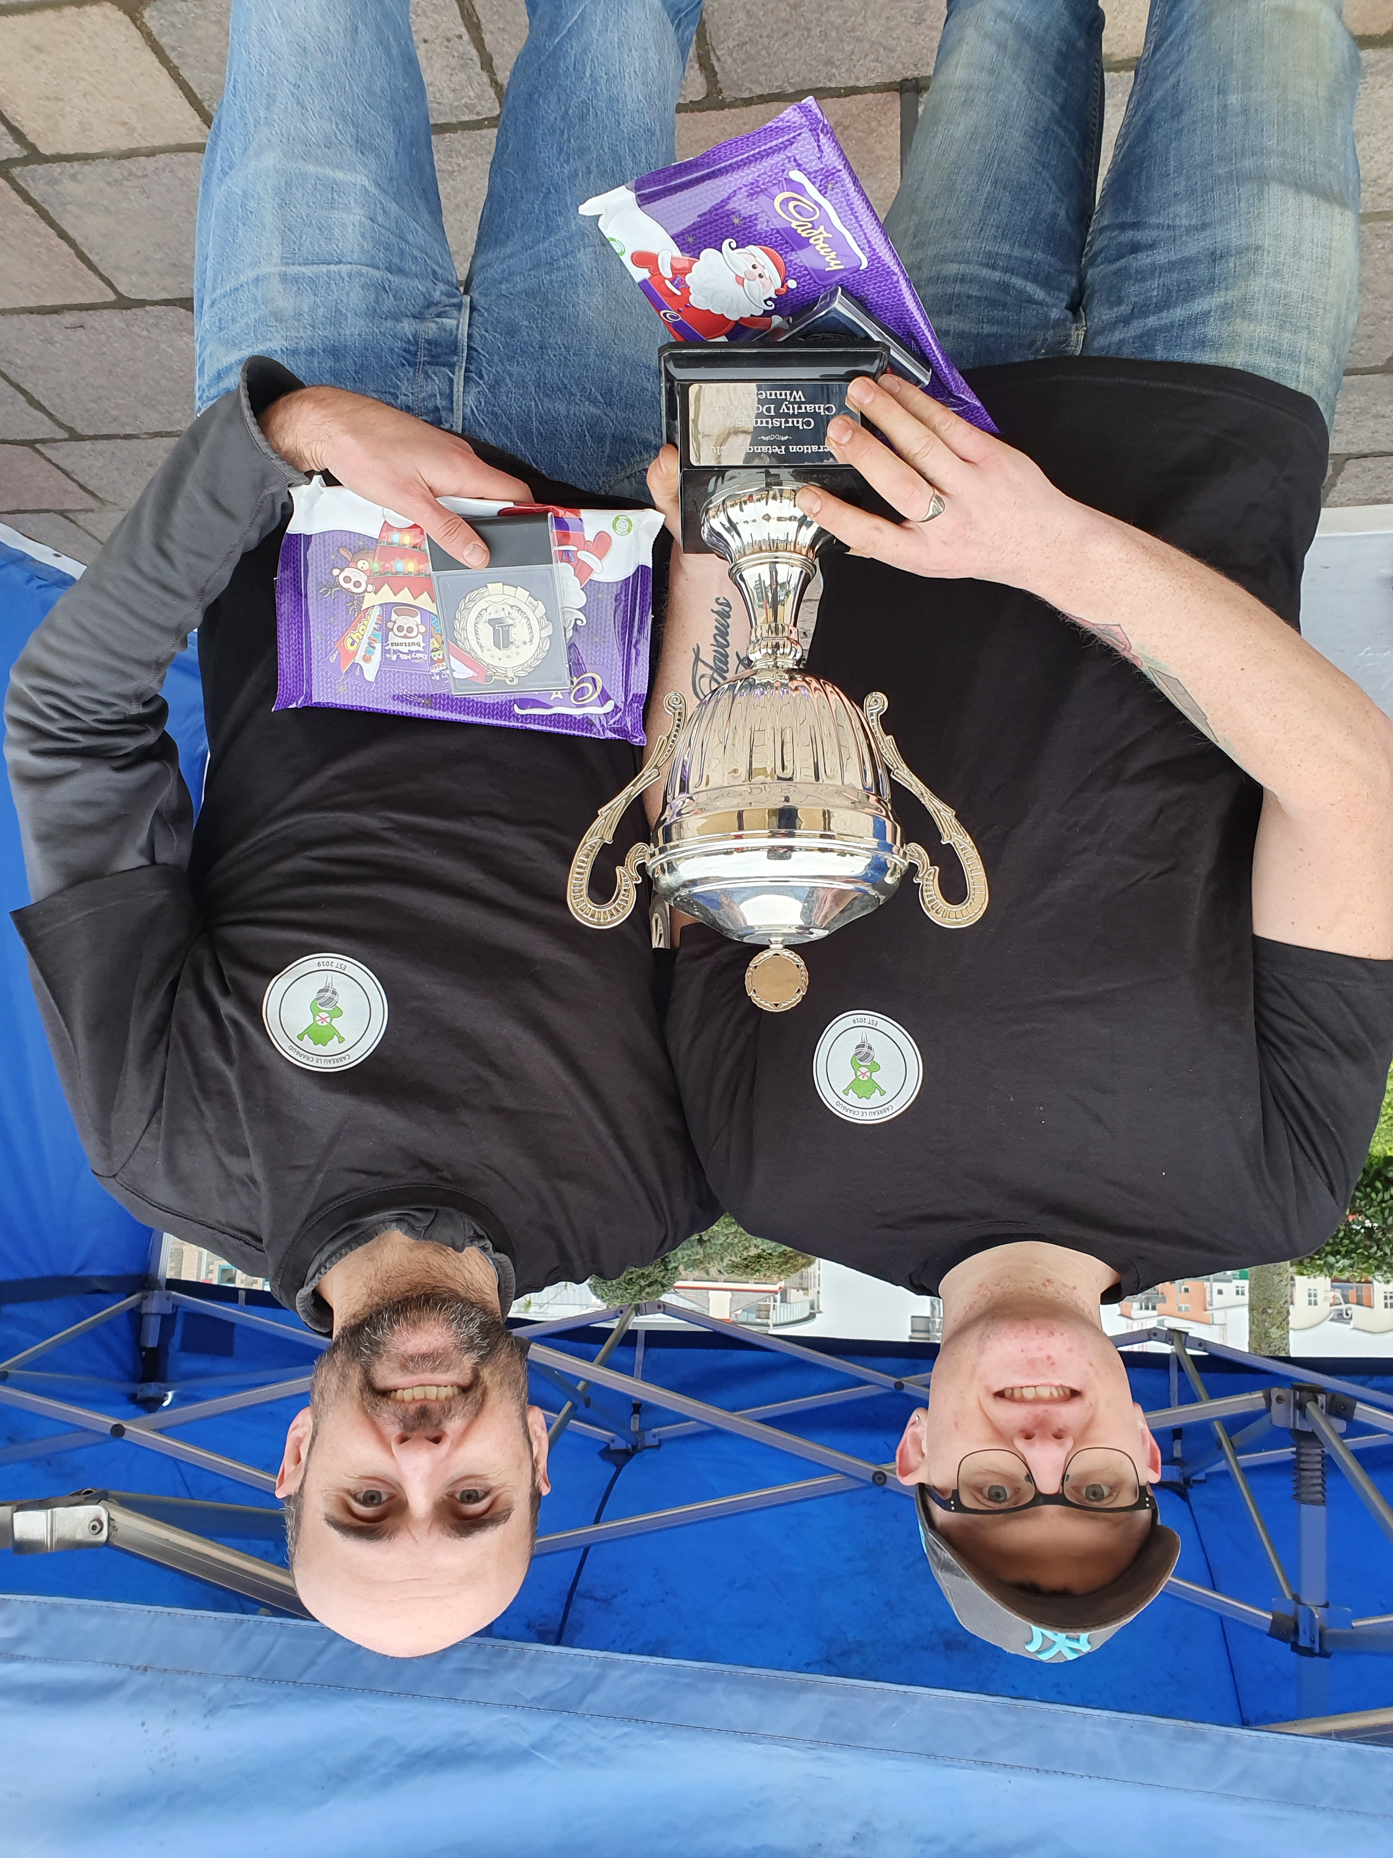
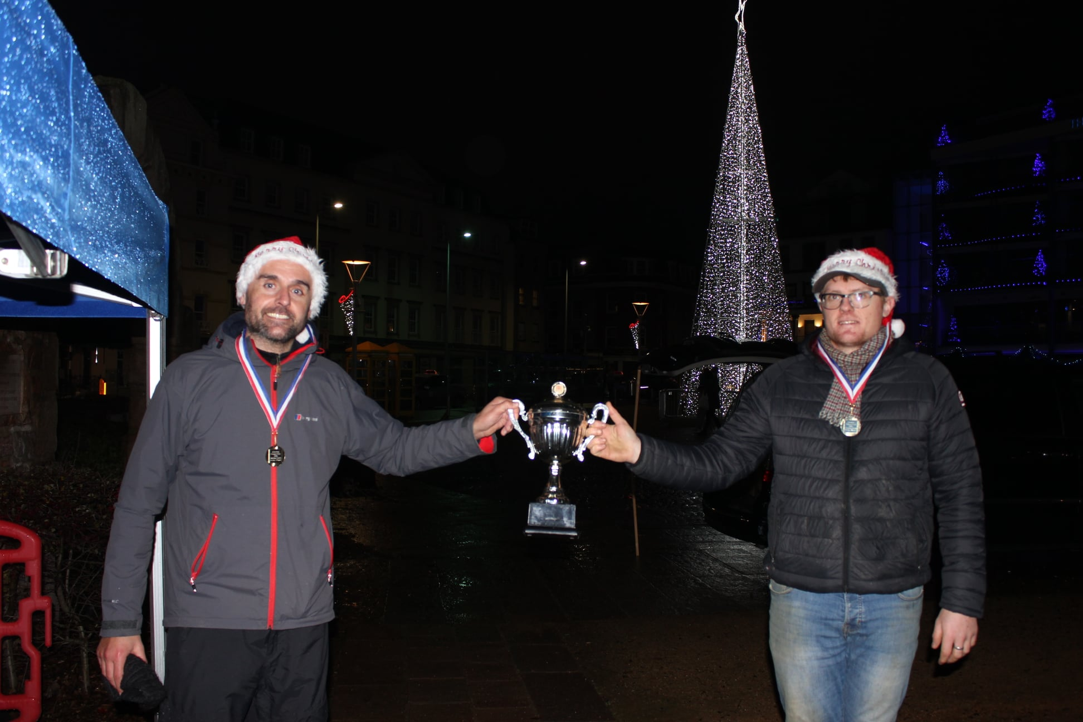
2019 2020

More photos on Facebook

Club email address - liberationpc@gmail.com

Club Website - www.liberationpetanque.co.uk

Kind Regards

Toby Northern

Chairman

Liberation Petanque Club

SPONSORED BY



