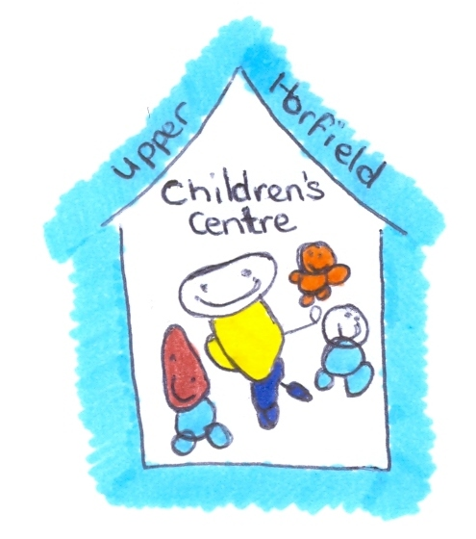
Upper Horfield Children’s Centre and Community School
Staff with Children Accessing the Nursery
February 2015

After consultation with the staff at Upper Horfield Children’s Centre it has been agreed to have children who are born to staff members, or adopted/fostered to attend the nursery where space allows.

Due to the nature of the placements the following must be adhered to at all times:

- The (Staff Member) with their own children attending the nursery must not work in the same room as their child.

- Other than for picking up and dropping off, the Staff Member must not for any reason access the room with their child in, unless there is written confirmation from the Team Leader in charge that the child has settled well and would not be disturbed by the parent entering.

- Staff in the room must not treat the child of another staff member with any differentiation. If this should be seen to be happening the staff member will be spoken to by the Team Leader. Further incidences may incur disciplinary action.

- Staff must not discuss the ‘child in question’ outside of the room unless for professional reasons within the office spaces. Discussions during personal breaks should be carefully considered. Any discussions with the parent regarding their child’s development or settling in etc, should take place professionally in a confidential space.

- The Staff Member is asked to be respectful of the EYP professional care of the child, and should there be a cause for concern, this should be addressed through a Team Leader. Conflict should be avoided at all times.

- The Staff Member should be treated as any other parent accessing the Centre, other than what is in this agreement and therefore will be subject to the same policies, including Safeguarding and Child Protection.

- The Staff Member is asked to be minded regarding social relationships with other parents accessing the nursery. The Staff Member should be aware that they are an employee of the Centre and Bristol City Council and must not be seen to cause any negative opinion or action toward the Centre or the Council. It is also important to be aware that relationships with parents accessing the nursery can have a conflict of interest if you are caring for their children.

- When there are occasions for the Parent and the Child to be together due to rooms coming together, it is important that the parent makes a sensible decision regarding whether or not this is suitable.

- Staff at the Centre must above all be honest and fair with the parent and child in the nursery, this will ensure that assessments are correct and that the child receives the very best service that we are able to offer

Signed Dated

