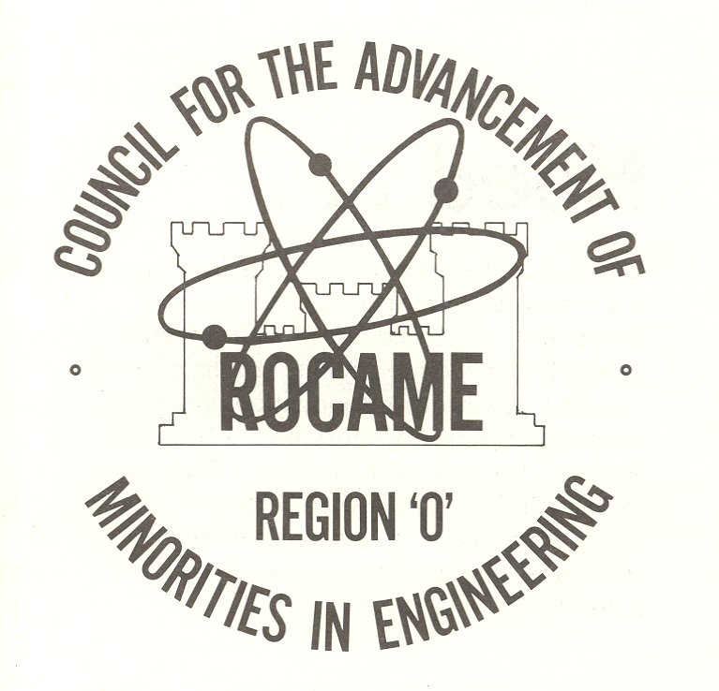

2018 ROCAME STUDENT OF THE YEAR
(High School)

Please type or use dark ink – must be legible

LEA:____________________________ SCHOOL: _______________________________

Student's Name _____________________________________________

Address _______________________________________________________________

Telephone Number ______________________

Grade Point Average (GPA) through First Semester 2017-2018:
Please list activities and achievements earned from March 2017 through February 2018.

Scholastic Achievements:

Other Significant Academic Achievements:

ROCAME Activities:

School Activities:

Community Activities:

List other skills to consider:

Attach a transcript and a typed 250 word essay on "What ROCAME Means to Me.”
Deadline for application to School System coordinator, March 30, 2018. One application from each school system must be submitted by the School System coordinator to the ROCAME Board of Directors by April 6, 2018.

2018 ROCAME STUDENT OF THE YEAR
(Middle School)

Please type or use dark ink – must be legible

LEA:____________________________ SCHOOL: _______________________________

Student's Name _____________________________________________

Address _______________________________________________________________

Telephone Number ______________________

Grade Averages through First Semester 2017-2018:
Please list activities and achievements earned from March 2017 through February 2018.

Scholastic Achievements:

Other Significant Academic Achievements:

ROCAME Activities:

School Activities:

Community Activities:

List other skills to consider:

Attach a copy of first semester grades (or transcript) and a typed 250 word essay on "What ROCAME Means to Me.”
Deadline for application to School System Coordinator, March 30, 2018. One application from each school system must be submitted by the School System Coordinator to the ROCAME Board of Directors by April 6, 2018.

