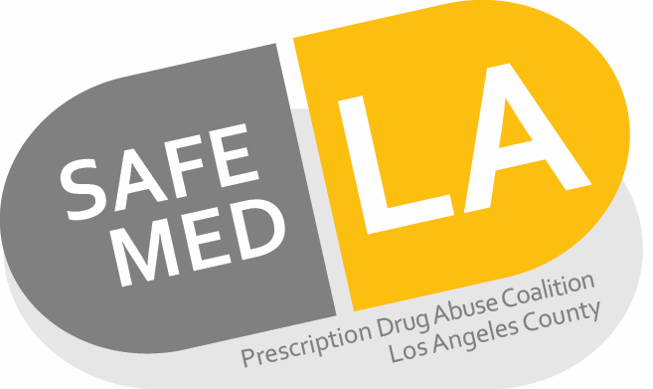
Formulary Naloxone Products
Health Plan | Line of Business (LOB) | Covered Products | Limits/Comments*
Aetna | Commercial | Narcan nasal spray and naloxone injection | n/a
Aetna | Medicare | Narcan nasal spray, and naloxone injections 0.4 mg/mL and 2 mg/mL | n/a
Anthem Blue Cross | Commercial | Naloxone vials and syringes, Evzio, Narcan nasal spray | Evzio is non-preferred, requires step therapy with preferred agents. Quantity limit of 6 syringes/vials per 3 months, 6 nasal sprays (3 cartons) per 3 months or 6 auto-injectors per 3 months
Anthem | Medicare | Naloxone vials and syringes (1 mg/mL, 0.4 mg/mL), Narcan nasal spray | n/a
Blue Shield of California | Commercial | Narcan nasal spray, vials and syringes | Quantity limit of two1mL vials/month or 2 syringes per month; for nasal spray quantity limit of 2 doses/month
Blue Shield of California | Medicare | Naloxone solution and syringes, Narcan nasal spray | Quantity limit of 2 mL per month for the solution; #2 per 30 days for the nasal spray
Care1st | Medicare | Narcan nasal spray | Quantity limit of 2 mL per day
CenCal Health | Medi-Cal | Naloxone hcl | Carved out for Medi-Cal members
Contra Costa Health Plan | All LOB | Naloxone 1 mg/ml Injector | Carved out for Medi-Cal members
Health Net of California | Commercial | Narcan nasal spray | Quantity limit of #4 sprays per month
Health Net of California | Medicare | Narcan nasal spray and naloxone syringes, Evzio, naloxone 2 mg/2 mL prefilled syringe | Quantity limit of #4 sprays per month, Evzio requires prior authorization
Humana | Medicare | Naloxone vial (0.4 mg/mL) and syringes (2 mg/2 mL) | n/a
Kaiser | All LOB | Naloxone hcl | n/a
L.A. Care Covered | Commercial | Naloxone syringes and Narcan nasal spray | n/a
L.A. Care | Medicare | Naloxone syringes and Narcan nasal spray | n/a
Medi-Cal plans | Fee for Service and Managed Medi-Cal Plan | Naloxone syringes and Narcan nasal spray | Carved out to fee for service
Molina Marketplace | Exchange | Narcan nasal spray, naloxone vials and syringes | Quantity limit of #2 per year
Molina | Medicare | Naloxone injection and syringes | n/a
Scan (Medicare) | Medicare | Narcan nasal spray and naloxone injection | n/a
Sharp Health Plan | Commercial | Narcan nasal spray | Quantity limit of #2 per 30 days on nasal spray
Sharp Health Plan | Medicare | Naloxone vials and syringes, Narcan nasal spray | Quantity limit of #4 per 30 days on the nasal spray
UnitedHealthcare | Medicare | Naloxone injection, Narcan nasal spray | n/a
*Prior authorization may be required, check individual benefit plans

Disclaimer: verification of individual plans and benefits may be required for formulary status. This information reflects formulary status as of January 2018 based on information available at the health plan websites.

