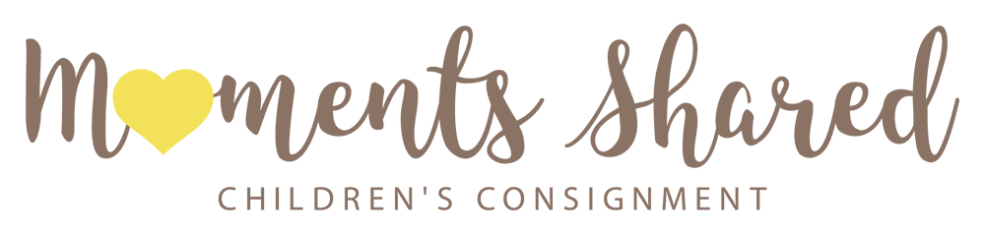

Consignment Agreement

Name: ________________________________ Email: ________________________________________
Address: __________________________________________ City: ________________ Zip: ___________
Phone Number: ( )_________________

Thank you for your interest in consigning with Moments Shared! Please read over our following terms and conditions:
- You have the option of receiving 40% of the selling price of your items by check or 60% in store credit toward any new or used purchase.

- Checks will be issued the first week of the month for the prior calendar month. A check will be issued once your account is over $5.00. Store credit is updated daily and can be redeemed in store.

- The consignment period is a total of 90 days. After the consignment period is over, any unsold items are to be picked up within 3 days. If not picked up after 3 days, items will be donated or become store property with no advance notice.

- Moments Shared will decide on the selling price of an item and can be discounted at any time up to 50% to encourage the sale.

- Accepted items will be chosen by Moments Shared. We reserve the right to select items based on current inventory, demand, season and current style.

- Clothing items must be clean and ready to sell in great condition with no stains, holes, rips, tears, fading, smells, pet hair or overly wrinkled.

- Non clothing items must also be clean and ready to sell, in great condition, in working order, include all original pieces and have no recalls or safety hazards for the particular model.
- Moments Shared is not responsible for lost or stolen items

Please select: Check
Store Credit

(If you wish to change your option in the future, you are free to do so in person for the following calendar month)

By signing below, you agree to the terms and conditions above.

_______________________________________________ _____________
Signature Date

Moments Shared appreciates your business!

