REGULAR MEETING

AUGUST 15, 2024

The Regular Meeting of the Town Board of the Town of Hampton, County of Washington and the State of New York was held at the Town Hall, 2629 State Route 22A, Hampton, New York, on the 15th day of August, 2024.

PRESENT: David K. O’Brien------------Supervisor

Donald Sady----------------- Councilman

Tamme Taran----------------Councilwoman - absent

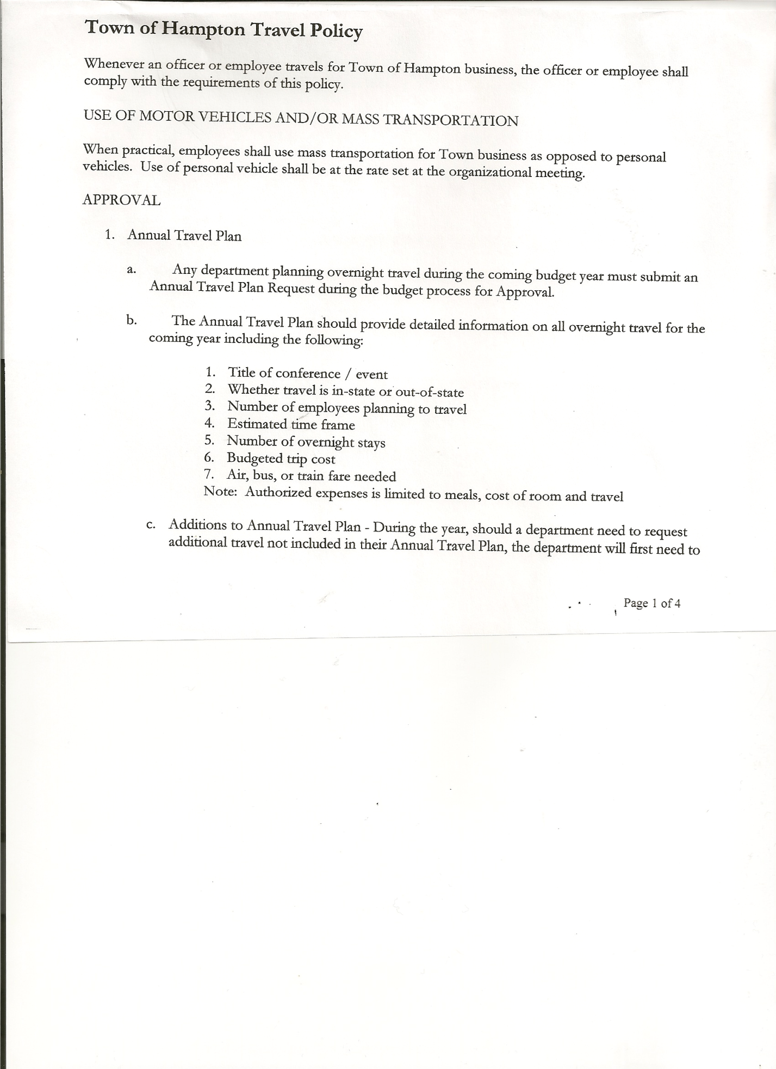 Michael Pietryka------------Councilman

Andrea Kugler---------------Councilwoman - absent

Rebecca Jones---------------Town Clerk

Camilla Shaw----------------Deputy Town Clerk

Tyler McClure---------------Highway Superintendent

Arek Gordon-----------------Town Assessor

Planning Board Member (s):… Bonnie Hawley, Chair; and Matthew Pratt

Others present at the Town Hall: see attached sheet

The Regular Meeting was called to order by Supervisor O’Brien at 7:30pm, followed by the Pledge of Allegiance. Location of Fire Exits were given. Quorum of board members present.

Supervisor O’Brien asked for a moment of silence in memory of Richard Dodd

**RESOLUTION NO. 74-2024**

**APPROVAL OF THE MINUTES**

On a motion of Councilman Pietryka, seconded by Councilman Sady, the following resolution was ADOPTED: AYES 3 O’Brien, Sady, Pietryka

NAYS 0

ABSENT 2 Taran, Kugler

RESOLVED, that the Regular Town Board Meeting Minutes for July 18th, 2024 are approved.

Dog Control Officer Report….no report submitted.

Tax Collector Report….Zero balance. The Town Clerk/Collector had Board Members review and sign bank reconciliation statements for the Tax Collector Account dated July 31, 2024.

Bonnie Hawley, Chair Planning Board….Planning Board Meeting was held August 14th, 2024.

Hampton Harvest on Rte. 4 is open daily from 10 to 5

Next meeting will be September 11, 2024 @7:00 at the Town Hall.

Tyler McClure, Highway Superintendent…submitted his report, copy of which is attached.

There were three (3) Sealed bids received for the purchase of the WB 150 2006 Komatsu Backhoe. The bids were as follows:

1. Caleb Loomis, no address given $ 3,250.00
2. Paul Hilder, 330 County Route 21,

Granville, NY $ 9,000.00

1. John Thomas Excavating, 2375 County Route 18

Hampton, NY $11,500.00

TOWN BOARD MEETING

AUGUST 15, 2024 PAGE 2

The following resolution was then introduced:

**RESOLUTION NO. 75-2024**

**HIGHWAY – BID**

On a motion of Councilman Pietryka, seconded by Councilman Sady, the following resolution was ADOPTED:

By Roll Call Vote: Supervisor O’Brien AYE

Councilman Sady AYE

Councilman Pietryka AYE

Councilwoman Taran ABSENT

Councilwoman Kugler ABSENT

RESOLVED to accept John Thomas Excavating bid of $11,500.00 for the WB 150 2006

Komatsu Backhoe.

**SUPERVISOR’S REPORT/COUNTY UPDATES/COMMUNICATIONS**

**RESOLUTION NO. 76-2024**

**APPROVAL OF SUPERVISOR’S MONTHLY REPORT**

On a motion of Councilman Pietryka, seconded by Councilman Sady, the following resolution was ADOPTED: AYES 3 O’Brien, Sady, Pietryka

NAYS 0

ABSENT 2 Taran, Kugler

RESOLVED that, the Supervisor’s Monthlyreport be accepted as submitted for **JULY**

ACCOUNT 7/01/24 Receipts Disbursed 7/31/24

Citizens Cemetery $ 3,590.57 $ .13 $ 562.90 $ 3,027.80

Citizens Total $ 3,590.57 $ .13 $ 562.90 $ 3,027.80

GFNB Fire, Trust & Agency $ 34,613.54 $ $ 33,195.50 $ 1,418.04

GFNB Fire, Trust & Agency ICS $ 33,805.00 $ $ $ 33,805.00

GFNB Health Insurance $ 2,591.23 $ $ $ 2,591.23

GFNB Trust & Agency $ 7,451.31 $ 3,780.89 $ 3,308.72 $ 7,923.48

GFNB General Fund $ 5,760.87 $ 7,910.79 $ 10,534.35 $ 3,137.31

GFNB General Fund ICS $ 59,180.41 $ 5,495.43 $ $ 64,675.84

GFNB Total $143,402.36 $17,187.11 $ 47,038.57 $113,550.90

GFNB Highway Fund $ 18,796.42 $123,000.00 $ 33,475.20 $108,321.22

GFNB Highway Fund ICS $ 227,239.16 $ 894.45 $ 123,000.00 $105,133.61

GFNB Capital Reserve $ 1,005.02 $ $ $ 1,005.02

GFNB Capital Reserve ICS $ 150,620.68 $ 592.87 $ $151,213.55

GFNB Total $ 397,661.28 $124,487.32 $ 156,475.20 $365,673.40

TOTALS $544,654.21 $141,674.56 $ 204,076.67 $482,252.10

All Board Members present signed Supervisor’s Report.

Great Meadow Correctional Facility….Supervisor O’Brien, Supervisor Scott Hahn (Hartford) retired Correctional Officer, Supervisor Nat Baker (Granville) retired Correctional Officer and Supervisor Bob Henke (Argyle) along with Carrie Woerner met with the Commissioner of Corrections to discuss the closure and repurpose of the Great Meadow Correctional Facility.

TOWN BOARD MEETING

AUGUST 15, 2024 PAGE 3

**RESOLUTION NO. 77-2024**

MOTION BY: Councilman Donald Sady

SECONDED BY: Councilman Michael Pietryka

**RESOLUTION IN OPPOSITION TO THE CLOSURE OF THE GREAT MEADOW CORRECTIONAL FACILITY IN THE TOWN OF FORT ANN**

**WHEREAS**, the Governor of New York has announced the closure of the Great Meadow Correctional Facility in the Town of Fort Ann, and

**WHEREAS**, the closure of the facility is currently slated for November 6, 2024, and

**WHEREAS**, the Great Meadow Correctional Facility is currently the top employer in Washington County with an estimate of 560 in its employ who are responsible for the operation of a correctional facility with a capacity of 1,595 inmates, and

**WHEREAS**, the economic impact of such a closure is not merely to the Town of Hampton, the Town of Fort Ann and Washington County, but to the other local municipalities, surrounding region, local school districts and local businesses that currently support the facility and staff, and

**WHEREAS,** the facility when abandoned will cause an additional blight on the local region due to the State’s lack of planning on any future use of the facility, which will sit abandoned, unmaintained, and deteriorating as have other facilities previously operated by the State, and

**WHEREAS**, Great Meadow has one of the only full mental health facilities as well as an intermediate level care facility and the effect of eliminating the availability of these mental health resources will be harmful to and dangerous for not only those individuals who must now be distributed to facilities without this level of support but as well as those entering the system who would be transferred to Great Meadow to assist with their personal needs, and

**WHEREAS**, Great Meadow’s Behavioral Health Unit (BHU) is a state of the art, self-contained unit with all housing, treatment classrooms, and recreational facilities and including 40 BHU beds, 102 Intermediate Care Program beds, 6 residential Care Treatment Program beds capable of 1:1 suicide watches, and 8 overflow dorm-style beds, and

**WHEREAS,** there is currently a statewide shortage of both BHU and ICP beds for incarcerated individuals in need, closure of Great Meadow will leave no facilities for care for individuals in crisis, and

**WHEREAS**, abandoning this BHU capability demonstrates a callous disregard for the mental health needs of incarcerated individuals and greatly diminishes their chances of returning to a safe, productive life after incarceration, and

**WHEREAS**, in the past five (5) years nearly $200 million in capital improvements to Great Meadow have been undertaken including a new facility powerhouse with a new boiler totaling $14 million, the rehabilitation of infrastructure plumbing and individual cell plumbing in 1,168 cells in A,B,C, and D Blocks, a new elevator in the Behavioral Health Unit, upgrades to the education building (Building 9) including new windows and HVAC totaling $15 million, a perimeter wall upgrade and repair for $11 million, a facility wide fire alarm upgrade totaling $13 million, facility-wide CCTV system installation including over 2300 cameras and related infrastructure, and an upgrade to the waste water treatment plant totaling over $3.1 million, and

**WHEREAS**, Washington Correctional and H Block (State Police Forensic Lab) is dependent on Great Meadow for their power supply, heating system, and sewer infrastructure, and

**WHEREAS**, the decision to close the facility is due to the inaction of the State to respond to long-known staffing and operational concerns presented over the past several years, and

TOWN BOARD MEETING

AUGUST 15, 2024 PAGE 4

**WHEREAS**, the estimated savings of the closure is projected at $77 million in year 1 with an additional $128 million annual thereafter, while at the same time adding $165.5 million for refugee and migrant programs that not only have no economic return but are projected to cost localities an additional $16.5 million in services, and

**WHEREAS**, the County is already facing significant budget crisis due to the additional costs of State imposed unfunded mandates for Medicaid, increased employer Retirement contributions and social service programs; now therefore be it

**RESOLVED**, that the Town Board of Hamton NY hereby states its opposition to the closure of the Great Meadow Correctional Facility; and be it further

**RESOLVED**, the closure of the Great Meadow Correctional Facility be reconsidered and in lieu of reconsideration be stayed until such time as a proper economic impact be prepared and reviewed and those impacted by the closure have proper and suitable time to review and consider any and all options that they may avail themselves to in order to plan for the safety, security and future prosperity of themselves and families; and be it further

**RESOLVED,** that a copy of this resolution be forwarded to Governor Hochul, Senators Stec and Ashby, Assemblymen Simpson, Woerner and Bendett along with the members of the NYS Commission of Corrections; Allen Riley; Yolanda Canty; and Elizabeth Gaynes.

BUDGET IMPACT STATEMENT: The closure of the Great Meadow Correction Facility will impact significantly the two (2) driving revenue sources for the County, namely Sales Tax and Property taxes and imposes an undue burden on the remainder of the Town and County residents.

DATED: August 15, 2024 Supervisor O’Brien AYE

Councilman Sady AYE

Councilman Pietryka AYE

Councilwoman Taran ABSENT

Councilwoman Kugler ABSENT

Arek Gordon, Town Assessor gave an update on the revaluation project for the Town of Hampton for the 2025 Assessment Roll. Arek has been working on analyzing all the sales required for the project. He will be doing data collection in the Town in the upcoming months. A Data Mailer will be going out to property owners around the end of October to verify inventory. Impact notices with new values will be sent out at the end of February.

**PUBLIC/COUNCIL COMMENTS**

North Quivey Hill Lane…..is a Class 4 road from Ambrosi’s driveway to the Granville Line, it is considered an unmaintained town road, which hasn’t been maintained for 40 years. Residents would need to update the road before the Town would maintain it again.

Supervisor O’Brien has received a paranormal request by the owner of the Hampton Motel on Route 4. He would like to visit several town cemeteries at night to take “readings” and to spend overnight in there. After a discussion it was the consensus of the board to let the people rest in peace in the cemetery.

Bonnie Hawley has an issue with a culvert by her property, Highway Superintendent Tyler McClure responded that she resides on a County Road and that they would need to come and clear the culvert.

TOWN BOARD MEETING

AUGUST 15, 2024 PAGE 5

**RESOLUTION NO. 78-2024**

**AUDIT OF CLAIMS**

On a motion of Councilman Sady, seconded by Councilman Pietryka, the following resolution was ADOPTED: AYES 3 O’Brien, Sady, Pietryka

NAYS 0

ABSENT 2 Taran, Kugler

RESOLVED that the bills have been reviewed by the Town Board and are authorized for payment in the following amounts.

General Fund No. 92 through No. 98 $ 2,210.29

Highway Fund No.110 through No.123 $ 15,521.64

Total both funds $ 17,731.93

The Town Clerk’s report for July 2024 was submitted to the Board. The Town Clerk had Board Members review and sign bank reconciliation statements for the Town Clerk Account and Special Town Clerk Account dated July 31, 2024.

**RESOLUTION NO. 79-2024**

**MEETING ADJOURNED**

On a motion of Councilman Sady, seconded by Councilman Pietryka the following resolution was ADOPTED: AYES 3 O’Brien, Sady, Pietryka, Taran

NAYS 0

ABSENT 2 Taran, Kugler

RESOLVED that the meeting adjourned at 8:22pm.

Respectfully submitted,

Rebecca S. Jones, RMC

Town Clerk