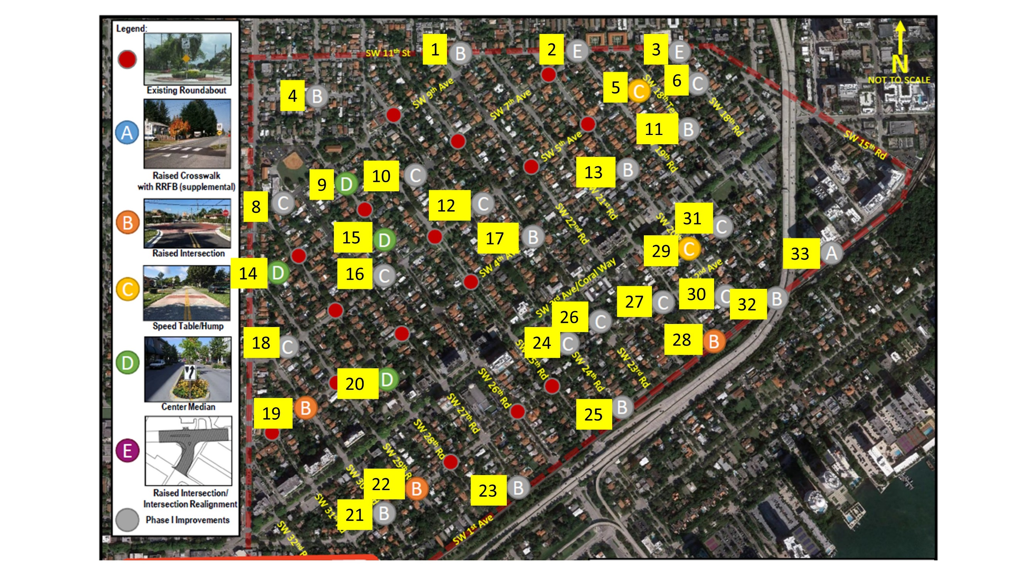

|  |  |
| --- | --- |
| **Number** | **Comments:** |
|  |  |
|  |  |
|  |  |
|  |  |
|  |  |
|  |  |
|  |  |
|  |  |
|  |  |