REGULAR MEETING
APRIL 16, 2020
A Regular Meeting of the Town Board of the Town of Hampton, County of Washington and the State of New York was held at the Town Hall and via Zoom, 2629 State Route 22A, Hampton, New York on the 16th day of April 2020.

Due to the Corona Virus, the OPEN MEETINGS LAW has been suspended by New York State,
therefore our Regular Town Board Meeting was closed to the Public. Supervisor O’Brien did provide a link to join the Zoom meeting.

PRESENT: David K. O’Brien------------Supervisor
Tamme Taran----------------Councilwoman, via Zoom
Donald Sady-----------------Councilman – via Zoom
Andrea Sweeney------------Councilwoman – via Zoom
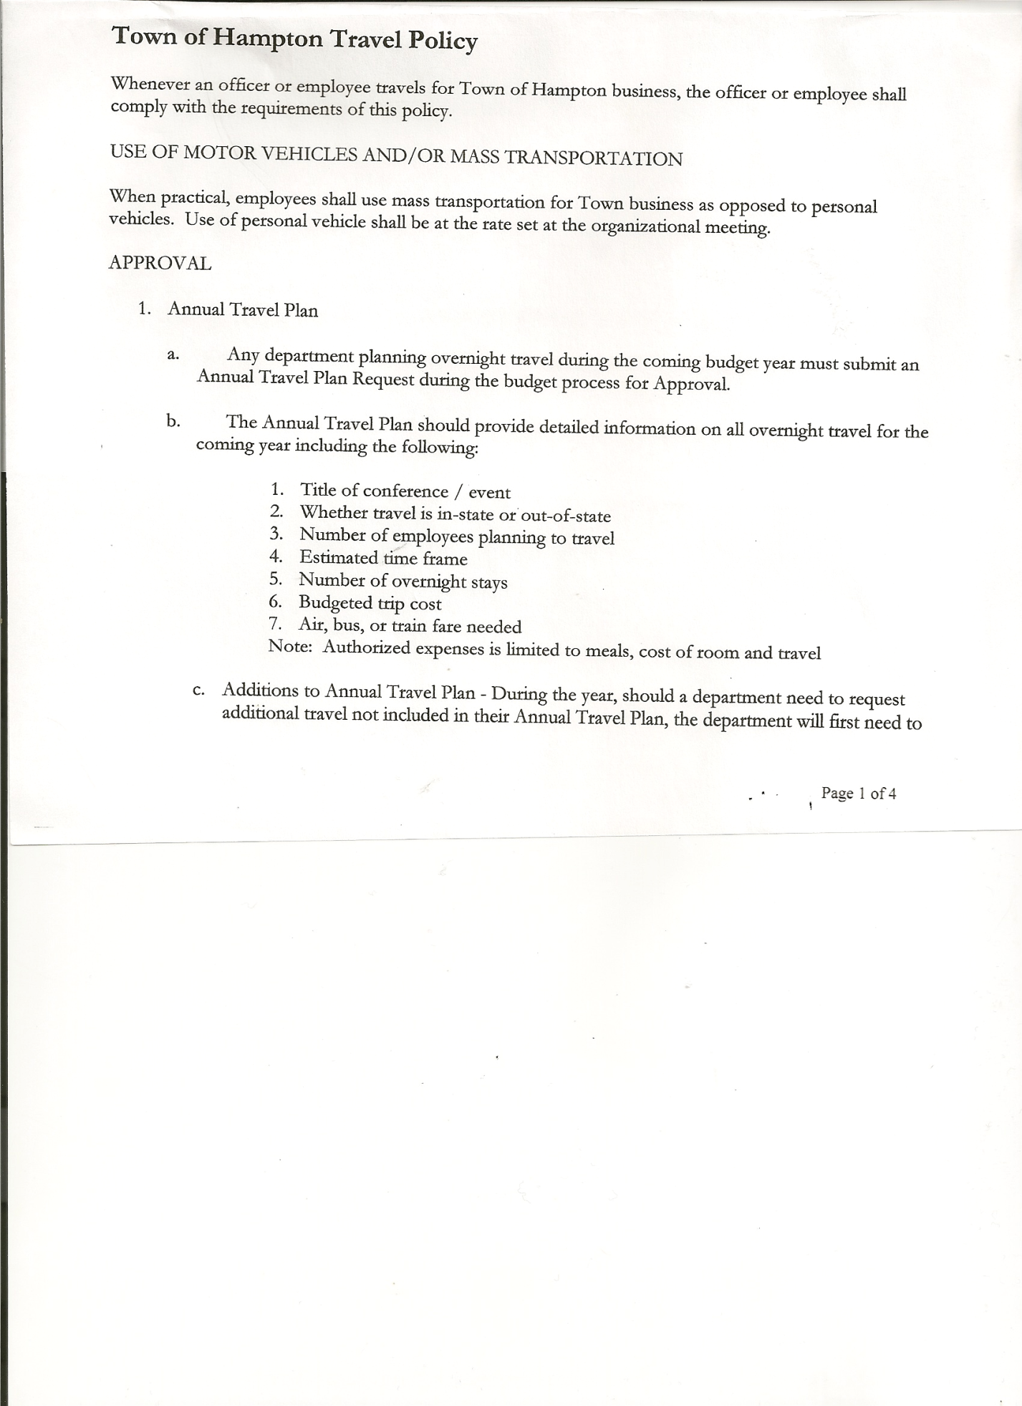
Michael Pietryka------------Councilman
Rebecca Jones---------------Town Clerk
Camilla Shaw----------------Tax Collector/Deputy Town Clerk – via Zoom
Herbert Sady, Jr.-------------Highway Superintendent – via Zoom

Planning Board Member(s): Bonnie Hawley, Chair; Ginny Kinsey, Matthew Pratt and Renee Rountree all via Zoom.

The Regular Meeting was called to order by Supervisor O’Brien at 7:30pm, followed by the Pledge of Allegiance. Location of Fire Exits were given. Quorum of board members present.

RESOLUTION NO. 34-2020
APPROVAL OF THE MINUTES
On a motion of Councilwoman Taran, seconded by Councilman Sady, the following resolution was ADOPTED:
By Roll Call Vote: Supervisor O’Brien AYE
Councilman Sady AYE
Councilwoman Taran AYE
Councilwoman Sweeney AYE
Councilman Pietryka AYE
RESOLVED, that the Regular Town Board Minutes for March 19th, 2020 are approved.

Larry Carman, Dog Control Officer submitted his report, which was read by Supervisor O’Brien, copy of report is attached for 03/17/20-04/15/20.

Tax Collector’s Report – Submitted March 2020 report to the Board. There were approximately 82 unpaid parcels. Also submitted Bank Statement to the Board for review and signatures.

Planning Board Report…
- Planning Board Presentation of Need for An Agricultural Protection Plan
(copy is attached)
- Preparation for Applying for a State Grant from NYS Dept. of Agriculture and Markets (copy is attached)
Supervisor O’Brien mentioned that most state grants you must put up the money first and then get reimbursed. Bonnie stated that is not how it was explained to her, but she would get clarity on this and about any other fees i.e. Attorney fees.

TOWN BOARD MEETING
APRIL 16, 2020 PAGE 2

Herbert Sady, Jr., Highway Superintendent submitted his report, copy of which, is attached.
On Tyler being out for COVID-19 reason, Supervisor O’Brien stated that the Town would follow County guidelines and would not penalize him for sick time due to virus reasons.

Town Clerk Jones thanked the Highway Dept. for cleaning up around the Town Hall and Garage.

Supervisor O’Brien stated that the WEX card is not being used as there were two (2) State Contract prices and we were not getting the best deal. Went back to buying diesel for the tank.

SUPERVISOR’S REPORT/COUNTY UPDATES/COMMUNICATIONS

RESOLUTION NO. 35-2020
APPROVAL OF SUPERVISOR’S MONTHLY REPORT
On a motion of Councilwoman Taran, seconded by Councilman Sady, the following resolution was ADOPTED:
By Roll Call Vote: Supervisor O’Brien AYE
Councilman Sady AYE
Councilwoman Taran AYE
Councilwoman Sweeney AYE
Councilman Pietryka AYE
RESOLVED that, the Supervisor’s Monthly report be accepted as submitted for MARCH
02/29/20 03/31/20
ACCOUNT BALANCE RECEIPTS DISBURSEMENTS BALANCE
General Fund $ 71,064.40 $ 1,454.95 $ 5,161.72 $ 67,357.63
Highway Fund $ 196,434.09 $ 8.05 $ 26,752.93 $ 169,689.21
Equipment Reserve $ 64,857.14 $ 2.75 $ 0.00 $ 64,859.89
Fire #1 $ 42,448.00 $ 0.00 $ 0.00 $ 42,448.00
Fire #2 $ 10,000.00 $ 0.00 $ 0.00 $ 10,000.00
Cemetery $ 1,727.00 $ 2.29 $ 0.00 $ 1,729.29
Totals $386,530.63 $ 1,468.04 $ 31,914.65 $356,084.02
All Board Members present signed Supervisor’s Report.

Broadband Info….copy of update from Supervisor O’Brien. (copy attached)

OLD BUSINESS
Reassessment….Vicki is starting to do some groundwork. She may not complete in the next year, as she is afraid if we do this year and prices fall from the virus effects – she may defer for a year to when things stabilize.

First Responder Progress….Matthew Pratt stated they have not had a meeting recently, but he will check with the Chief on the progress.

NEW BUSINESS
Supervisor O’Brien emailed to board members for their review a Franchise Agreement with Spectrum.

TOWN BOARD MEETING
APRIL 16, 2020 PAGE 3

The Town Clerk’s report for March 2020 was submitted to the Board. The Town Clerk had Board Members review and sign bank reconciliation statements for the Town Clerk Account and Special Clerk Account dated March 31st, 2020.

RESOLUTION NO. 36-2020
AUDIT OF CLAIMS
On a motion of Councilwoman Taran, seconded by Councilman Sady, the following resolution was ADOPTED:
By Roll Call Vote: Supervisor O’Brien AYE
Councilman Sady AYE
Councilwoman Taran AYE
Councilwoman Sweeney AYE
Councilman Pietryka AYE
RESOLVED that the bills have been reviewed by the Town Board and are authorized for payment in the following amounts.
General Fund No. 35 through No. 41 $ 2,528.45
Highway Fund No. 42 through No. 49 $ 4,053.57
Total both funds $ 6,582.02

RESOLUTION NO. 37-2020
MEETING ADJOURNED
On a motion of Councilman Sady, seconded by Councilwoman Taran, the following resolution was ADOPTED:
By Roll Call Vote: Supervisor O’Brien AYE
Councilman Sady AYE
Councilwoman Taran AYE
Councilwoman Sweeney AYE
Councilman Pietryka AYE
RESOLVED that the meeting adjourned at 8:18pm.

Respectfully submitted,

Rebecca S. Jones, RMC
Town Clerk

