Montessori Summer Camp 2015 Information
Camp Dates: June 15th – August 21st
Ages: 13 months to 9 years
Camp Hours: 8 a.m. to 4 p.m.
Before Camp Hours: 7 a.m. to 8 a.m.
After Camp Hours: 4 p.m. to 5:30 p.m.
Registration Fee: A one-time $30.00 registration fee will be charged to each individual camper. This fee includes a camp T-shirt, water bottle and two healthy snacks daily.
Special Pricing: Register your camper by April 27th and pay in advance for 6 weeks of camp or more, to waive ALL before and after camp fees!
Important information: MCHL does not offer meals. Parents are to send a lunch daily (we are nut-free). We offer water at lunch time and with each snack. Please provide one labeled bottle of sunscreen (complete a medical form), change of clothes, bathing suit and towel to keep in your child’s locker.
Field Trips: We try to attend one field trip per week. Participation is optional. This is an additional expense and you will be notified with details the week prior to the trip. Trips include: Adrian City Library, Bohn Pool, and The Centre Park. Field trips are for campers ages 5 and up.
Payments: MUST ARRANGE IN ADVANCE & PAY BY WEEK
Toddler (Ages 13 months - 3 Years) June 15 - August 21
Preprimary/School Age (3-9 Years) June 15 – August 21
PROGRAM DAYS | WEEKLY RATE | 10 WEEKS FULL-TIME PAID IN FULL AMOUNT
FULL DAYS 8 a.m. – 4 p.m.
5 Full (M-F) | $125.00 | $1250.00
3 Full | $90.00 | $900.00
2 Full | $70.00 | $700.00
1 Full | $40.00 | $400.00
Before & After Camp Care |  | $40.00 per week for unlimited use
Open: 7-8 a.m. & 4-5:30 p.m. |  | Drop in rate $7.00 per hour (must be approved by office administration)

Montessori Camp Commitments
Parents: Please return these forms completed to the MCHL front office. One packet per child.

Week 1 Dates: June 15-19 Theme: Creative Creations
My child will be attending: O 1 Day O 2 Days O 3 Days O 4 Days O 5 Days
If attending less than 5 days please circle below what days your child will be attending camp:
MONDAY TUESDAY WEDNESDAY THURSDAY FRIDAY

Week 2 Dates: June 22-26 Theme: Lego Engineering
My child will be attending: O 1 Day O 2 Days O 3 Days O 4 Days O 5 Days
If attending less than 5 days please circle below what days your child will be attending camp:
MONDAY TUESDAY WEDNESDAY THURSDAY FRIDAY

Week 3 Dates: June 29- July 3 Theme: All about Me!
My child will be attending: O 1 Day O 2 Days O 3 Days O 4 Days O 5 Days
If attending less than 5 days please circle below what days your child will be attending camp:
MONDAY TUESDAY WEDNESDAY THURSDAY FRIDAY

Week 4 Dates: July 6-10 Theme: Mad Scientist
My child will be attending: O 1 Day O 2 Days O 3 Days O 4 Days O 5 Days
If attending less than 5 days please circle below what days your child will be attending camp:
MONDAY TUESDAY WEDNESDAY THURSDAY FRIDAY

Week 5 Dates: July 13-17 Theme: Storytelling/Drama
My child will be attending: O 1 Day O 2 Days O 3 Days O 4 Days O 5 Days
If attending less than 5 days please circle below what days your child will be attending camp:
MONDAY TUESDAY WEDNESDAY THURSDAY FRIDAY

Week 6 Dates: July 20-24 Theme: Authors
My child will be attending: O 1 Day O 2 Days O 3 Days O 4 Days O 5 Days
If attending less than 5 days please circle below what days your child will be attending camp:
MONDAY TUESDAY WEDNESDAY THURSDAY FRIDAY

Week 7 Dates: July 27-31 Theme: Summer Fiesta
My child will be attending: O 1 Day O 2 Days O 3 Days O 4 Days O 5 Days
If attending less than 5 days please circle below what days your child will be attending camp:
MONDAY TUESDAY WEDNESDAY THURSDAY FRIDAY

Week 8 Dates: August 3-7 Theme: Let’s Get Cooking!
My child will be attending: O 1 Day O 2 Days O 3 Days O 4 Days O 5 Days
If attending less than 5 days please circle below what days your child will be attending camp:
MONDAY TUESDAY WEDNESDAY THURSDAY FRIDAY

Week 9 Dates: August 10-14 Theme: Jungle Safari
My child will be attending: O 1 Day O 2 Days O 3 Days O 4 Days O 5 Days
If attending less than 5 days please circle below what days your child will be attending camp:
MONDAY TUESDAY WEDNESDAY THURSDAY FRIDAY

Week 10 Dates: August 17-21 Theme: Water Works
My child will be attending: O 1 Day O 2 Days O 3 Days O 4 Days O 5 Days
If attending less than 5 days please circle below what days your child will be attending camp:
MONDAY TUESDAY WEDNESDAY THURSDAY

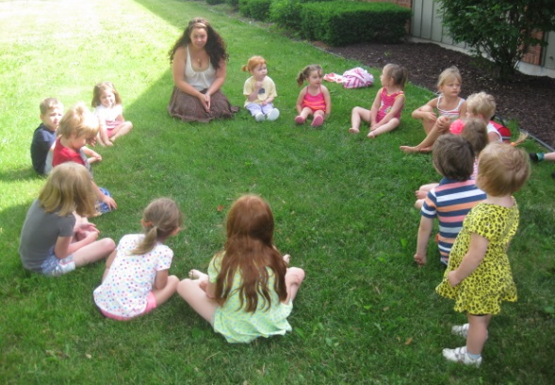
Child Information
Last Name: ______________________________ First Name: ______________________________
DOB: ________________________
Address: _______________________________________ City: __________________ State: _____
Zip Code: ___________________
Phone #: _____________________ Gender: ___________________ Age: ____________________

Parent/Guardian Information
Last Name: _____________________________ First Name: _______________________________
Email: ___________________________________________________
Primary #: ___________________ Secondary #: __________________

Last Name: ______________________________ First Name: ______________________________
Email: ___________________________________________________
Primary #: ___________________ Secondary #: __________________

Emergency Contact
Name: ___________________________________Telephone #:___________________________
Relation: _________________________________

Name: ___________________________________Telephone #: ___________________________
Relation: _________________________________
Office Use Only
Registration Fee: $30.00 O PAID CASH or CHECK #__________
T-shirt size: ___________________________________________
DATE FILED: ______________________ INITIALS: ______________________

