Ladies in Training: Session 5– December 5th, 2014
Today’s lesson was all about reading comprehension!
Academics
At first, we went over the math homework from last session about math- we specifically focused on the harder problems that were more frequently missed and we encourage students to make corrections to all their homework!
We started practicing reading comprehension straight after- allowing them to go through a “pretest” packet in which they read a passage and answered questions. They also got to write their very own continuation of the story!
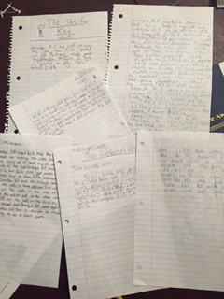

Creative and Teamwork Skill
The kids participated in a game where the girls worked together in order to form a circle where each person sat on another without anyone shouldering all the weight. This game stressed trust, reliance, and teamwork, and the girls performed amazingly!
Next, we played Heads Up, a popular iPad game in which one team member guesses what the others are trying to “act out”. The girls seemed to really enjoy the game and the team-bonding exercise. They were also given a sweet treat afterwards!
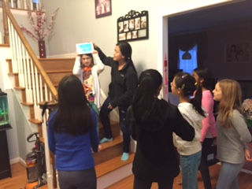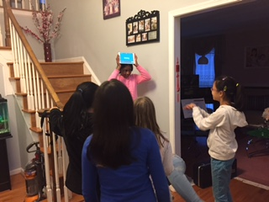

We look forward to seeing everyone next session!
-Isabelle and Emily

