PPL 388 Public Policies of European Union

SPRING 2019

LOTT 213

Tuesday-Thursday 8.00-9.15

Left: Interieur d’una habitation Russe pendant la nuit (the interior of a Russian habitation at night) in Chappe D’Auteroc, 1768. West European travelers to Russia in the 18th Century found evidence of backwardness both in the exterior forms of ‘huts’ and in the interior scenes of domestic life, considered promiscuous and inappropriate. Right: Map of the European Union, 2019. This course analyzes how the formation of identity in Europe since the 18th Century was built upon the denigration of the ‘East,’ and how such a deeply seated understanding of Eastern Europe as relatively backward is influencing today the concrete policies of the European Union. In doing so, it shows the interrelations between identity, public policy, and economic change in Europe.

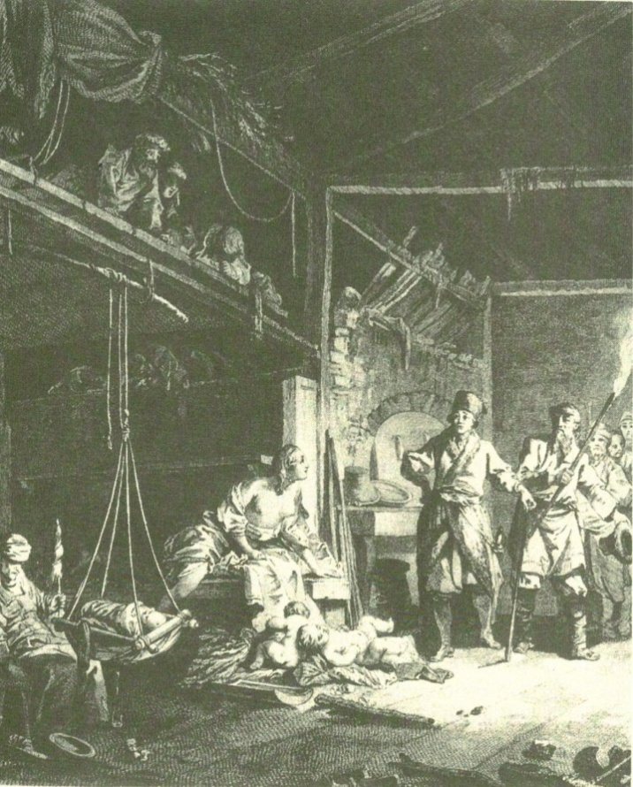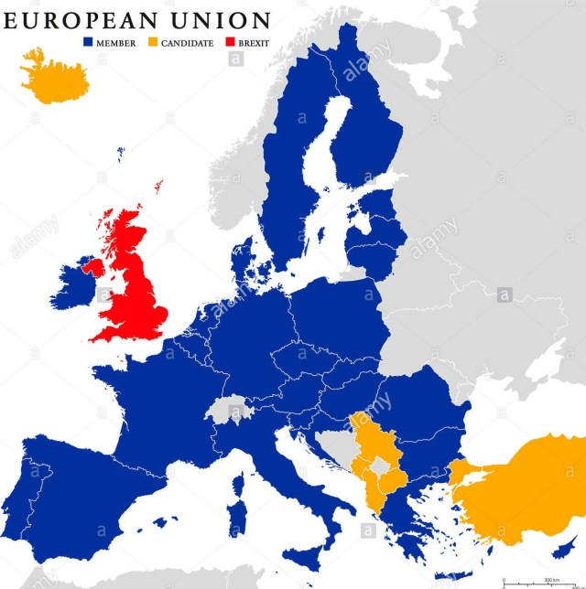

Christian Sellar,
106 Lott Leadership
Tel. (office) 662.915.6613
csellar@olemiss.edu
Office hours: by appointment, Mon-Wed-Fri 10.00-11.00

Description
This course focuses on the mutual influence between identity politics in Europe and policies of the European Union. Specifically, it analyzes Government policies at EU, national, and local levels, highlighting how policies constitute the pivotal points between identity politics – and specifically the contested emergence of a European identity – and recent threats such as the decision of the UK to leave the EU (Brexit) and immigration

The course builds on geography, economic sociology, and cultural studies. It is reading based, organized around three main sections: 1) European identity, politics, and the ‘New Europe;’ 2) European Union regional policies and neighbourhood; 3) Brexit. In the first section, students will familiarize with the debates concerning the emergence of a European identity, and the specific role of Eastern Europe in shaping IT. It builds upon the work of philosophers, geographers, sociologists, historians. The second section discusses the process of institutional integration in the European Union. The third section focuses on the UK exiting the Union. Class time will be divided between short lectures that contextualize the readings, exercises and quizzes, and discussion of selected readings. Videos and films will be integrated into class times wherever possible.

Students will carry out weekly readings, write response papers, make presentations and lead discussions on specific readings, write one policy analysis, and take a map quiz.

Learning objective
- Students will analyse philosophical debates about the meaning of ‘Europe’ and ‘European identity’
- Students will describe the institutions and policy processes of the European Union, and learn how specific policies shape affect government agencies within the EU and its neighbourhood.
- Students will understand how the framing of identity translates into policies.
- Students will be able to produce a memo on a specific EU policy

Description of examinations
One quiz on geographical locations will be given during the semester. These will variously test students’ knowledge of the geographical aspects of the EU integration and European history.

Students will write a paper that analyzes a EU policy of their choice. The paper will be written in several steps, each of them will be graded. The final paper will be revised and developed, with visual supporting materials, for presentation at the end of the semester.

Students will each write one three page response paper, from specific readings and topics from the course syllabus.

Students will prepare presentations and lead discussions on the readings

Presentations 20%
Attendance 20%
Response paper 10%
Map Quiz 20%
Policy analysis 30%

Grading Scale

A + | 97-100 |  | C+: | 77-79%
A: | 94-100% |  | C: | 74-76%
A-: | 90-93% |  | C- | 70-73
B+: | 87-89% |  | D: | 60-69%
B: | 84-86% |  | F: | Below 60%
B-: | 80-83%

Grading standards
A range: the task has been fully completed, bringing new and original insights to the work. Basically, you need to go beyond what is expected in the assignment. The A range will be graded on a curve, comparing A level works in each given assignment.
B range: an upper B grade corresponds to a perfect execution of the task assigned (consisting of a combination of style and fulfillment of instructions, as well as persuasiveness when needed). A low level B means there are some minor areas of improvement in the execution of the task.
C range: various levels of imperfection in style, fulfillment of instructions, or persuasiveness (for example, student writes a good paper, but uses a smaller amount of sources than required, or uses sources not appropriate to the level of the assignment).
D: Obvious deficiencies in understanding the assignment, highly problematic stylistic choices.
F: Student did not carry on the assignment as requested

Attendance and other Policies:
The University requires instructors to verify the attendance/participation of students in ALL courses within the first two weeks of the semesters. Formal verification of student attendance/participation will be done in the second week of classes.
In this class, attendance is mandatory throughout the semester. Homework assignments will count as verification. Unjustified continuous absence for more than two weeks will result in an F grade at the end of class. Cumulative unjustified absence for more than eight classes (30% of class) will result in an F grade.
‘Unjustified absence’ is an absence without previous agreement with the instructor via email, phone or other means.
Unjustified late assignments (except homework) are not accepted. “Unjustified late assignment” is an assignment turned in after the deadline without previous consent of the instructor. Late homework are NOT accepted. Instead, students will be able to miss up to 4 homework with no penalty
Queries on grades may result in a lower grade.
Honor code applies.
Syllabus subject to change

Texts:
Online readings only; either posted on blackboard or available through hyperlinks on syllabus.

SCHEDULE

Introduction. Defining Europe and the European Union

1 Week 1. Tue January 22 – Thu Jan 24 Introduction: European Union, ‘Europe’ as identity, and the Brexit challenge

Adler-Nissen, R., Galpin, C., & Rosamond, B. (2017). Performing Brexit: How a post-Brexit world is imagined outside the UK. British Journal of Politics and International Relations, 19(3).

Michael Biggs. Putting the state on the map: Cartography, Territory, and European State Formation. Comparative Studies in Society and History, 41(2) April 1999: 374-405.

From the EU portal:
History of the European Union: http://europa.eu/about-eu/eu-history/index_en.htm
Europe in 12 lessons (available on blackboard)
EU in slides. Heavy file! Please go to https://europa.eu/european-union/documents-publications/slide-presentations_en . Either download ‘all the slides in one file’ (~20 mega) or download sections separately

Section 1 The shifting identities of Europe and Europeans

Week 2 Tue Jan 29 – Thu Jan 31 – Tue Feb 5 The construction of identity, or why ‘others’ matter in world politics:

Tuesday: watch BBC News Special Desperate Journeys Europe's Migrant Crisis - BBC Documentary 2015 https://www.youtube.com/watch?v=6g0Ps14_oLI

And NIGEL FARAGE 2015 - SHOCKING, UNSEEN FOOTAGE OF MUSLIM REFUGEES ATTACKING EVERYWHERE IN EUROPE! https://www.youtube.com/watch?v=xgV9clS5iG8

Prepare a three page essay explaining how the videos represent a) Europe and European institutions b) their response to the migrant crisis c) what do you understand about European identities from the films? Which one do you think it matter most, the ‘European’ or ‘national’ identities in the face of the crisis?

Thursday/Tuesday

Neumann, I. Uses of the other Minneapolis, U. Of Minnesota Press, 1999, Chapter 1 “Uses of the other in world Politics” pp 1-39

Book review: Benedict Anderson, reflections on the origin and spread of nationalism http://worldview.carnegiecouncil.org/archive/worldview/1984/07/4183.html/_res/id=sa_File1/v27_i007_a010.pdf

Checkel (2001) Why Comply? Social Learning and European Identity Change International Organization, Vol. 55, No. 3 pp. 553-588

Week 3 Thu Feb 7 Tue Feb 12 Constructing Europe: Europeans and the ‘East.’ The Cold War

Europeans and the East
Neumann, I. Uses of the other Minneapolis, U. Of Minnesota Press, 1999, Chapter 3 “Making Europe: the Russian other” pp 1-39

Bakic-Hayden, M. (1995) Nesting Orientalisms: The Case of Former Yugoslavia Slavic Review, Vol. 54, No. 4 pp. 917-931
The Cold War

Woodrow Wilson International Center for Scholars: Cold War International History Project:
http://www.wilsoncenter.org/index.cfm?fuseaction=topics.home&topic_id=1409
publications list on the bottom right – browse those

Documents Relating to American Cold War Foreign Policy:
http://www.mtholyoke.edu/acad/intrel/coldwar.htm
those are real documents from the State department and other official sources. Not all links work. Open one or two just to get an idea

The Harvard Project on Cold War Studies: http://www.fas.harvard.edu/~hpcws/index2.htm
contains a link to the journal of Cold War Studies. Some articles are free

The Parallel History Project on NATO and the Warsaw Pact: http://www.php.isn.ethz.ch/
Interesting because it’s a non-US source. Many links don’t work, some do

Thursday February 14: MAP QUIZ – THE EU

Week 4 –Tue Feb 19 – Thu Feb 21 The end of the Cold War 2
Film: Goodbye Lenin – selected parts and discussion

Week 5 Tue Feb 26 – Thu Feb 28 Post Cold war reworking of European identities

Toal, G. O Loughlin, J. (2009). “After Ethnic Cleansing: Return Outcomes in Bosnia Herzegovina a decade Beyond War.” Annals, Association of American Geographers Vol. 99, no. 5
http://www.colorado.edu/ibs/pec/johno/pub/AnnalsBiHreturns.pdf

C. Sellar (2009) From ‘Exotic’ to ‘Familiar.’ Italian Textile and Clothing Firms and the Shifting Perception of Eastern Europe Journal of Cultural Geography 26: 3, 327-348.

Cash, J. (2009) The Communists cannot take us to Europe’’: negotiating Moldova’s place in the post-socialist world Eastern Europe Journal of Cultural Geography 26: 3,

Light, J. Young, C. (2009) European Union enlargement, post-accession migration and imaginative geographies of the ‘New Europe’: media discourses in Romania and the United Kingdom Journal of Cultural Geography 26: 3,

Mamadouh, V. (2009) Establishing a Constitution for Europe during European Union enlargement? Visions of ‘Europe’ in the referenda campaigns in France and the Netherlands Journal of Cultural Geography 26: 3,

Week 6 Tue March 5 Thu March 7 European citizenship and migration

Zemni (2002) Islam, European identity and the limits of multiculturalism Published in: SHADID, W.A.R. & VAN KONINGSVELD, P.S. (red.), Religious Freedom and the Neutrality of the State: The Position of the European Union, Leuven: Peeters, 2002, pp.158-173. http://www.cie.ugent.be/CIE/zemni3.htm

Maarten P. Vink, R. Baubock (2012) Citizenship conﬁgurations: Analysing the multiple purposes of citizenship regimes in Europe Comparative European Politics 1, 28 http://www.migrationpolicycentre.eu/docs/SummerSchool2013/readings/Baubock%20-%20Reading.pdf

van Riemsdijk, M. (2012). (Re)scaling governance of skilled migration in Europe: Divergence, harmonization, and contestation. Population, Space and Place 18 (3), 344-358.
http://www.ecsa-c.ca/biennial2010/Conference_Papers_files/Vanriemsdijk.pdf

van Riemsdijk, M. (2010). Variegated privileges of whiteness: Lived experiences of Polish nurses in Norway. Social and Cultural Geography 11 (2), 117-137.

van Riemsdijk, Micheline (2013). Obstacles to the free movement of professionals: Mutual recognition of professional qualifications in the European Union. European Journal of Migration and Law 15 (1), 47-68

van Riemsdijk, Micheline (2010). Neoliberal reforms in elder care in Norway: Roles of the state,
Norwegian employers, and Polish nurses. Geoforum 41 (6), 930-939

MARCH 9-17 – SPRING BREAK

Week 7 Tue March 19 – Thu March 21

Brexit vote
Debates before:
Vasilopoulou, S., 2016. UK Euroscepticism and the Brexit Referendum. The Political Quarterly, 87(2), pp.219-227.

Curtice, J., 2016. A Question of Culture or Economics? Public Attitudes to the European Union in Britain. The Political Quarterly, 87(2), pp.209-218.

Hix, S., 2016. Does the UK Have Influence in the EU Legislative Process?. The Political Quarterly, 87(2), pp.200-208.

Minto, R., Hunt, J., Keating, M. and Mcgowan, L., 2016. A Changing UK in a Changing Europe: The UK State between European Union and Devolution. The Political Quarterly, 87(2), pp.179-186.

Reflections after
Jessop, B. (2017). The organic crisis of the British state: Putting Brexit in its place. Globalizations, 14(1), 133-141.

Becker, S. O., Fetzer, T., & Novy, D. (2017). Who voted for Brexit? A comprehensive district-level analysis.

Hix, S. (2018). Brexit: where is the EU–UK relationship heading?. JCMS: Journal of Common Market Studies, 56, 11-27.

Hobolt, S. B. (2018). Brexit and the 2017 UK general election. JCMS: Journal of Common Market Studies, 56, 39-50.

Colantone, I., & Stanig, P. (2018). Global competition and Brexit. American political science review, 112(2), 201-218.

Tue March 26 – Thu March 28 flex week,
Brexit special
Subscribe and listen to ‘Brexit a Love story’ podcast by BBC 4

Brexit explained
https://www.youtube.com/watch?v=NgVhRVrANhA

Watch key Brexit videos by the BBC:
Brexit: Theresa May gives Downing Street statement - BBC News Jan 15 2019 https://www.youtube.com/watch?v=Ov9a-PDTpoM

Others coming while Brexit approaches

Thu MARCH 28 : RESEARCH STEP 1
Volunteer needed

APRIL 1-7 PROFESSOR AWAY AT CONFERENCE
Work on research project

Section 2 EU widening, or how identity shifts are affecting policies

Week 8 Tue April 9 Thu April 11 ‘Europeanization’: how EU institutions shape identity and vice-versa

EU Commission (2013) The European Union Explained Brussels, DG Communications

Kuus,, M. (2011), Bureaucracy and place: expertise in the European Quarter. Global Networks, 11: 421–439. doi: 10.1111/j.1471-0374.2011.00334.x

Clark J, A. Jones (2011) ‘Telling Stories about Politics’: Europeanization and the EU’s Council Working Groups JCMS 49, 2, 341-366

Clark, J. Jones, A. (2008) The spatialities of Europeanization: territory, power and governance in Europe, Transactions of the Institute of British Geographers NS, 33, 300–318.

C. Sellar, L. McEwen (2011) A cosmopolitan analysis of the contradictions in EU Regional and Enlargement policies as drivers of Europeanization European Urban and Regional Studies, 18:3, 289-305.

From the EU portal:
List of EU institutions and their competencies http://europa.eu/about-eu/institutions-bodies/index_en.htm
EU Procedures http://europa.eu/eu-law/decision-making/procedures/index_en.htm

Tue April 9 RESEARCH STEP 2
This is your only chance to get feedback

Week 9 Tue April 16 – Thu April 18 –Enlargement: policies

European Commission, “Enlargement Strategy 2014-2015 http://ec.europa.eu/enlargement/pdf/key_documents/2014/20141008-strategy-paper_en.pdf

Milada Anna Vachudova (2008) “Tempered by the EU? Political Parties and Party Systems Before a nd After Accession,” Journal of European Public Policy 15,

Moravcsic A. M. Vachudova (2005) Preferences Power and Equilibrium in The Politics of European Union Enlargement: Theoretical Approaches in Schimmelfenning and Sedelmeier The Politics of European Union Enlargement: Theoretical Approaches New York Routledge

Kuus, M. ‘Europe’s eastern expansion and the reinscription of otherness in East-Central Europe’, Progress in Human Geography, 28: 2004, 472-89.

Kuus, M (2011) Whose regional expertise? Political geographies of knowledge in the European Union European Urban and Regional studies 18, 3, pp. 275-288.

Section 3 EU Deepening: the issues and challenges to economic integration

Week 10 Tue April 23 Thu April 25 regional policies and the neighborhood

EU – Inforegio. Powerpoint presentations on EU regional policies: http://ec.europa.eu/regional_policy/information/presentations/index_en.cfm
Please download powerpoint ‘History and evolution of EU Regional and Cohesion Policy’ and ‘General presentation on proposals for Cohesion Policy 2014-2020 ‘

Prokkola E. K. Zimmerbauer, F. Jakola (2012) Performance of regional identity in the implementation of European cross-border initiatives European Urban and Regional Studies published online 25 November 2012 DOI: 10.1177/0969776412465629

Sellar, C. (2014) Building a transnational fusion bureaucracy? A study of state officials and opinion leaders in Rousse (Bulgaria) and Transcarpathia (Ukraine) Geopolitics published online 9 May 2014, DOI: 10.1080/14650045.2014.883381

European Neighborhhod Policy http://eeas.europa.eu/enp/index_en.htm
Please browse the website, especially the subheadings on the right: ‘What is the ENP/’ How does it work? How is it financed? What are the benefits
Then read: Neighbourhood at the Crossroads: Implementation of the European Neighbourhood Policy in 2013 http://eeas.europa.eu/enp/pdf/2014/joint_communication_en.pdf

Kuus, M. (2011) Policy and Geopolitics: Bounding Europe in Europe Annals of the Association of
American Geographers, 101:5, 1140-1155

M. Casas-Cortes, S. Cobarrubias, and J. Pickles, (2012) ‘Re-Bordering the Neighbourhood: Europe’s Emerging Geographies of Non-Accession Integration’, European Urban and Regional Studies, p. 8 (published online 30 May 2012) doi:10.1177/0969776411434848.

Tue April 23 RESPONSE PAPER DUE

Week 12 Tue April 30 – RESEARCH SUPPORT LECTURE class will take place in Library classroom 106E – librarian Cecilia Parks will instruct on the use of library resources

Thu May 2 CLASS WRAP UP AND OPEN QUESTIONS

Final exam, Tuesday May 7, 8 am RESEARCH STEP 3

INSTRUCTIONS ON HOW TO WRITE YOUR PAPERS FOLLOW:

RESPONSE PAPERS

All the short papers assigned in class must be written as response papers. They must NOT summarize the main points of the article/s read during the previous weeks, but must develop a point or set of points or themes that struck you, upon reading the assigned material, or listening to class discussions, as interesting, surprising, or puzzling; or which led you to think differently about the issue in question. In each instance you must not only say that statement X or point Y was interesting, or surprising, but explain exactly why it was interesting, or surprising. Or what it was about the point in the article that led you to think in a new or different way about the issue under discussion. For the reflection paper to work, it is important that your discussion be concrete and grounded, and not abstract, vague, or overly general. To avoid abstractness please be as specific as possible about the point you are making, and illustrate it, and ground it within concrete examples. The papers must not exceed three double-spaced pages.

POLICY PAPER

PPL students: this research paper builds upon what you have learned in PPL 101, and especially in Kraft Furlong, Public Policy. Politics, analysis, and Alternatives, Washington, CQ Press, 2007. Part 2 ‘Analyzing Public Policy’ pp92-179

STEP 1. In class exercise: discussion on how to write a policy paper

STEP 2. Choose the broad issue you want to research (i.e. ‘environment,’ ‘energy,’ ‘enlargement,’’employment,’ ‘taxation,’ or what else you can think about). Please investigate the following websites to become familiar with the specificities of your issue in Europe today. Define a problem policy makers had to address (i.e. environment degradation in eastern Europe, harmonization of certain rules and regulations and property rights, or what else). Please write a three page report defining A) the broad area you will investigate, B) the policy problem and the reasons why it is important and C) what is specifically European about the policy problem. Papers should quote an appropriate amount of sources (at least five) and display statistical data where it is possible.

Webistes containing general information about the EU

The European Union: A Guide for Americans
http://www.eurunion.org/eu/index.php?option=com_content&task=view&id=34&Itemid=43

Useful background materials on the European Common Market available at the Center for European Studies, University of North Carolina at Chapel Hill:
http://www.unc.edu/depts/europe/index.htm
Click on a title for a summary page and link to download the document in PDF format.
1. North Carolina and the European Union: A Transatlantic Relationship
Doing Business in Europe
2. The Single Market (and voluntary industrial standards)
3. Corporate Governance (the development of an EU company statute)
4. Corporate Taxation (moves toward harmonization)
5. Financial Services (efforts to implement the financial services directive)
6. Intellectual Property Rights (efforts to establish and EU patent)
Europe as a Trading Partner
7. The External Face of Europe (how the EU and the member states represent trade)
8. Agriculture
9. Textiles
10. Steel and Heavy Industry
11. Information and Communications Technology
Macroeconomic and Market Considerations
12. Money and Exchange Rates (inside and outside the euro)
13. Monetary and Fiscal Policy (the ECB and the stability and growth pact)
14. Unemployment and Welfare State Reform (the Lisbon Strategy)
15. Wage Bargaining and Worker Representation
16. Education and Labor Mobility (Bologna Process, recognition of degrees, etc.)
Political and Institutional Factors
17. Decision making and Legislation (Council, Commission, Parliament, Member States )
18. Rule Enforcement and Dispute Resolution (Commission and ECJ)
19. Security, Internal and External (CFSP, JHA, and GWOT)
20. Special Relationships, Special Problems
(Neighborhood, Euro-Med, Immigration)
21. Europe as a Political Entity (Federalism, Subsidiarity, Democracy)
22. Political and Institutional Factors (The New European Constitution)

websites reporting EU policies:
http://www.euractiv.com/en/Fixed/communication/advertising.htm

Official website of the European Commission:
http://ec.europa.eu/policies/index_en.htm

Booklets explaining the policies of the EU, by the European Commission:
http://ec.europa.eu/publications/booklets/index_en.htm

websites of think tanks/policy research:

Center for European Policy
http://www.ceps.be/index3.php#

European Research papers Archive
http://eiop.or.at/erpa/
Through this link, access the working papers of at least three of the institutions listed

European Policy Centre
http://www.epc.eu/home.asp

European Policy Research Centre
http://www.eprc.strath.ac.uk/eprc/

Institute for European Environmental Policy
http://www.ieep.eu/

Trans European Policy Studies Association
http://www.tepsa.be/index.asp

European Policy institutes network
http://www.epin.org/new/index.php

STEP 3
Investigate the various kinds of policy proposals that think tanks, governments, advocacy groups put forward to solve the policy problem. Assess the policy options and explain which option the EU chose, and why. Prepare a ten page policy analysis that combines Step 3 (improved following my comments) with new research that: A) discusses the various policy options; B) describe the chosen policy, and the reason why the EU chose it; C) Assess the success of the policy by looking at evaluations and/or statistics from the EU and other government sources.

The full paper must have the following format:
Cover
TOC
executive summary or abstract
introduction
background
context
policy options
policy chosen by the EU
evaluation
references.

